**Microservices**

Contents

BuildPacks 2

Google Jib 10

Approach Comparison – Dockerfile, Buildpacks and Jib 23

Pushing Local Images to Dockerhub Repository 25

Docker Compose 35

Docker Commands Deep Dive 53

Docker Extensions and Logs Explorer 57

Configuration Management in Microservices 62

### BuildPacks

So what is a Buildpacks. Using Buildpacks, we can transform our application source code into a Docker image that can run on any cloud. There is no need of writing low level instructions with the help of Docker file. With a single maven command, we can generate a Docker image very easily. So this buildpacks is developed by Heroku. So initially they started this concept of Buildpacks. Later on both Pivotal and Heroku. They work together and they build a cloud native build packs and with these cloud native build packs, we can generate Docker images very easily because behind the scenes build a pack is going to scan all your source code, it is going to scan your dependencies and accordingly it is going to generate a Docker image.

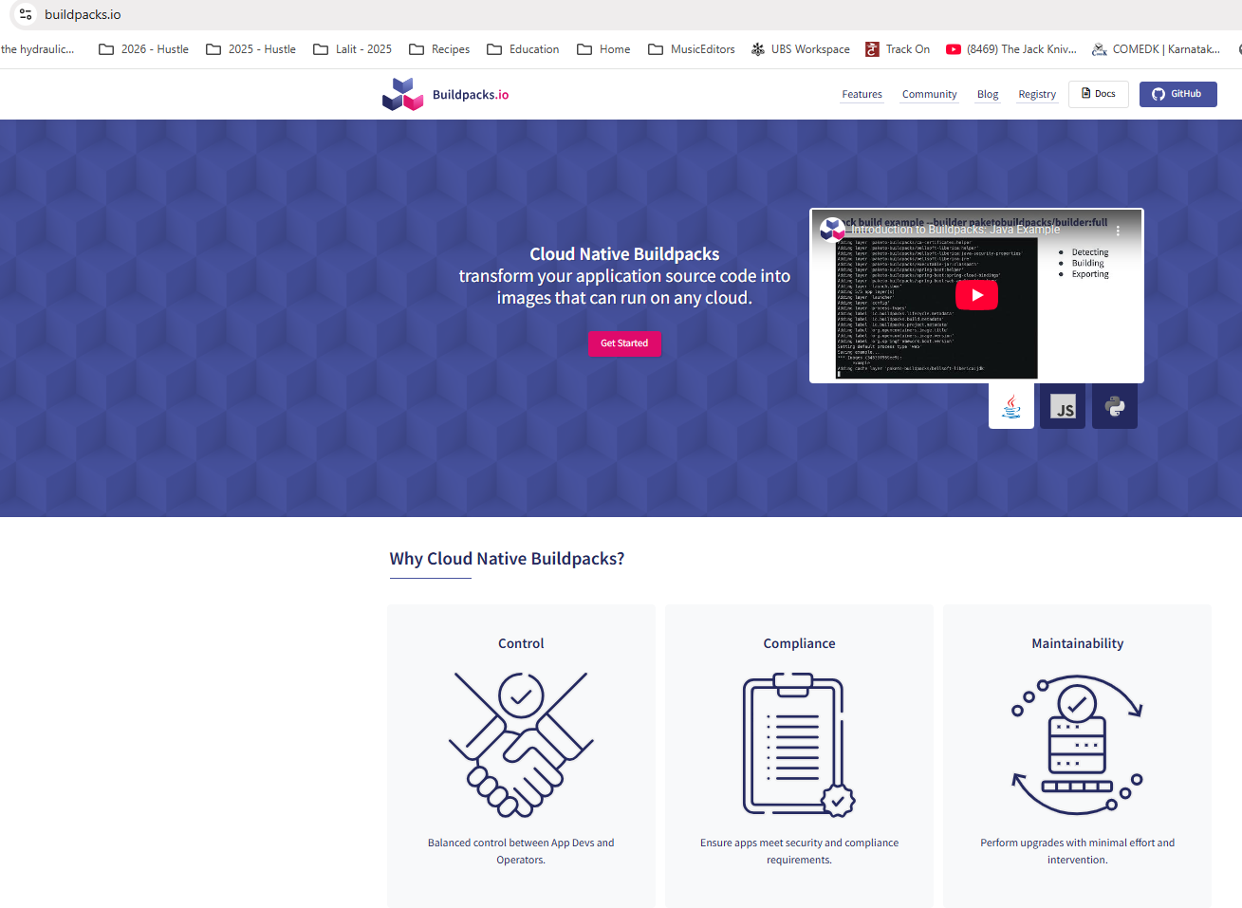

So during the generation of this Docker image, this build packs is going to follow all the standards of Docker in terms of security, in terms of compressing, in terms of caching. So regardless, whatever standard you talk about, Buildpacks is going to take care of everything. And if you want to achieve the same result with the Docker file approach, you need to be a super, super expert at Docker and understanding all the standards of Docker. Since we are the developers and don't want to learn everything about Docker, it will be a wise decision to use Buildpacks instead of Docker file. Because already these build packs is built based upon years of experience at Heroku and Pivotal and they know all the standards that we need to follow while generating a Docker image. We can use this ready to solution instead of reinventing the wheel again and again. So Buildpacks is a framework or an ecosystem or a concept. Based upon this ecosystem, we have Pacchetto Buildpacks that we can use for Java based applications.

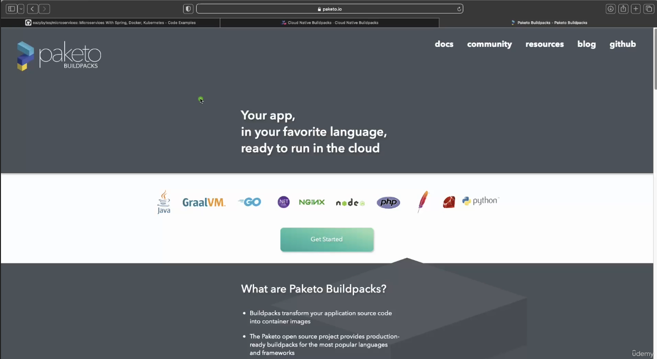

Apart from Java, it is also going to support many other languages like Go, Graalvm, Python, Ruby, PHP node. So if your microservice or if your web application is written in any of these languages, you can safely use buildpacks. And behind the scenes this buildpacks is going to use these Pacchetto build packs, which is an implementation of Buildpacks ecosystem. I hope you are clear with this quick introduction about Buildpacks. Now let's try to understand how to generate a Docker image with the help of this Buildpacks. For the same, first, let me close all these files of accounts microservice, post that I'm going to go to the loans microservice inside this pom.xml, first I need to make sure just after this version I'm mentioning the packaging as jar.

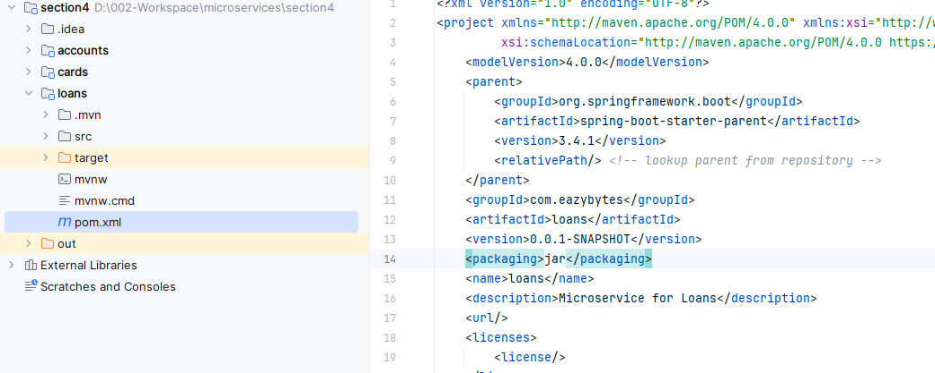

So once we mention this packaging as jar, you need to make sure you have a plugin related to the maven inside your pom.xml. Like you can see whenever we try to generate a spring boot web application from start.spring.io website. By default you will get this plugin which is like Spring boot maven plugin. With the help of this Spring boot Maven plugin.

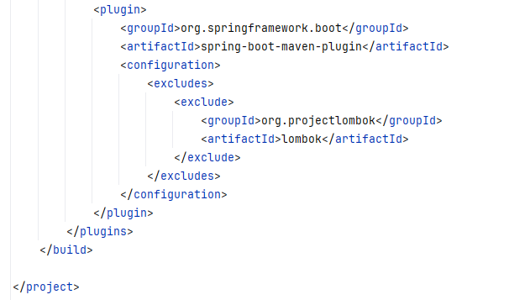

We can generate a Docker image and behind the scenes this Spring Boot Maven plugin is going to leverage Buildpacks and Paquito to generate a production ready Docker image. But in order to generate a Docker image, first we need to provide what is the name that we want to consider for that Docker image that we are going to generate. That's why inside this configurations we need to invoke a tag which is image. So inside this image tag we need to invoke one more tag, which is name. Under this name tag we need to provide what is that Docker image name. The Docker image name that we want to follow is very similar to accounts microservice First, we need to make sure that we are mentioning the Docker username that we have created inside the Docker website. So my username is eazybytes, so please make sure you are mentioning your own Docker username, post that slash followed by what is the name of your application. The name of my application is loans. Again this name can be anything but you need to make sure with the help of this Docker image name, you should be able to identify your microservice. That's why I'm giving this name as loans, which is same as my microservice name. After this, we need to mention colon. And what is the tag name or what is the version name? The tag name that we want to follow here is s4, which indicates section 4, since this image belongs to the section 4, I'm mentioning this S4 here.

<plugin>

<groupId>org.springframework.boot</groupId>

<artifactId>spring-boot-maven-plugin</artifactId>

<configuration>

<image>

<name>lalitrnagpal/loans:s4</name>

</image>

<excludes>

<exclude>

<groupId>org.projectlombok</groupId>

<artifactId>lombok</artifactId>

</exclude>

</excludes>

</configuration>

</plugin>

</plugins>

</build>

</project>

Now, if you see, instead of hard coding these loans anyway we decided to use the same as microservice name. What we can do is we can try to read this application name with the help of this dollar and curly braces.

<plugin>

<groupId>org.springframework.boot</groupId>

<artifactId>spring-boot-maven-plugin</artifactId>

<configuration>

<image>

<name>lalitrnagpal/${project.artifactId}:s4</name>

</image>

<excludes>

<exclude>

<groupId>org.projectlombok</groupId>

<artifactId>lombok</artifactId>

</exclude>

</excludes>

</configuration>

</plugin>

</plugins>

</build>

</project>

So inside this I'm going to mention project.artifactId, this project.artifactId we have defined in the top. So the artifactId name is loans. So the same name comes here. This way I'm trying to avoid hardcoding my microservice name.

<?xml version="1.0" encoding="UTF-8"?>

<project xmlns="http://maven.apache.org/POM/4.0.0" xmlns:xsi=<http://www.w3.org/2001/XMLSchema-instance> xsi:schemaLocation=

"http://maven.apache.org/POM/4.0.0 https://maven.apache.org/xsd/maven-4.0.0.xsd">

<modelVersion>4.0.0</modelVersion>

<parent>

<groupId>org.springframework.boot</groupId>

<artifactId>spring-boot-starter-parent</artifactId>

<version>3.4.1</version>

<relativePath/> <!-- lookup parent from repository -->

</parent>

<groupId>com.eazybytes</groupId>

<artifactId>loans</artifactId>

<version>0.0.1-SNAPSHOT</version>

<packaging>jar</packaging>

<name>loans</name>

<description>Microservice for Loans</description>

. . .

</project>

So with this we have mentioned that Docker image name that we want to consider whenever we are trying to generate a Docker image with the help of Buildpacks.

So let me save this changes post that I'll go to the terminal. So here, let me clean the console. Right now my terminal is at a location where my pom.xml of loans microservice is available here. I need to issue a maven command and the command is mvn spring-boot:build-image. So with this command we are telling to the maven to generate a docker image of my spring boot microservice by leveraging buildpacks. So behind the scenes it is going to leverage Buildpacks. Let me press enter here and if you are doing this very first time, it is going to take some five minutes because it has to download all the Buildpacks or package related libraries and images inside your local system. You can see right now it is downloading the base image from the paketo buildpacks using this base image only it is going to generate a Docker image. That's why very first time it is going to take some time. But once you have done this from next time onwards, it is going to be quick compared to the very first time. So let's wait for this to complete.

PS D:\002-Workspace\microservices\section4\loans> mvn spring-boot:build-image

[INFO] Scanning for projects...

[INFO]

[INFO] ------------------------< com.eazybytes:loans >-------------------------

[INFO] Building loans 0.0.1-SNAPSHOT

[INFO] from pom.xml

[INFO] --------------------------------[ jar ]---------------------------------

[INFO]

[INFO] >>> spring-boot:3.4.1:build-image (default-cli) > package @ loans >>>

[INFO]

[INFO] --- resources:3.3.1:resources (default-resources) @ loans ---

[INFO] Copying 1 resource from src\main\resources to target\classes

[INFO] Copying 1 resource from src\main\resources to target\classes

[INFO]

[INFO] --- compiler:3.13.0:compile (default-compile) @ loans ---

[INFO] Nothing to compile - all classes are up to date.

[INFO]

[INFO] --- resources:3.3.1:testResources (default-testResources) @ loans ---

[INFO] skip non existing resourceDirectory D:\002-Workspace\microservices\section4\loans\src\test\resources

[INFO]

[INFO] --- compiler:3.13.0:testCompile (default-testCompile) @ loans ---

[INFO] Nothing to compile - all classes are up to date.

[INFO]

[INFO] --- surefire:3.5.2:test (default-test) @ loans ---

[INFO] Using auto detected provider org.apache.maven.surefire.junitplatform.JunitPlatformProvider

. . .

PS D:\002-Workspace\microservices\section4\loans> mvn spring-boot:build-image

. . .

[INFO] > Pulling builder image 'docker.io/paketobuildpacks/builder-jammy-java-tiny:latest' 0%

[INFO] > Pulling builder image 'docker.io/paketobuildpacks/builder-jammy-java-tiny:latest' 5%

[INFO] > Pulling builder image 'docker.io/paketobuildpacks/builder-jammy-java-tiny:latest' 9%

[INFO] > Pulling builder image 'docker.io/paketobuildpacks/builder-jammy-java-tiny:latest' 17%

[INFO] > Pulling builder image 'docker.io/paketobuildpacks/builder-jammy-java-tiny:latest' 23%

[INFO] > Pulling builder image 'docker.io/paketobuildpacks/builder-jammy-java-tiny:latest' 29%

[INFO] > Pulling builder image 'docker.io/paketobuildpacks/builder-jammy-java-tiny:latest' 32%

[INFO] > Pulling builder image 'docker.io/paketobuildpacks/builder-jammy-java-tiny:latest' 34%

[INFO] > Pulling builder image 'docker.io/paketobuildpacks/builder-jammy-java-tiny:latest' 35%

[INFO] > Pulling builder image 'docker.io/paketobuildpacks/builder-jammy-java-tiny:latest' 36%

[INFO] > Pulling builder image 'docker.io/paketobuildpacks/builder-jammy-java-tiny:latest' 36%

[INFO] > Pulling builder image 'docker.io/paketobuildpacks/builder-jammy-java-tiny:latest' 36%

[INFO] > Pulling builder image 'docker.io/paketobuildpacks/builder-jammy-java-tiny:latest' 36%

[INFO] > Pulling builder image 'docker.io/paketobuildpacks/builder-jammy-java-tiny:latest' 36%

[INFO] > Pulling builder image 'docker.io/paketobuildpacks/builder-jammy-java-tiny:latest' 36%

[INFO] > Pulling builder image 'docker.io/paketobuildpacks/builder-jammy-java-tiny:latest' 36%

[INFO] > Pulling builder image 'docker.io/paketobuildpacks/builder-jammy-java-tiny:latest' 36%

[INFO] > Pulling builder image 'docker.io/paketobuildpacks/builder-jammy-java-tiny:latest' 100%

[INFO] > Pulled builder image 'paketobuildpacks/builder-jammy-java-tiny@sha256:da6ccadf959933cb4c2c463e9e75527174cd966fcd211335a0133efc087d90ac'

. . .

Right now it is 36% post at 41% and please make sure while running this mvn command, your Docker server should be running behind the scenes. If you don't have your Docker server is running your Buildpacks can't do anything because at the end of the day, behind the scenes it is going to give instructions to your Docker server to generate a Docker image inside your local system. So you can see it is trying to understand my Java version, which version I'm using inside my pom.xml So inside my pom.xml I have mentioned the Java version as 17. If you can go to the top of this pom.xml, here under this properties we have mentioned the Java version as 17.

So based upon all the details and dependencies that we have mentioned inside the pom.xml, it is going to scan for all the dependencies. And by considering all these behind the scenes it is going to generate a Docker image. Finally, after waiting for few more minutes, my Docker image generation of loans microservice got successful with the help of Buildpacks. You can see a Docker image is built with this image name. Now I can try to clean this console and run the docker images command. So here I'm trying to run the same and this time you can see there is also a loans image with the tag S4 and the size is 311 MB.

[INFO] [creator] Saving docker.io/lalitrnagpal/loans:s4...

[INFO] [creator] *** Images (048cf5d6b293):

[INFO] [creator] docker.io/lalitrnagpal/loans:s4

[INFO] [creator] Adding cache layer 'paketo-buildpacks/syft:syft'

[INFO] [creator] Adding cache layer 'paketo-buildpacks/spring-boot:spring-cloud-bindings'

[INFO] [creator] Adding cache layer 'buildpacksio/lifecycle:cache.sbom'

[INFO]

[INFO] Successfully built image 'docker.io/lalitrnagpal/loans:s4'

[INFO]

[INFO] ------------------------------------------------------------------------

[INFO] BUILD SUCCESS

[INFO] ------------------------------------------------------------------------

[INFO] Total time: 02:03 min

[INFO] Finished at: 2025-10-27T07:26:15+05:30

[INFO] ------------------------------------------------------------------------

PS D:\002-Workspace\microservices\section4\loans>

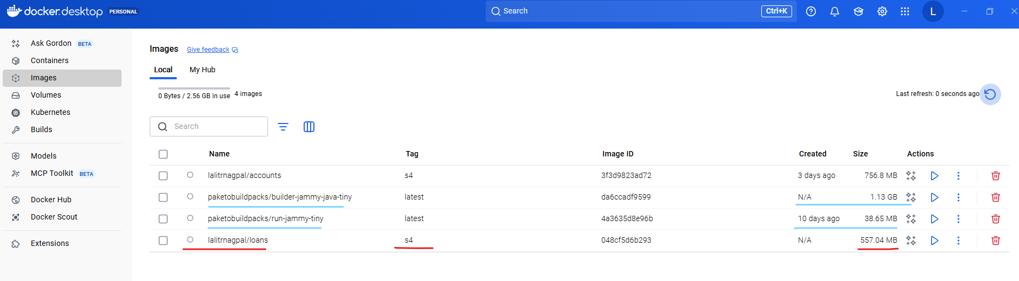

PS D:\002-Workspace\microservices\section4\loans> docker image list

REPOSITORY TAG IMAGE ID CREATED SIZE

lalitrnagpal/accounts s4 3f3d9823ad72 2 days ago 757MB

paketobuildpacks/run-jammy-tiny latest 4a3635d8e96b 9 days ago 38.7MB

lalitrnagpal/loans s4 048cf5d6b293 45 years ago 557MB

paketobuildpacks/builder-jammy-java-tiny latest da6ccadf9599 45 years ago 1.13GB

PS D:\002-Workspace\microservices\section4\loans>

If you see for accounts microservice, we have used the Docker file and the size of the accounts Docker image is 757 MB because we don't know how to follow the best standards, how to cache multiple layers, how to compress our multiple components inside Docker image. We don't know about all those standards and the Docker concept, but with the help of Buildpacks, you can see there is a lot of improvement in terms of the size of our Docker image. It reduced from 757 MB to 557 MB. So this is one of the great advantage if you use the products like Buildpacks, you can also see there is a paketo Buildpacks Docker image downloaded. So this image is going to do all the work of generating a Docker image for your spring boot microservice. And this is of 1.13 GB. So this is a very heavy image and of course you don't have to take this into your deployment. You just need only the loans Docker image. Now I can try to run my loans Docker image as a container.

PS D:\002-Workspace\. . .\loans> docker run -d -p 8081:8080 lalitrnagpal/loans:s4

6462e849d4ca6df9dc712a80942a23ac0360ad064393040dfdc88314d89f4593

PS D:\002-Workspace\microservices\section4\loans> docker ps -a

CONTAINER ID IMAGE COMMAND CREATED STATUS PORTS NAMES

6462e849d4ca lalitrnagpal/loans:s4 "/cnb/process/web" 5 seconds ago Up 4 seconds 0.0.0.0:8081->8080/tcp, [::]:8081->8080/tcp blissful_cartwright

PS D:\002-Workspace\microservices\section4\loans> docker stop 6462e849d4ca

6462e849d4ca

For the same, the command is very similar if you go to the previous commands that we have executed. So this is the one which we have executed docker run -d -p and the loans microservice is going to start at the port 8090. First, I need to make sure I'm mentioning the same and I will try to expose at the same port which is 8090 and the Docker image name of loans is eazybytes/loans and the tag name is S4 only. So we should be good with that. Now, if I try to execute this command, a Docker container will get created behind the scenes. You may see this warning, don't worry, you can simply ignore that. Now if you can go to the Docker desktop first, under the images, you should be able to see the new image that got generated, which is lalitrnagpa/loans:s4.

PS D:\...\section4\loans> docker run -d -p 8090:8090 lalitrnagpal/loans:s4

3c0666f5f0b1d833014497aa53300f019a03f02df1383fb72de0d7e063d0706d

PS D:\002-Workspace\microservices\section4\loans> docker ps -a

CONTAINER ID IMAGE COMMAND CREATED STATUS PORTS NAMES

3c0666f5f0b1 lalitrnagpal/loans:s4 "/cnb/process/web" 5 seconds ago Up 4 seconds 0.0.0.0:8090->8090/tcp, [::]:8090->8090/tcp silly_edison

6462e849d4ca lalitrnagpal/loans:s4 "/cnb/process/web" About a minute ago Exited (143) 36 seconds ago blissful_cartwright

And very similarly, if we can go to the containers, you can see there is a running container of loans. If you can click on this container name, you should be able to see all the logs and you can see your loans microservice started at the port 8090. I can also confirm the same by invoking a REST API against loans microservice with the help of postman. So here you can see, I'm trying to send a request for my create loan with the help of this mobile number. As soon as I click send, you should be able to get a response. So I'm getting a successful response here. So this confirms we have a proper running container of loans microservice that built with the help of Buildpacks concept.

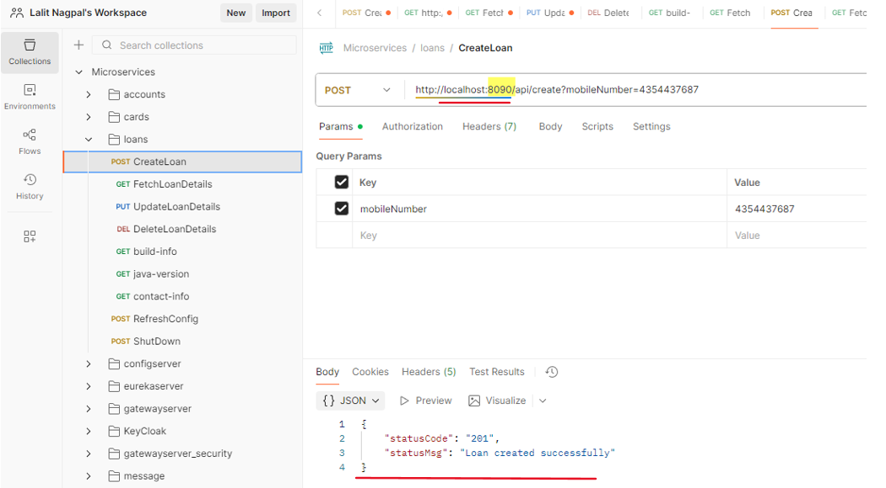

So let's try to revise the steps very quickly that we followed inside this Buildpacks approach. The very first step that we need to follow while building a Docker image with the help of Buildpacks is, we need to add the image name details inside your pom.xml like you can see on the right hand side. Along with the image name, please make sure you also have the Spring boot Maven plugin configured inside your pom.xml. This comes by default inside your spring boot web application. If you don't have, please mention that by referring to the code present inside the GitHub repo. Post that we need to run a mvn command which is mvn spring boot build image. So when you try to run this command behind the scenes, your spring boot Maven plugin is going to utilize Buildpacks to generate a Docker image without the need of Docker file.

|  |  |
| --- | --- |
|  |  |

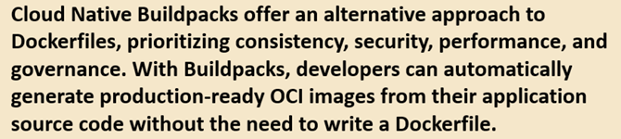

Once you generate a Docker image, you can run this Docker image as a Docker container by using the command which is Docker run along with the port mapping and your Docker image name. So these are the steps that we need to follow. So I have mentioned this inside this slide so that in future you can always refer them and you can always try to brush up the concepts that we have discussed. So on a high level, what is Buildpacks? Buildpacks offers alternative approach to Docker files. So without writing the Docker files this Buildpacks, it is going to help developers to automatically generate production ready Docker images from their application source code. And while generating these Docker images, these Buildpacks is going to follow all the production standards like security, caching, performance, compressing. So that's why this approach is better than Docker file approach. With this, I'm assuming your super clear about Buildpacks in the next lecture, let's try to explore the last approach that we have, which is Google Jib.

### Google Jib

Let's try to explore Jib from the Google to generate a Docker image for the cards microservice. So like you can see you need to go to this URL which is github.com slash Google container tool slash jib. The same URL I have mentioned inside the GitHub repository. Under the important links you can see this is the link of Google Jib website.

Docker hub website - <https://hub.docker.com>

Buildpacks website - <https://buildpacks.io>

Google Jib website - <https://github.com/GoogleContainerTools/jib>

Docker compose website - <https://docs.docker.com/compose/>

Once you are onto this GitHub repository, you can scroll down and there are instructions on how to use this jib and containerize our Java applications.

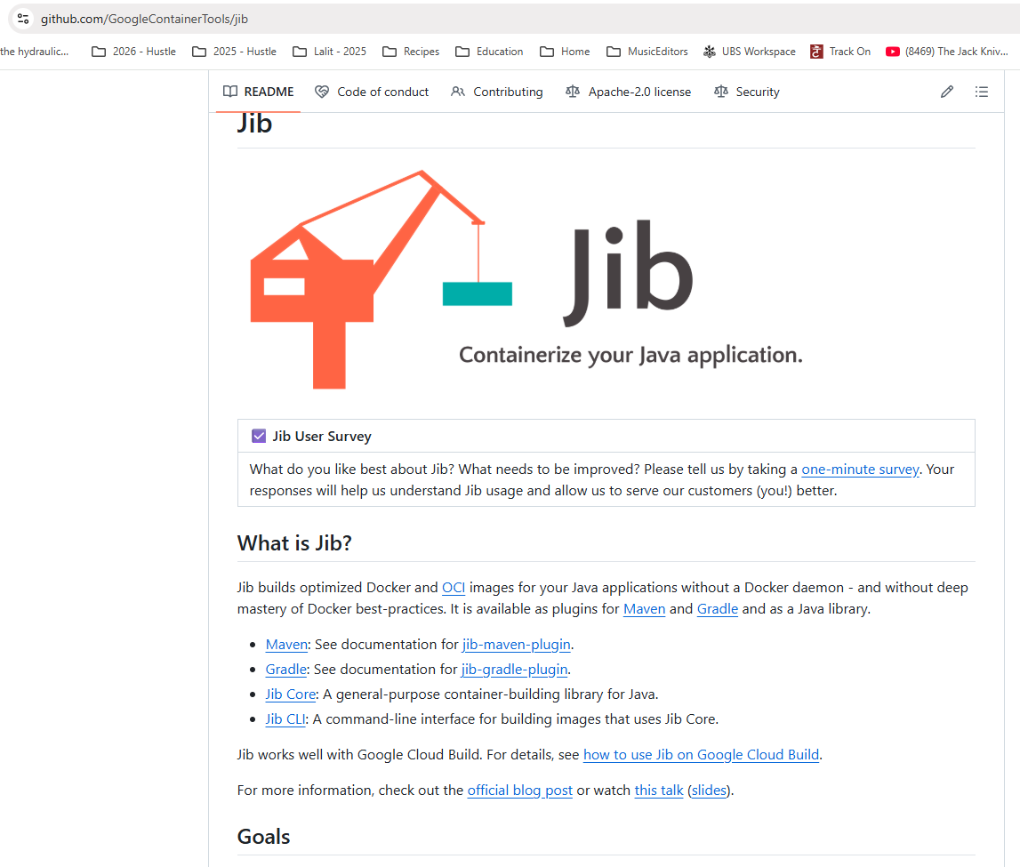

So please note that Jib is going to work only for Java applications, whereas Buildpacks is going to work for many other famous languages like Python, Ruby, Node.js. So there are many other languages that Buildpacks is going to support apart from Java, whereas Jib is strictly for Java applications. Since we are building Java based microservice, we can use this Jib without any issues. We can scroll down here. There are links to know more details about how to use this Jeep with the help of Maven and Gradle. If you are using Gradle, you can click on this Gradle link. Otherwise you can click on this Maven. Since we are using Maven, we need to click on this Maven link, which will redirect us to the GitHub repo page where this Maven plugin is available. If you can scroll down here, there are details on how to get started. The very first setup that you need to do is inside your Pom.xml. We need to make sure to copy this plugin detail which will help us to generate a Docker image. So let me copy these configurations. So here inside my cards microservice, first I'll try to delete the existing content of target folder. For that I'll go to my Pom.xml and I'll make sure to mention the packaging details after this versioning.

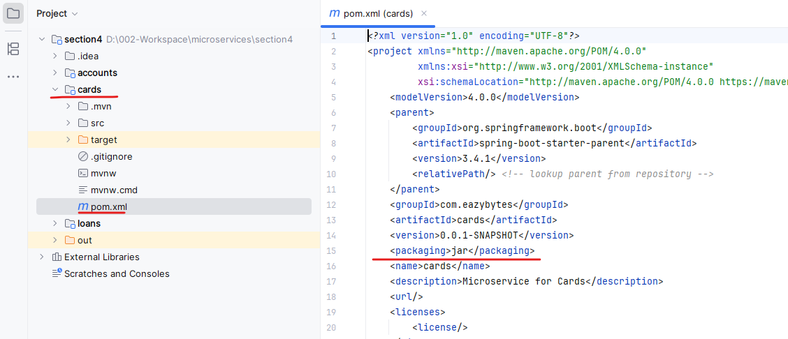

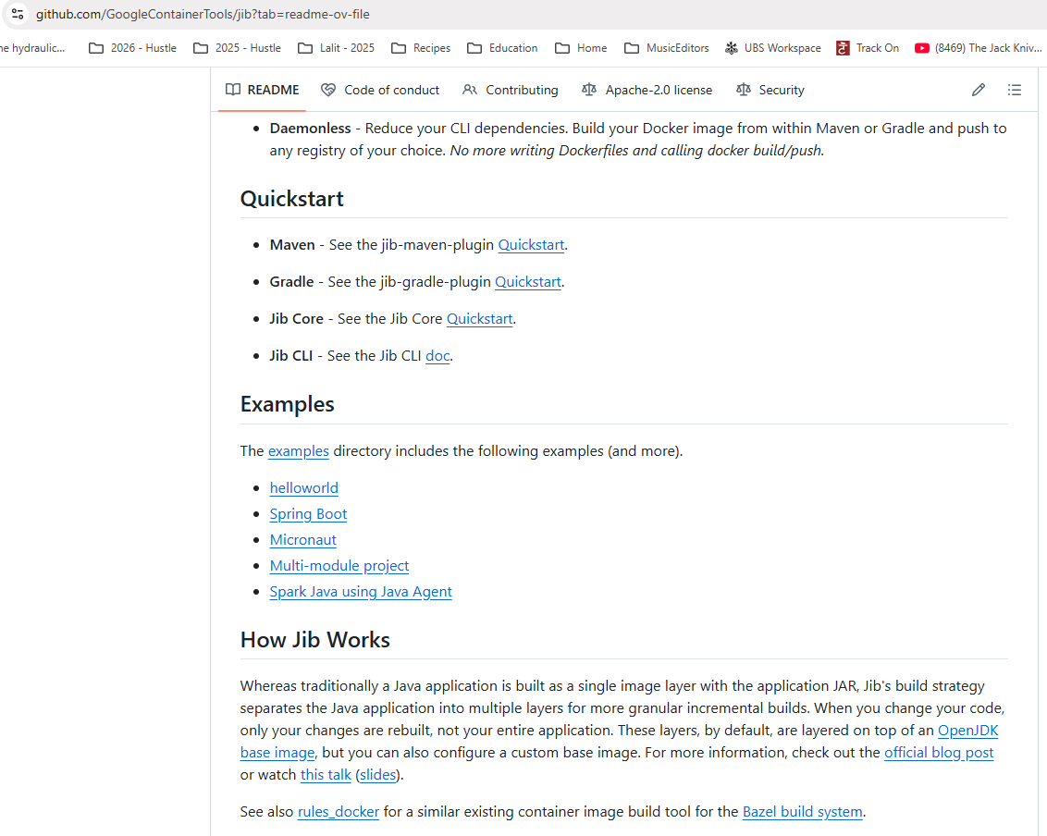

So the packaging configurations that I want to use is Jar. So let me mention the same. Now we can go to the end of this palm dot XML. We already have a Spring Boot Maven plugin here, so we can introduce one more plugin.

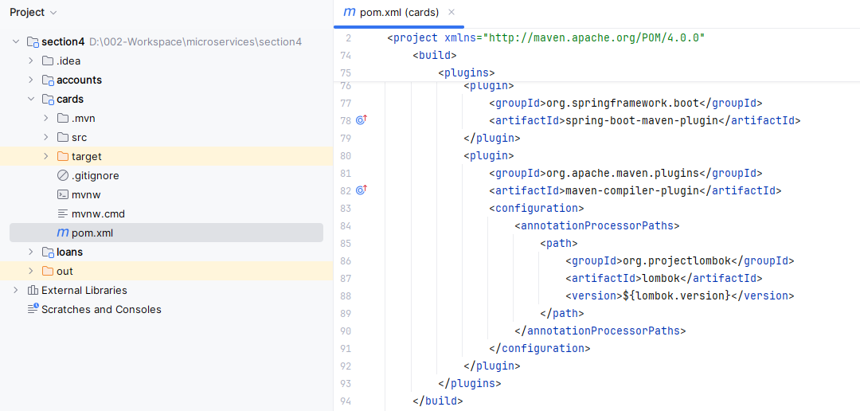

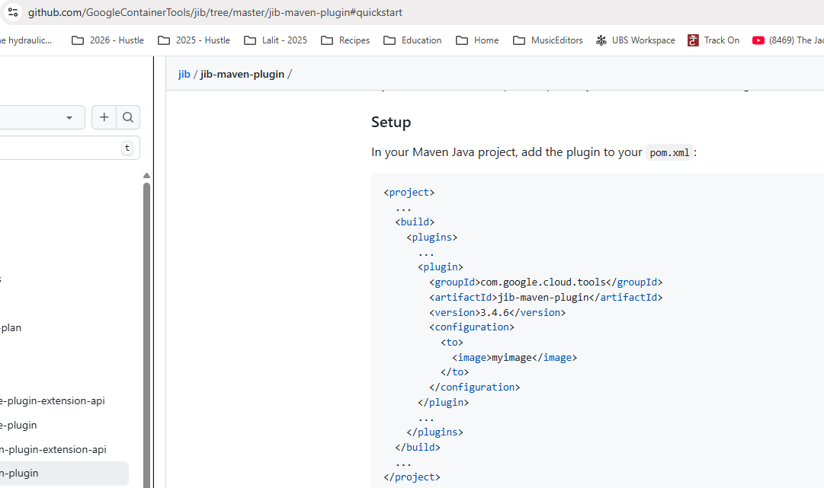

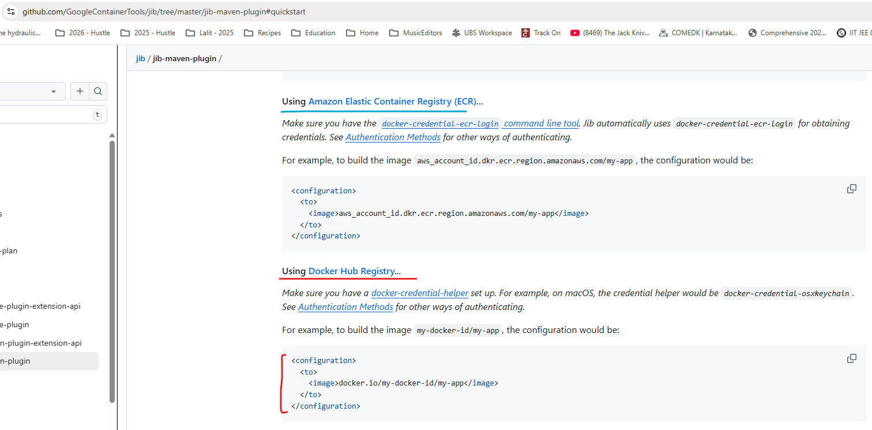

So let me copy the new plugin details. So the plugin details is it belongs to a group ID com.google.cloud.tools. And the artifact ID is Maven plugin. The version is 3.3.2. And under this configuration we need to mention a tag which is two. After this we can mention the image and what is the image name? The image name we can follow the very similar to what we have been following for the loans microservice. So let me copy the name from the loans microservice. So I'll take this value and I'll mention the same under the cards pom.XML as well.

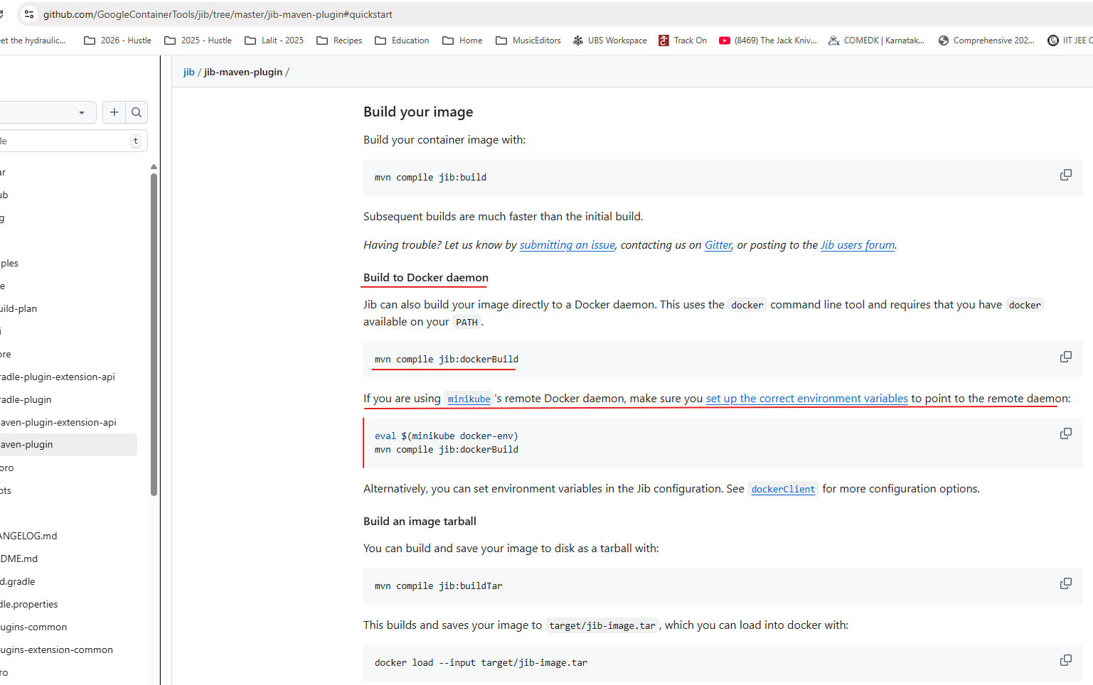

So lalitrnagpal is the Docker user name that I have created and the {project.artifactId} of this pom.xml is cards. So there is no need to worry even though we copied from the loans. Since this variable is going to get derived from the existing pom.xml we should be good post that. The tag name that I want to mention here is S4. Once we added these changes inside pom.xml, we can go to the GitHub repository here. If you can scroll down, there is a command that you can use to generate a Docker image. So the command is mvn compile jib:docker build. So this will use your local Docker server setup to generate a Docker image. So let's try to execute this command inside my terminal. So for the same first I need to go to the cards microservice location. So I'm just going there was that I'm clearing my console. After this the command that I need to run is mvn compile jib:dockerBuild with B as capital.

PS D:\002-Workspace\microservices\section4\cards> mvn compile jib:dockerBuild

[INFO] Scanning for projects...

Downloading from central: https://repo.maven.apache.org/maven2/com/google/cloud/tools/jib-maven-plugin/3.4.6/jib-maven-plugin-3.4.6.pom

Downloaded from central: https://repo.maven.apache.org/maven2/com/google/cloud/tools/jib-maven-plugin/3.4.6/jib-maven-plugin-3.4.6.pom (4.9 kB at 13 kB/s)

Downloading from central: https://repo.maven.apache.org/maven2/com/google/cloud/tools/jib-maven-plugin/3.4.6/jib-maven-plugin-3.4.6.jar

Downloaded from central: https://repo.maven.apache.org/maven2/com/google/cloud/tools/jib-maven-plugin/3.4.6/jib-maven-plugin-3.4.6.jar (567 kB at 4.7 MB/s)

[INFO]

[INFO] ------------------------< com.eazybytes:cards >-------------------------

[INFO] Building cards 0.0.1-SNAPSHOT

[INFO] from pom.xml

[INFO] --------------------------------[ jar ]---------------------------------

[INFO]

[INFO] --- resources:3.3.1:resources (default-resources) @ cards ---

[INFO] Copying 1 resource from src\main\resources to target\classes

[INFO] Copying 1 resource from src\main\resources to target\classes

[INFO]

[INFO] --- compiler:3.13.0:compile (default-compile) @ cards ---

[INFO] Nothing to compile - all classes are up to date.

[INFO]

[INFO] --- jib:3.4.6:dockerBuild (default-cli) @ cards ---

. . .

[WARNING] The credential helper (docker-credential-desktop) has nothing for server URL: registry.hub.docker.com

[WARNING]

Got output:

credentials not found in native keychain

[INFO] Using credentials from Docker config (**C:\Users\Lalit\.docker\config.json**) for eclipse-temurin:17-jre

[INFO] Using base image with digest: sha256:696817d4fb79b9c442e84e18483d8345dd2d0b6710546344e5eb182bd3153333

[INFO]

[INFO] Container entrypoint set to [java, -cp, @/app/jib-classpath-file, com.eazybytes.cards.CardsApplication]

[INFO]

[INFO] Built image to Docker daemon as lalitrnagpal/cards:s4

[INFO] Executing tasks:

[INFO] [==============================] 100.0% complete

[INFO]

[INFO] ------------------------------------------------------------------------

[INFO] BUILD SUCCESS

[INFO] ------------------------------------------------------------------------

[INFO] Total time: 44.231 s

[INFO] Finished at: 2025-10-29T08:16:48+05:30

[INFO] ------------------------------------------------------------------------

PS D:\002-Workspace\microservices\section4\cards>

PS D:\002-Workspace\microservices\section4\cards> docker images

REPOSITORY TAG IMAGE ID CREATED SIZE

lalitrnagpal/accounts s4 3f3d9823ad72 4 days ago 757MB

paketobuildpacks/run-jammy-tiny latest 4a3635d8e96b 11 days ago 38.7MB

lalitrnagpal/loans s4 048cf5d6b293 45 years ago 557MB

paketobuildpacks/builder-jammy-java-tiny latest da6ccadf9599 45 years ago 1.13GB

lalitrnagpal/cards s4 36eb5ff7f0d3 55 years ago 493MB

PS D:\002-Workspace\microservices\section4\cards>

Dropping -d parameter to see how it runs our image

PS D:\002-Workspace\microservices\section4\cards> docker run -p 9000:9000 lalitrnagpal/cards:s4

. ____ _ __ _ _

/\\ / ___'_ __ _ _(_)_ __ __ _ \ \ \ \

( ( )\___ | '_ | '_| | '_ \/ _` | \ \ \ \

\\/ ___)| |_)| | | | | || (_| | ) ) ) )

' |____| .__|_| |_|_| |_\__, | / / / /

=========|_|==============|___/=/_/_/_/

:: Spring Boot :: (v3.4.1)

2025-10-29T02:51:49.613Z INFO 1 --- [ main] com.eazybytes.cards.CardsApplication : Starting CardsApplication using Java 17.0.16 with PID 1 (/app/classes started by root in /)

2025-10-29T02:51:49.617Z INFO 1 --- [ main] com.eazybytes.cards.CardsApplication : No active profile set, falling back to 1 default profile: "default"

2025-10-29T02:51:50.716Z INFO 1 --- [ main] .s.d.r.c.RepositoryConfigurationDelegate : Bootstrapping Spring Data JPA repositories in DEFAULT mode.

2025-10-29T02:51:50.775Z INFO 1 --- [ main] .s.d.r.c.RepositoryConfigurationDelegate : Finished Spring Data repository scanning in 49 ms. Found 1 JPA repository interface.

2025-10-29T02:51:51.517Z INFO 1 --- [ main] o.s.b.w.embedded.tomcat.TomcatWebServer : Tomcat initialized with port 9000 (http)

2025-10-29T02:51:51.528Z INFO 1 --- [ main] o.apache.catalina.core.StandardService : Starting service [Tomcat]

2025-10-29T02:51:51.529Z INFO 1 --- [ main] o.apache.catalina.core.StandardEngine : Starting Servlet engine: [Apache Tomcat/10.1.34]

2025-10-29T02:51:51.599Z INFO 1 --- [ main] o.a.c.c.C.[Tomcat].[localhost].[/] : Initializing Spring embedded WebApplicationContext

2025-10-29T02:51:51.600Z INFO 1 --- [ main] w.s.c.ServletWebServerApplicationContext : Root WebApplicationContext: initialization completed in 1916 ms

2025-10-29T02:51:51.872Z INFO 1 --- [ main] com.zaxxer.hikari.HikariDataSource : HikariPool-1 - Starting...

2025-10-29T02:51:52.039Z INFO 1 --- [ main] com.zaxxer.hikari.pool.HikariPool : HikariPool-1 - Added connection conn0: url=jdbc:h2:mem:testdb user=SA

2025-10-29T02:51:52.041Z INFO 1 --- [ main] com.zaxxer.hikari.HikariDataSource : HikariPool-1 - Start completed.

2025-10-29T02:51:52.138Z INFO 1 --- [ main] o.hibernate.jpa.internal.util.LogHelper : HHH000204: Processing PersistenceUnitInfo [name: default]

2025-10-29T02:51:52.198Z INFO 1 --- [ main] org.hibernate.Version : HHH000412: Hibernate ORM core version 6.6.4.Final

2025-10-29T02:51:52.228Z INFO 1 --- [ main] o.h.c.internal.RegionFactoryInitiator : HHH000026: Second-level cache disabled

2025-10-29T02:51:52.464Z INFO 1 --- [ main] o.s.o.j.p.SpringPersistenceUnitInfo : No LoadTimeWeaver setup: ignoring JPA class transformer

2025-10-29T02:51:52.508Z WARN 1 --- [ main] org.hibernate.orm.deprecation : HHH90000025: H2Dialect does not need to be specified explicitly using 'hibernate.dialect' (remove the property setting and it will be selected by default)

2025-10-29T02:51:52.527Z INFO 1 --- [ main] org.hibernate.orm.connections.pooling : HHH10001005: Database info:

Database JDBC URL [Connecting through datasource 'HikariDataSource (HikariPool-1)']

Database driver: undefined/unknown

Database version: 2.3.232

Autocommit mode: undefined/unknown

Isolation level: undefined/unknown

Minimum pool size: undefined/unknown

Maximum pool size: undefined/unknown

2025-10-29T02:51:53.240Z INFO 1 --- [ main] o.h.e.t.j.p.i.JtaPlatformInitiator : HHH000489: No JTA platform available (set 'hibernate.transaction.jta.platform' to enable JTA platform integration)

Hibernate: alter table if exists cards alter column card_id set data type bigint

Hibernate: alter table if exists cards alter column created_at set data type timestamp(6)

Hibernate: alter table if exists cards alter column created_by set data type varchar(255)

Hibernate: alter table if exists cards alter column updated_at set data type timestamp(6)

Hibernate: alter table if exists cards alter column updated_by set data type varchar(255)

Hibernate: alter table if exists cards alter column card_number set data type varchar(255)

Hibernate: alter table if exists cards alter column card_type set data type varchar(255)

Hibernate: alter table if exists cards alter column mobile_number set data type varchar(255)

2025-10-29T02:51:53.307Z INFO 1 --- [ main] j.LocalContainerEntityManagerFactoryBean : Initialized JPA EntityManagerFactory for persistence unit 'default'

2025-10-29T02:51:53.857Z WARN 1 --- [ main] JpaBaseConfiguration$JpaWebConfiguration : spring.jpa.open-in-view is enabled by default. Therefore, database queries may be performed during view rendering. Explicitly configure spring.jpa.open-in-view to disable this warning

2025-10-29T02:51:54.594Z INFO 1 --- [ main] o.s.b.a.h2.H2ConsoleAutoConfiguration : H2 console available at '/h2-console'. Database available at 'jdbc:h2:mem:testdb'

2025-10-29T02:51:54.638Z INFO 1 --- [ main] o.s.b.a.e.web.EndpointLinksResolver : Exposing 1 endpoint beneath base path '/actuator'

2025-10-29T02:51:54.748Z INFO 1 --- [ main] o.s.b.w.embedded.tomcat.TomcatWebServer : Tomcat started on port 9000 (http) with context path '/'

2025-10-29T02:51:54.770Z INFO 1 --- [ main] com.eazybytes.cards.CardsApplication : Started CardsApplication in 5.544 seconds (process running for 5.949)

So if I try to execute this command, it will scan all the details inside my pom.xml and it is going to generate a docker image for my cards microservice. And this jib is going to be faster than build packs. You can see I'm able to get my Docker image within 11 seconds, whereas builder packs is going to take a lot of time. So now let me clear the console and try to run the Docker images. So if you can see here we got a new Docker image with the name cards. And this also is having a size of 322 MB, which is very similar to build a pack, but far better than the image size that we have for the accounts microservice. This confirms that Jib also is doing very good job in following all the standards and providing a production ready Docker image. Of course, this tool is from Google.

We can confidently use this tool because they might be using this from many years and optimized it to a great extent. That's why we can always leverage these kind of open source tools like jib and build packs. Now here you may have question like for the images that got generated with the help of build packs and zip. There is a created value which is like 43 years ago or 53 years ago. Is this a bug inside this build? Packs and zip. No, this is not a bug. This is a feature provided by them. The reason on why they are using such old dates is they will have a starting date, which is somewhere in 1970 or 1960, which they are going to use whenever you try to generate a Docker image. And if you try to generate a Docker image again without making any changes, intentionally or unintentionally, this new Docker image is also going to have the same created it, and since it is going to have the same content inside it, the regeneration process of the same Docker image is going to be the same.

PS D:\002-Workspace\microservices\section4\cards> docker images

REPOSITORY TAG IMAGE ID CREATED SIZE

lalitrnagpal/accounts s4 3f3d9823ad72 4 days ago 757MB

paketobuildpacks/run-jammy-tiny latest 4a3635d8e96b 11 days ago 38.7MB

lalitrnagpal/loans s4 048cf5d6b293 45 years ago 557MB

paketobuildpacks/builder-jammy-java-tiny latest da6ccadf9599 45 years ago 1.13GB

lalitrnagpal/cards s4 36eb5ff7f0d3 55 years ago 493MB

But instead of this old created date, if they use a normal current created date, then the same is not going to work because they cannot really compare two images to identify if the same or not, because the created date is going to differ due to that reason, they are using older dates. You can also look about this these inside the web. Lot. Many people thought this is a bug inside the build packs and zip and why they are showing it as part three years or 53 years. But this is not a bug. This is a feature to optimize the generation of the Docker images again and again. So now my Docker image is available. As a next step we can run docker run command which is docker run, followed by hyphen d, followed by hyphen p. And the port mapping that I want to follow for the cards is 9000 9000. Since our cards microservice is going to start at 9000, I have mentioned this port mapping and the image name is easy byte slash cards and the tag name is S4. So now I'm trying to execute this command. You can see the new container started. I can go to the Docker desktop under the containers. Right now you can see there is a cards related container also running right now. I can also confirm by looking at the logs, you can see it is still starting and the logs are being updated behind the scenes. So now my cards application container is started. I can also validate if it is working properly or not. With the help of postman inside the postman, I'm trying to send a request to the create API available inside the card. So let me click on this send button.

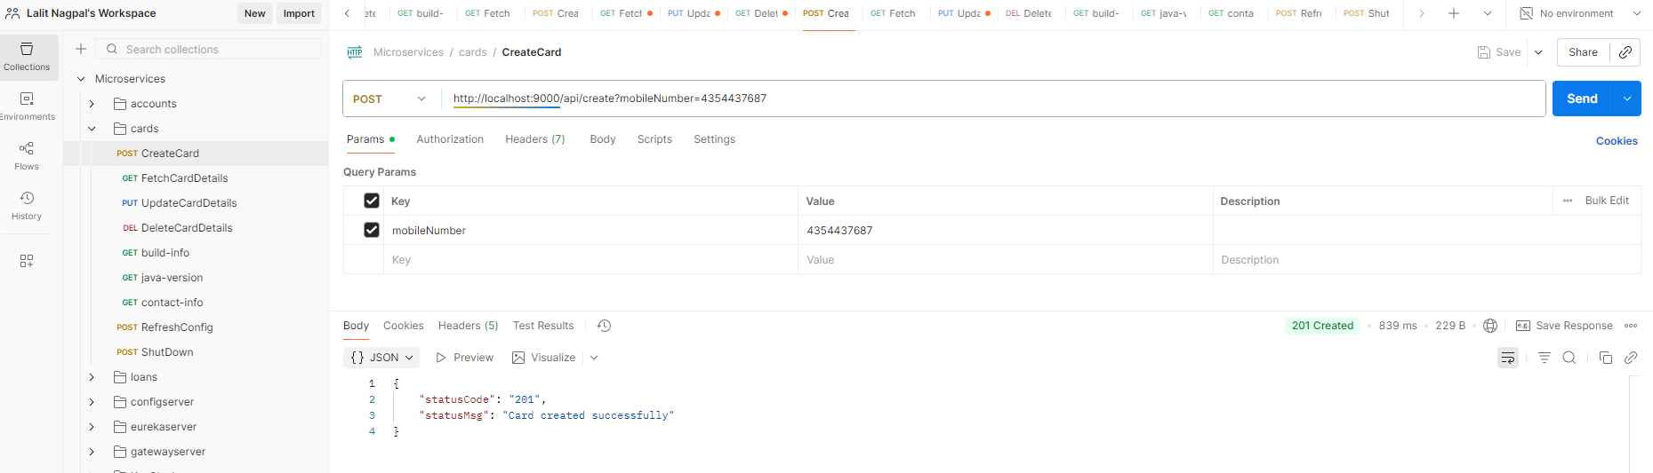

After clicking on the send button, you can see I'm getting a successful response, which means our cards microservice is also working fine. After converting as a Docker container, you can also try to run the Docker PS command which will show all the existing running containers. So these cards and loans containers are running and accounts microservice container is not running because I have stopped it long back.

Lets see some more details about Google Jib. There is a one more great advantage of Google Jib compared to Buildpacks. Whenever we are using Jib, we can generate a Docker image. Even if you don't have Docker installed inside your system. That's the beauty of jib. So if you don't want to install Docker inside your local system, but at the same time you want to convert your application to a Docker image, then you can use a command which is mvn compile jib build.

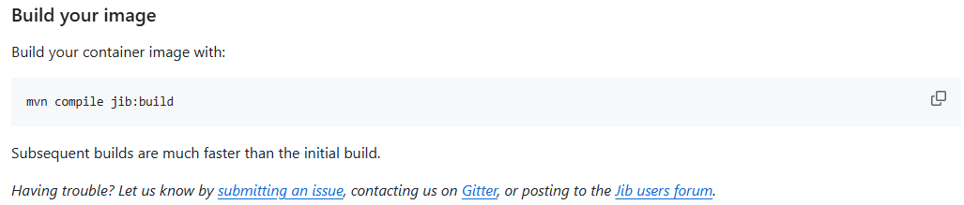

So when you try to use this build command, it is going to generate a Docker image from your application. And the same will be pushed into the remote repository. Because if you're not running a Docker inside a local system, that means there is no place for your jib to generate the Docker image.

PS D:\002-Workspace\microservices\section4\cards> mvn compile jib:build

[INFO] Scanning for projects...

[INFO]

[INFO] ------------------------< com.eazybytes:cards >-------------------------

[INFO] Building cards 0.0.1-SNAPSHOT

[INFO] from pom.xml

[INFO] --------------------------------[ jar ]---------------------------------

[INFO]

[INFO] --- resources:3.3.1:resources (default-resources) @ cards ---

[INFO] Copying 1 resource from src\main\resources to target\classes

[INFO] Copying 1 resource from src\main\resources to target\classes

. . .

credentials not found in native keychain

[INFO] Using credentials from Docker config (C:\Users\Lalit\.docker\config.json) for eclipse-temurin:17-jre

[INFO] Using base image with digest: sha256:696817d4fb79b9c442e84e18483d8345dd2d0b6710546344e5eb182bd3153333

[INFO]

[INFO] Container entrypoint set to [java, -cp, @/app/jib-classpath-file, com.eazybytes.cards.CardsApplication]

[INFO]

[INFO] Built and pushed image as lalitrnagpal/cards:s4

[INFO] Executing tasks:

[INFO] [==============================] 100.0% complete

[INFO]

[INFO] ------------------------------------------------------------------------

[INFO] BUILD SUCCESS

[INFO] ------------------------------------------------------------------------

[INFO] Total time: 01:48 min

[INFO] Finished at: 2025-10-29T09:29:39+05:30

[INFO] ------------------------------------------------------------------------

That's why it will look for the remote repository details where it has to store. If you can see here there are many other remote repository details that you can configure. If you are using GCR to store your Docker image, you can mention this image name as gcr.io. And what is your GCP project name followed by what is your app name?

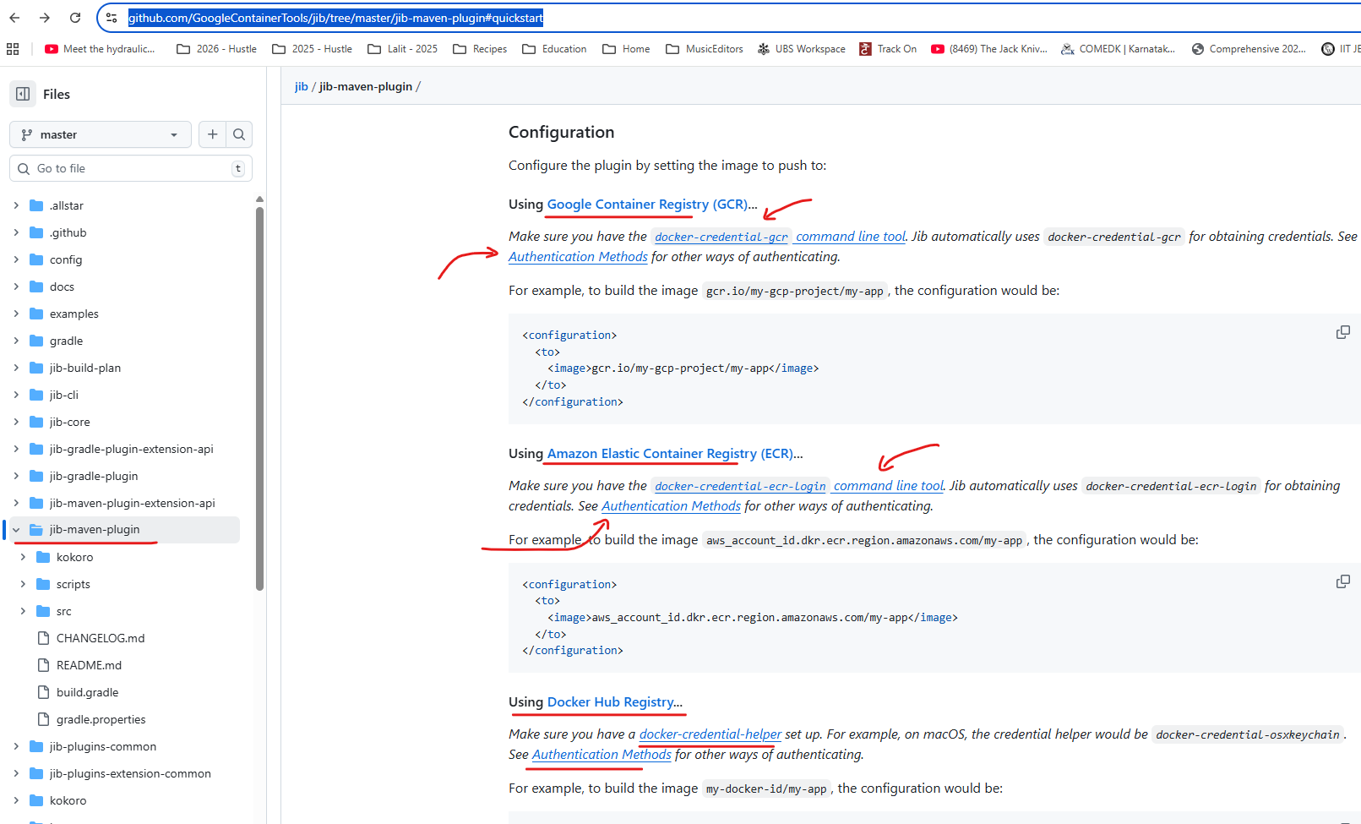

And very similarly for ECR. Also we can configure image name by following these standards. Whereas for Docker Hub you can mention docker.io. What is your docker username and post that? What is your app name followed by tag name? Tag name is always optional. So whenever it is trying to push your Docker image into the remote repository, it may need some credentials like your Docker credentials or your Amazon credentials, or your GCP credentials. So to provide those details you can always look these documentation on how to provide.

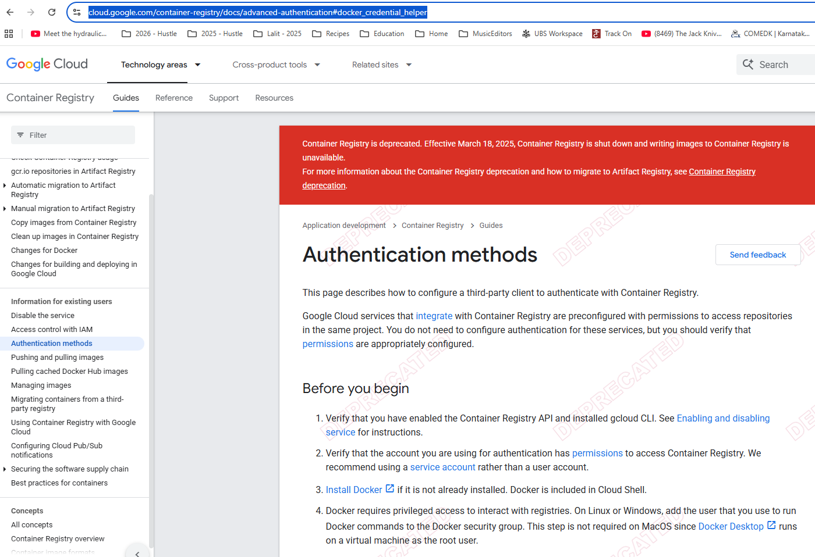

But in this course we are not going to use any of these approaches. Because first we want to store inside our local system. We want to test it. Once we satisfied then only we want to manually push into the remote repository. But this approach is going to be super, super helpful for the projects where the developers are not responsible to generate a Docker images, they are simply responsible to push the code into the GitHub repository inside the GitHub repository using CI, CD tools like Jenkins or GitHub actions or any other tool. You can write scripts to generate the Docker image from your application and inside your CI CD server you don't have to install this heavy software, which is Docker. In such scenarios, this is going to be super, super helpful. But like I said, inside this course we are going to use docker build command. Throughout the course. But I just wanted to highlight these advantages that we have with Jib. And this is the true differentiator for many projects where they are trying to prefer Jib compared to Buildpacks. Now let me show you the steps that we have followed to generate a container with the help of Google Jib.

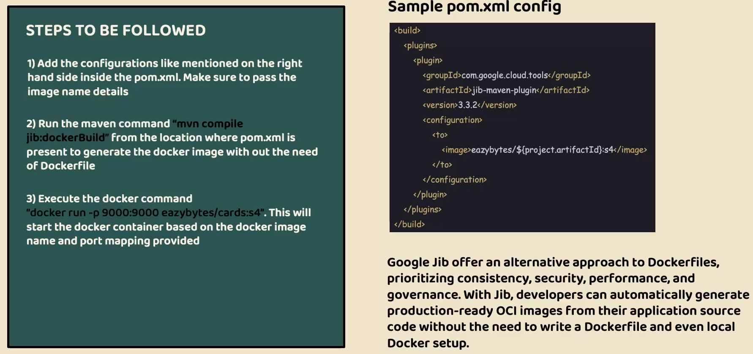

In the very first step, we need to configure the plugin details of Jib Maven plugin inside our Pom.xml. Like you can see on the right hand side and inside this plugin details. We should also configure what is the image name with the help of these two tag available under the configuration tag. Once we configure these details, we can run a command which is Maven compile jib docker build. And when we run this command, a Docker image will be generated inside your local system with the help of Docker server Were installed. And here we're not writing any Docker file. And the last step is once we have the Docker image available, you can run your Docker image as a container with the help of docker run command. And with that, your application is ready to accept requests in the form of Docker container.

And a high level Google chip help us to generate production ready Docker images by following all the production standards like performance, security, caching, compressing and developers are not forced to write any Docker files, they can simply generate production ready images for their application source code without the need of writing any low level Docker file and if needed. Jib also is capable of generating a Docker image without even local docker setup. I hope you are clear with all the details that we discussed about Google Jib in the next lecture, let's try to compare three different approaches that we have, and try to select one of them for the rest of the course.

### Approach Comparison – Dockerfile, Buildpacks and Jib

We looked at three most commonly used approaches to generate a Docker image of our microservices. And now you may have a question like which approach is better, Which one I can use? Frankly speaking, there is no better approach. Every approach has its own advantages and disadvantages. So based upon your scenario, you need to select one of them. You see, for the Docker file, it has disadvantages. Like you need to be an expert to write a Docker file. You need to follow all the production standards and best practices by yourself. And at the same time, the Docker file has to be maintained for all your microservices, but it also has an advantage. This Docker file will give a lot of flexibility to you. If you have any custom requirements while you are generating a Docker image, you can achieve all of them with the help of Docker file approach. Whereas with the buildpacks and jib, you just need to accept what you have received or what they are supporting. That's why if you have any such custom requirements, you can always follow these Docker file approach. But we're not going to use this Docker file approach throughout this course because we as a developers, we don't have to learn all the concepts of Docker file and follow all the best practices manually. We don't want to take that burden. Instead, we can rely on these open source platforms like Buildpacks and Google jib inside these two approaches, which one to choose. Again here, a confusion. Let's try to understand the advantages and disadvantages of them.

So inside the Buildpacks website, if you click on this features tab and scroll down, there is a comparison table provided by the Buildpacks team among the various approaches that you can use to generate a Docker image. The very first approach is of course the Buildpacks approach. The second approach is Docker file and similarly we have jib approach.

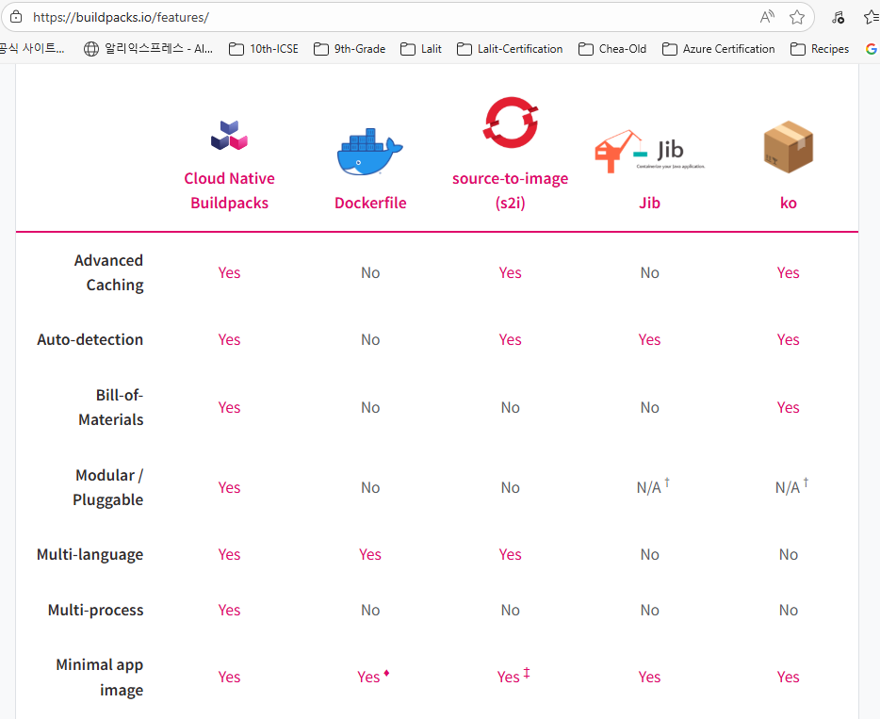

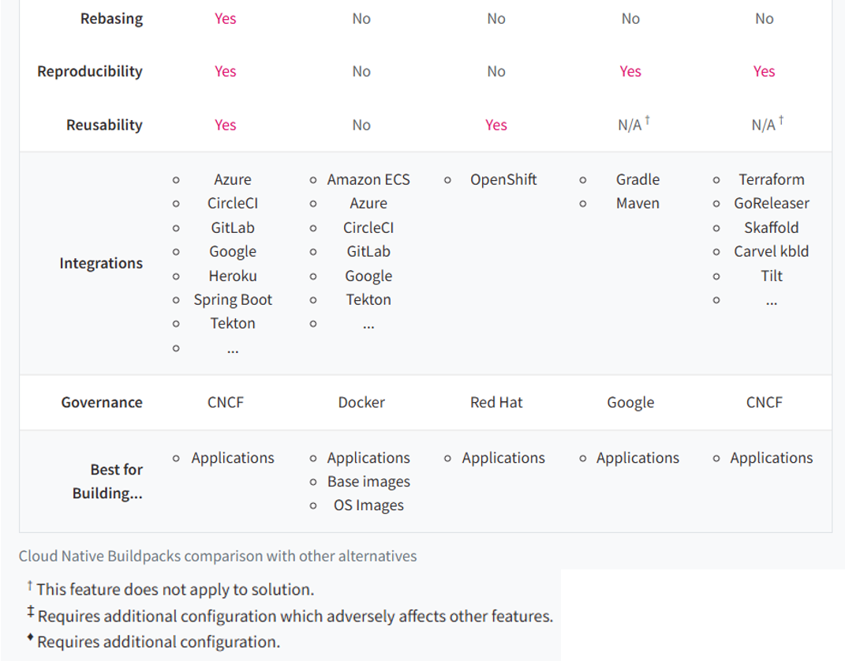

And apart from that, we also have other approaches like source to image and ko. Inside this ko I showed you three different approaches like Buildpacks, Dockerfile and Jib. That's why let's focus on them only and ignore the other approaches because those are not commonly used. You see here, Buildpacks is a winner in most of the scenarios like caching. Buildpacks is providing and the jib it is not providing this bill of materials Buildpacks is providing, Jib is not providing and similarly modular and pluggable Buildpacks is providing and multi-language support this is very, very important because Buildpack supports various languages and even the Docker file, whereas Jib is going to support only Java and same Multi-process Buildpacks is a winner.

Minimal app image both a buildpacks and jib by default provide, whereas dockerfile with some conditions. This way there are many other advantages and you can see Buildpacks is a clear winner. That's why you'll be seeing many people using Buildpacks. And this also give them flexibility. If they have different microservices based upon different languages, they can always use a buildpacks. But whereas if they go with jib, then only for Java based microservice, they can use jib and for the other microservice where they are using Python or any other language. In such scenarios they have to use buildpacks. So instead of using two different approaches they will go with the Buildpacks. They have microservices focusing on various languages. But the question right now is which one we are going to use inside this course. The approach that I'm going to use inside this course is jib. You may get surprise here, why I'm using Jib.

There are three different reasons why I'm going to use Jib inside this course.

1. The very first one is Jib is going to take very less time to generate a Docker image. It is going to super quick compared to Buildpacks. That's the very first reason and it is also going to take less memory inside my system. So inside local system, since I want to save some storage and ram memory, I'm going with this jib option. Even many of my students, they may have some laptops with eight GB Ram only or 16 GB Ram only. And since we are going to build lot many other microservice components in the coming sections, the following buildpacks inside local system, I won't recommend because it is going to need a lot of storage and ram capacity and many times it is going to be super slow.
2. The second reason why I'm preferring Jib or Buildpacks is right now our microservice is only Java based microservice. I don't have any intentions to develop microservice based upon other languages. That's why I'm not going to choose Buildpacks. I'll simply follow the jib. But in real projects where you have multi language microservice, please follow the buildpacks.
3. The last reason why I'm using jib is, Buildpacks has some issues inside the Mac operating systems. There are some official defects are also logged inside Buildpacks and the Buildpacks team is trying to fix them in the coming months or may take years also to stabilize these buildpacks inside the Mac operating system. Since I'm using Mac operating system and many of my students are also going to use Mac operating system. I don't want to follow an approach which is going to give some issues in a particular operating system, whereas I validated it is working perfectly fine in Windows Mac and at the same time it is also working perfectly Linux operating system. Buildpacks also working fine in Mac operating system like we saw in the loans demo, but it is going to work very slowly inside the Mac operating system. And few students may even have some challenges to generate a Docker image with the Buildpacks.

With all these reasons I am going with the jib approach inside this course. But like I said, in real projects where we use heavy servers to generate a Docker images, you can go with the Buildpacks because inside local system many of the softwares running and you may not have 32 GB Ram laptop or any other higher configurations. With all these reasons we are going with jib but not the Buildpacks, but in production applications I recommend Buildpacks. Off course, Jib also works for production applications. This buildpacks has more advantages like we saw like it supports advanced caching, it supports multiple languages. So there are many, many other advantages which you can identify by looking at this comparison table. I hope you are clear on why we are using Jib as a approach that we are going to continue to use throughout this course. So there is no bad and good approach. All of them are very good. They all have their own strengths and disadvantages. Please choose whatever works based upon your project and scenario.

### Pushing Local Images to Dockerhub Repository

As of now, we have the Docker images generated and they are available inside our local system. If you keep them inside your local system, then obviously it's not going to make sense. Because the images has to be eventually deployed into your production server or inside a dev server or QA server. To achieve this deployment in higher environment, just like how we push our code into the GitHub. Very similarly, we need to push our Docker images into a remote repository provided by the Docker hub or any other private registries available inside AWS, GCP Azure. So there are many private registries available even from GitHub also there is a private registry, but inside the course, like we discussed, we are going to store all our Docker images inside the remote repository provided by the Docker hub. For the same, we need to push our Docker images from local system into the remote Docker hub repository. The command that we need to run to push our Docker images into the Docker hub repository is docker space image space push. After this push you need to give the space and followed by docker.io. Since we decided to push our Docker images into the Docker hub, we need to provide this docker.io followed by what is your complete image name? So your image name should also have your Docker username, which is eazybytes in my case post that accounts. And what is the tag name? The tag name of my accounts microservice is S4. So this is a complete command that I need to use to push the image from my local system to the remote repository.

PS D:\...\accounts> docker images

REPOSITORY TAG IMAGE ID CREATED SIZE

lalitrnagpal/accounts s4 3f3d9823ad72 5 days ago 757MB

paketobuildpacks/run-jammy-tiny latest 4a3635d8e96b 12 days ago 38.7MB

lalitrnagpal/loans s4 048cf5d6b293 45 years ago 557MB

paketobuildpacks/builder-jammy-java-tiny latest da6ccadf9599 45 years ago 1.13GB

lalitrnagpal/cards s4 36eb5ff7f0d3 55 years ago 493MB

PS D:\...\accounts> docker image push docker.io/lalitrnagpal/accounts:s4

The push refers to repository [docker.io/lalitrnagpal/accounts]

1fe172e4850f: Pushed

44d3aa8d0766: Pushed

6ce99fdf16e8: Pushing [====================> ] 77.59MB/187.9MB

389234bc1800: Pushed

d8ee7a091f5f: Pushed

I have mentioned all the Docker commands that I have used inside the GitHub repository, so please refer them if you have any questions. Now let me try to execute this command. You see, my image is getting pushed into the remote repository provided by the Docker hub. Here you may have a question like I didn't give my credentials to push into the Docker hub. So there is a password for my account inside the Docker hub, but I have not provided that password or username anywhere inside my command. So here what my CLI will do is behind the scenes since I already logged in into my Docker desktop with the same username, it is going to fetch my username and password details from the Docker desktop. So the CLI and Docker desktop, they are going to work together and based upon the credentials that I have used to log in into my Docker desktop, the same is going to be utilized while we are trying to push our image into a remote repository.

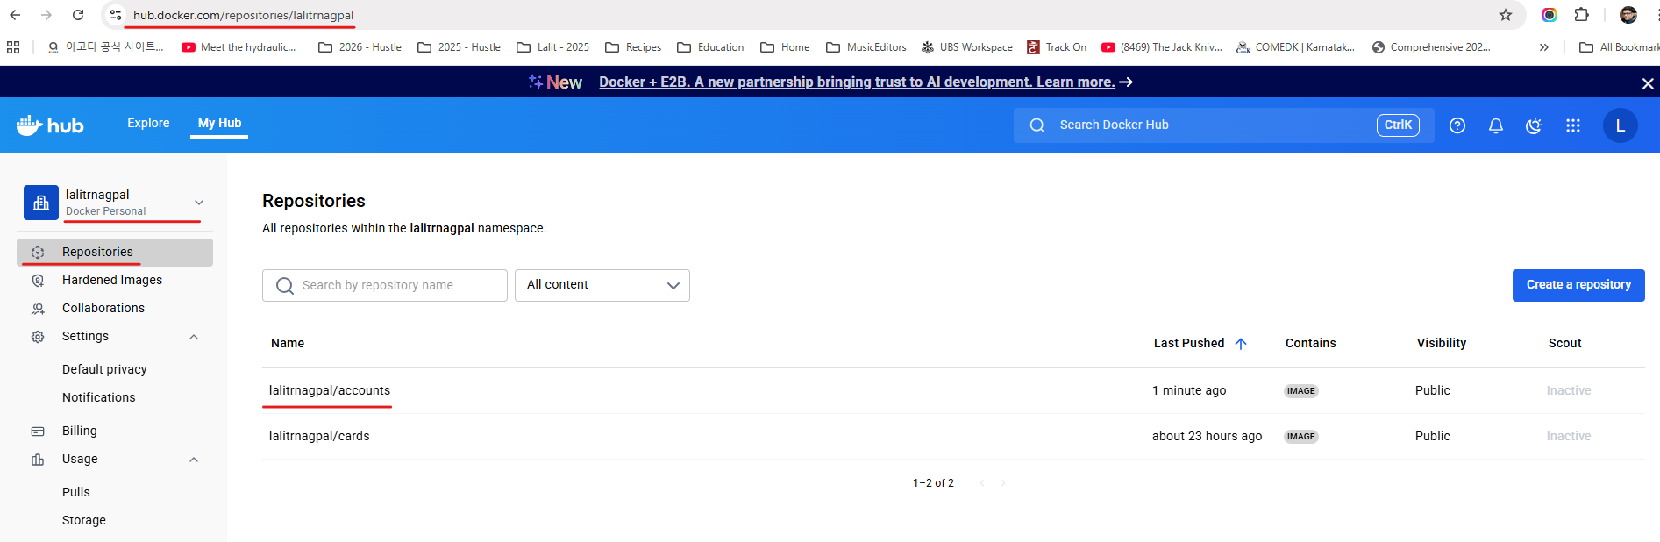

If you have not logged in into your Docker desktop or if there are no login details configured inside the local system, then obviously you will get an error saying that login failed or access denied. And here also make sure that you are mentioning your own Docker username. Don't mention myeazybytes username inside your docker push command because you will not have my credentials. That's why this is very very important to use your own username. And the same username also should be used inside your pom.xml or while generating a docker image. So your image name should have your username followed by your application name. And this is the tag name. Now I'm going to push my loans microservice image as well. The command is going to be the same instead of accounts, we are going to mention loans and I'm pushing the loans microservice right now. So you can see here this is being pushed from my local system into the remote repository.

After I logout from both the browser and docker desktop, I get the below behavior

PS D:\...\section4> docker image push docker.io/lalitrnagpal/loans:s4

The push refers to repository [docker.io/lalitrnagpal/loans]

0cebb6f35598: Waiting

bea0a3dc2651: Waiting

ac1aec1fa948: Waiting

a907216185f3: Waiting

40168ffbc66f: Waiting

78f775610b35: Waiting

5f70bf18a086: Waiting

979b659da65a: Waiting

1dc94a70dbaa: Waiting

18d9bfb23721: Waiting

366ce7d1a7f9: Waiting

460771a03062: Waiting

89732bc75041: Waiting

5f5c595091e4: Waiting

4585c2473079: Waiting

4d13fcd94d75: Waiting

3b28a7ec9e02: Waiting

6c77e73b74bc: Waiting

f0e9078fd509: Waiting

417e5bfc3c82: Waiting

push access denied, repository does not exist or may require authorization: server message: insufficient_scope: authorization failed

PS D:\002-Workspace\microservices\section4> docker login

USING WEB-BASED LOGIN

i Info → To sign in with credentials on the command line, use 'docker login -u <username>'

Your one-time device confirmation code is: JJLW-VPGN

Press ENTER to open your browser or submit your device code here: https://login.docker.com/activate

Waiting for authentication in the browser…

login canceled

PS D:\002-Workspace\microservices\section4> docker login -u lalitrnagpal

i Info → A Personal Access Token (PAT) can be used instead.

To create a PAT, visit https://app.docker.com/settings

Password:

Login Succeeded

After few seconds, my loans Docker image is also successfully pushed into the remote repository. As a next step, I can try to push my cards microservice. The command is going to be the same instead of loans, I'm going to mention the name cards. So you can see the command is Docker image push docker.io/eazybytes/cards and what is the tag name which is S4 here. So let me execute this command.

PS D:\...\section4> docker image push docker.io/lalitrnagpal/loans:s4

The push refers to repository [docker.io/lalitrnagpal/loans]

3b28a7ec9e02: Pushed

5f5c595091e4: Pushed

366ce7d1a7f9: Pushed

18d9bfb23721: Pushed

5f70bf18a086: Pushed

979b659da65a: Mounted from paketobuildpacks/run-jammy-tiny

4585c2473079: Pushed

bea0a3dc2651: Pushed

4d13fcd94d75: Pushed

78f775610b35: Pushed

a907216185f3: Pushed

f0e9078fd509: Pushed

0cebb6f35598: Mounted from paketobuildpacks/run-jammy-tiny

6c77e73b74bc: Pushed

417e5bfc3c82: Pushed

89732bc75041: Mounted from paketobuildpacks/builder-jammy-java-tiny

460771a03062: Pushed

1dc94a70dbaa: Pushed

ac1aec1fa948: Mounted from paketobuildpacks/run-jammy-tiny

40168ffbc66f: Pushed

s4: digest: sha256:048cf5d6b293388ae104ddb302ea6b0b7784471174a38056939e15c5f87661b0 size: 3432

This will also push my cards Docker image into my remote repository. So this is going to take few seconds, so let's wait for this to get completed. Now my Cards Docker image is also pushed into the remote repository. To validate if these images are really pushed into the remote repository or not. First, we can go to the Docker desktop. Here under these images you can see these are all the images available inside our local system. Very similarly, if you can click on this hub, this will show you all the images available inside your remote repository with the Docker account name eazybytes. So you can see there are three different Docker images with three different names along with the tag names. And when they are pushed, what is the size of them? All these details are available here.

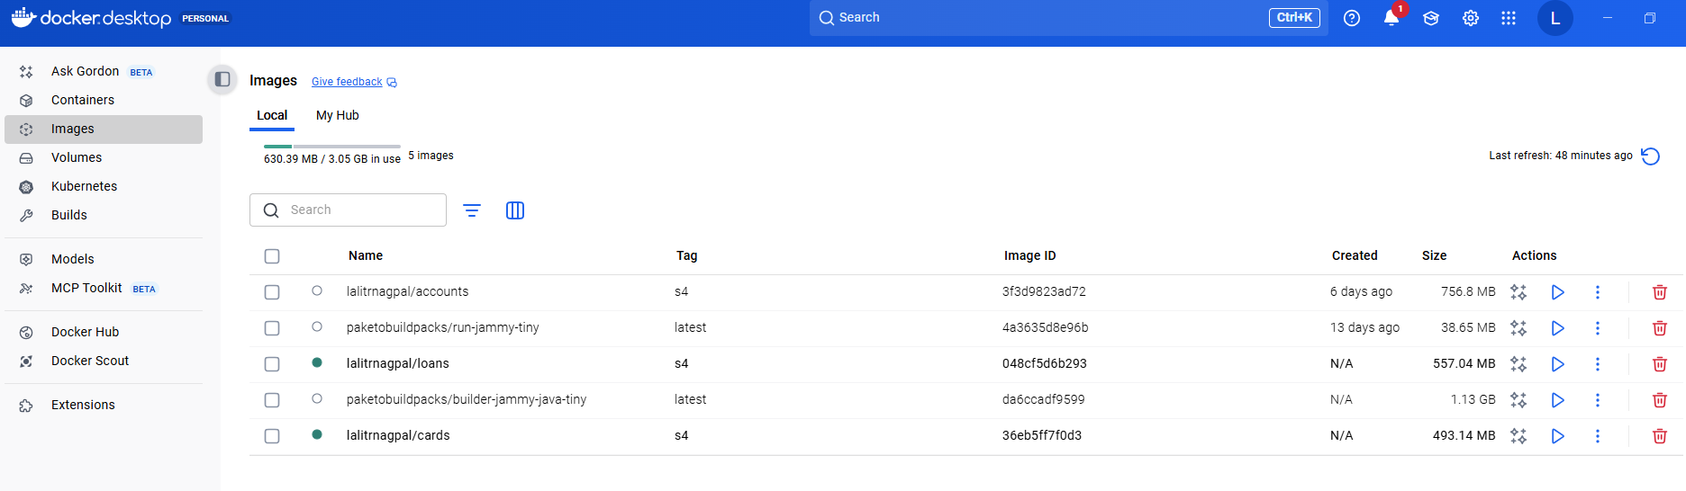

You can also validate these details by going into the Docker Hub website. So here I logged in into the Docker Hub website. And this is my username, which is eazybytes. You can see there are three different images pushed like this accounts is pushed nine minutes back and similarly loans pushed five minutes back and cards pushed two minutes back.

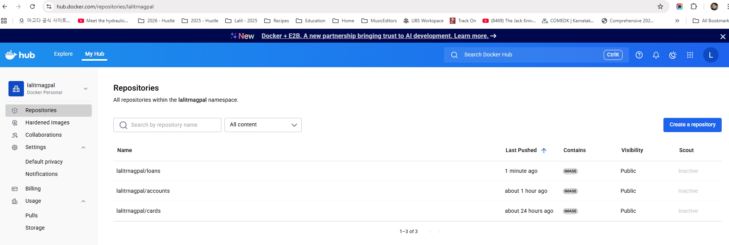

If you can click any of these image, you will have all the details. Like this image has a tag with the name S4. You can also see this image can be viewed by anyone. Since this public view is available. This means I can push into my Docker hub repository and anyone can pull my Docker images into their local system and they can start using them without any credentials. That's the meaning of this public view here. This is very similar to GitHub private repository and public repository, so this works very similarly. If you want to change this Docker image from public view to private view, then you need to go to the settings. Here under the visibility settings, you can make this as private, but like I said, with a basic personal plan, we can only have one image as a private repository. But I'm not going to make this as a private because I want my Docker images to be visible for everyone. So this is the default behavior of my Docker images that I have pushed.

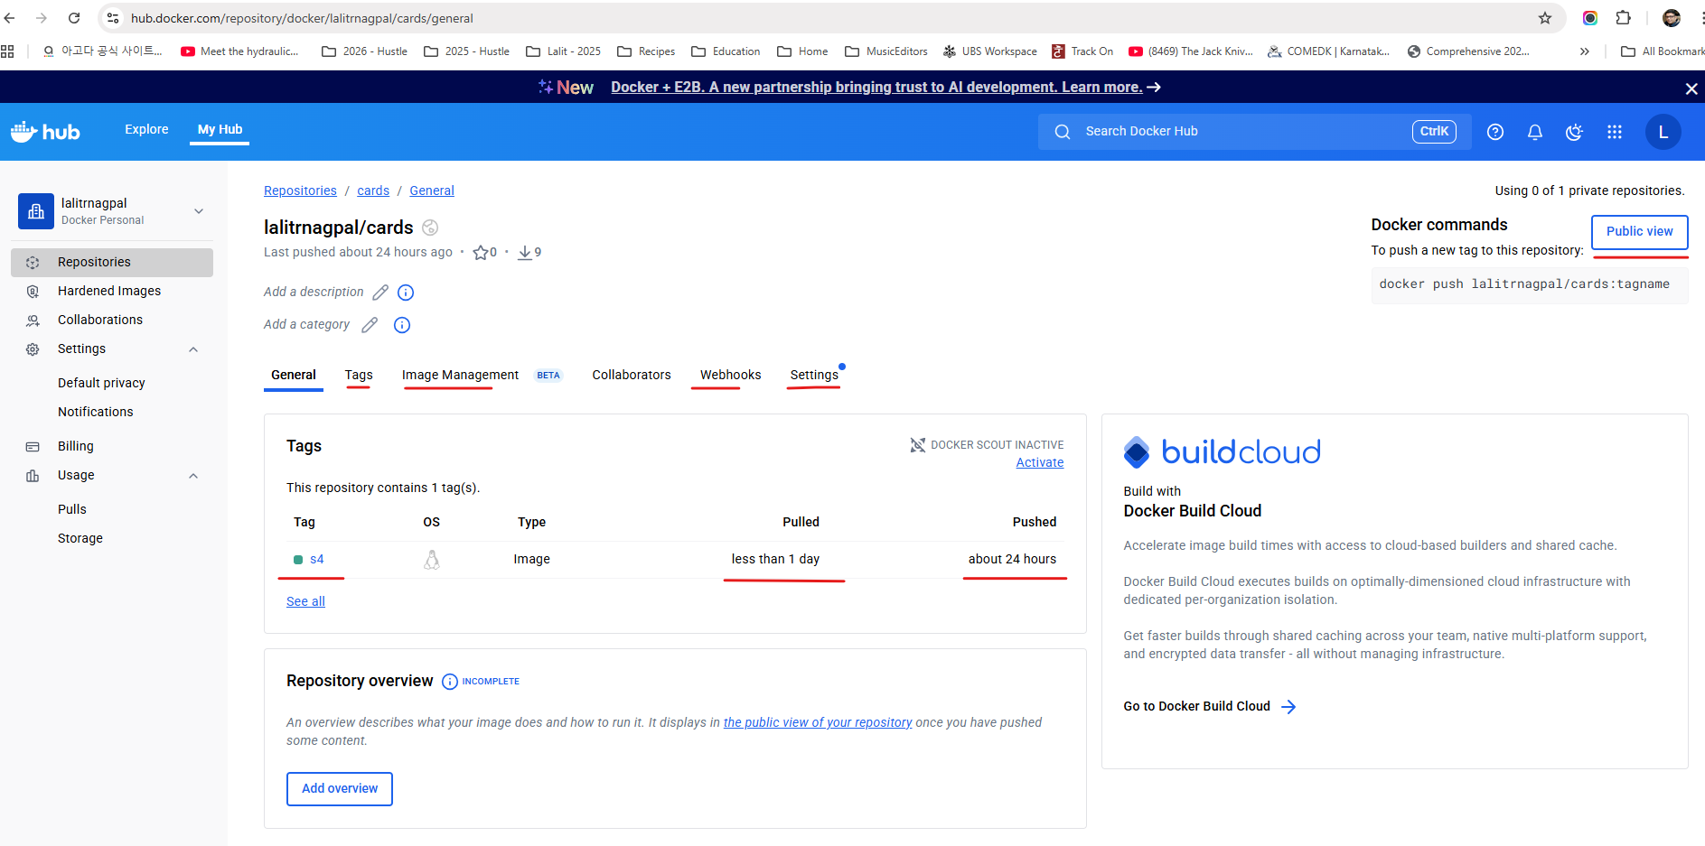

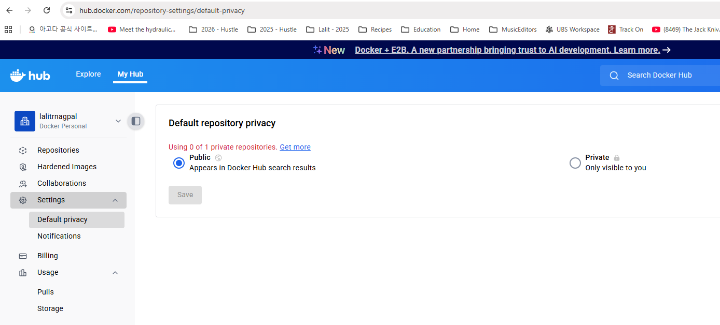

And if you want to understand more details about the tags available inside my Docker image, you can see as of now I have only one tag, which is S4. If anyone want to use this Docker image with this tag, they can simply execute this command docker pull eazybytes/cards:S4.

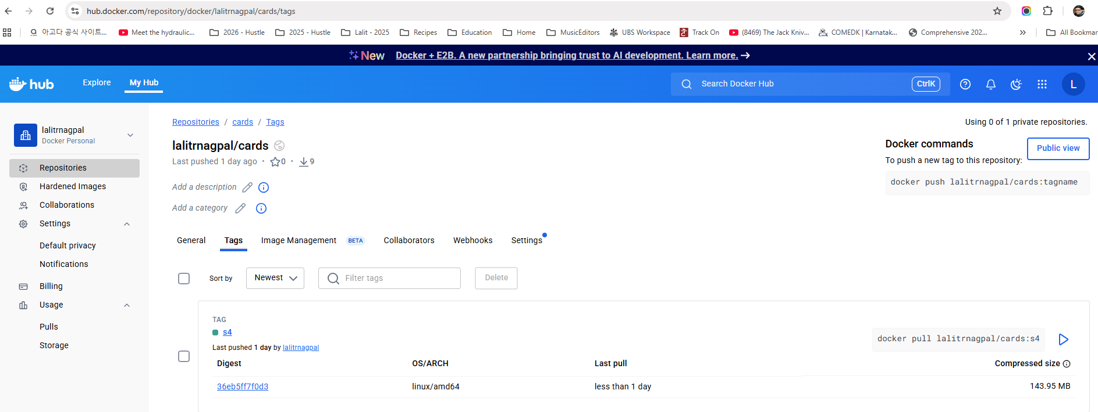

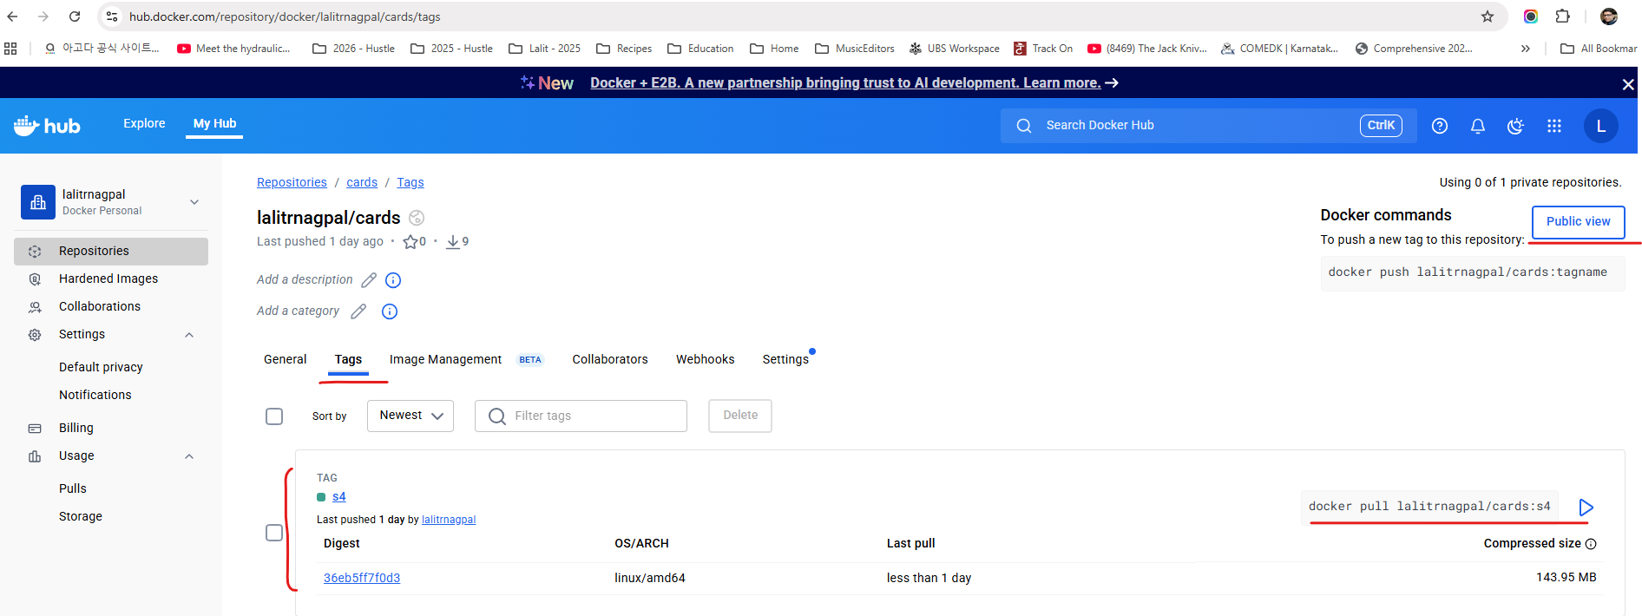

We can also try to validate the same. So let me copy this. I'll go to my Docker desktop. First I'll try to delete the cards Docker image from my mission. So I'm just selecting this cards. I'm clicking on this delete button. So let me click on this Delete forever. I'm not able to delete it because there is a container with this docker image created.

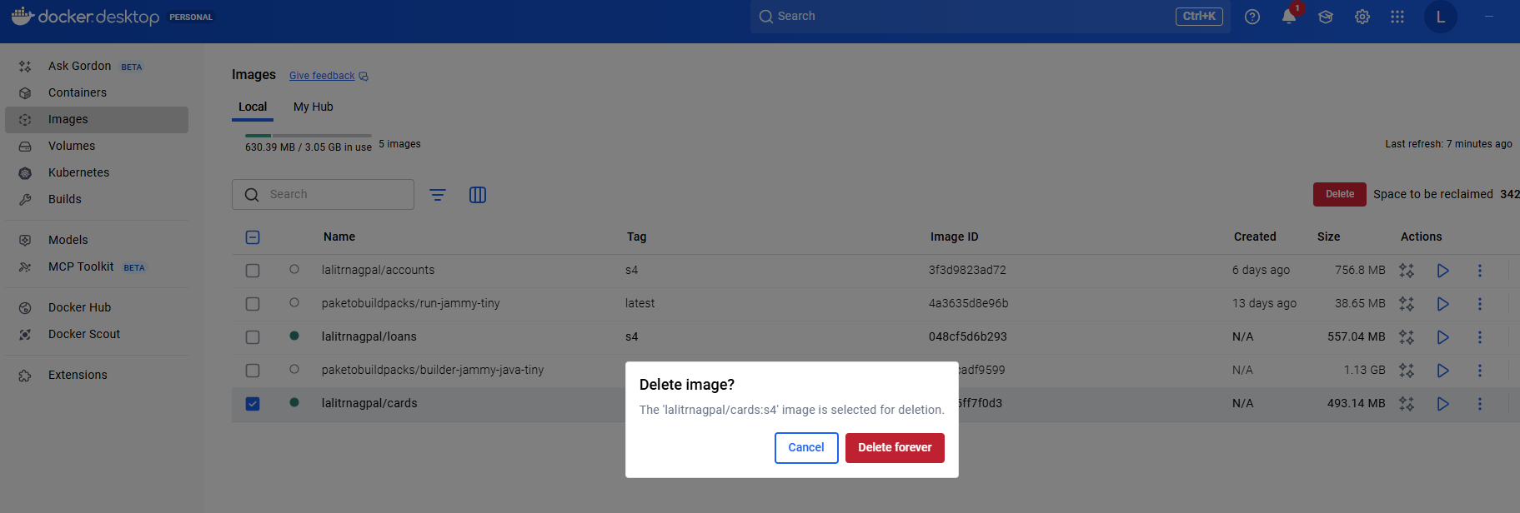

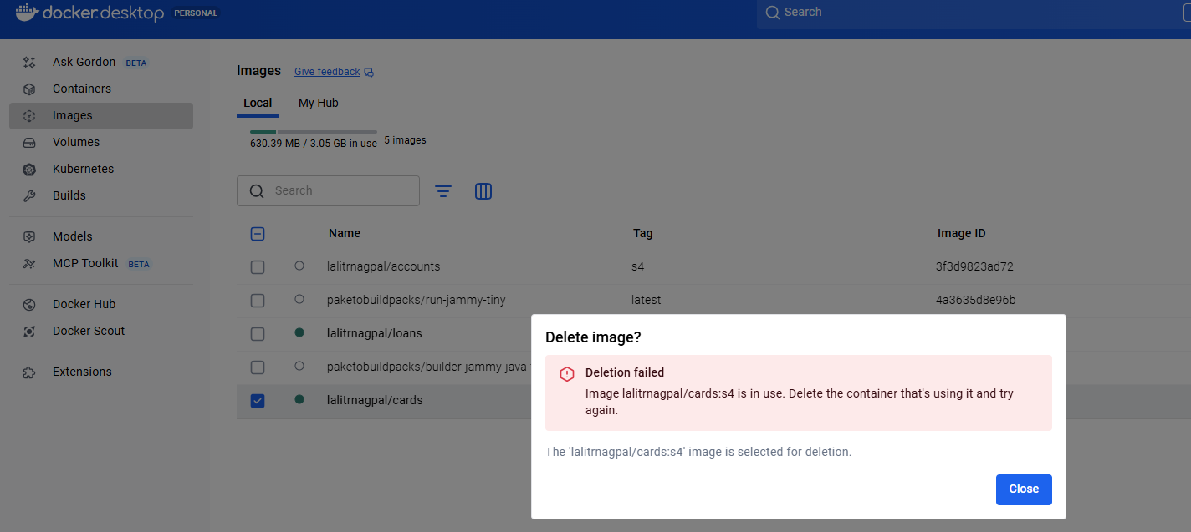

So first we need to delete the cards related container. So let me delete that post that I'll go to images and delete these cards Image.

Containers show the image they are using, but you can see further details using the inspect option

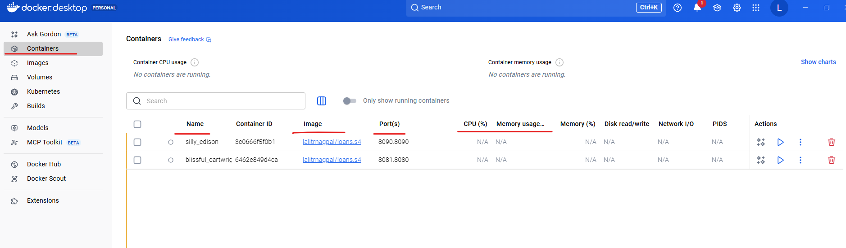

To see which container is using which image, click on the container and see under inspect

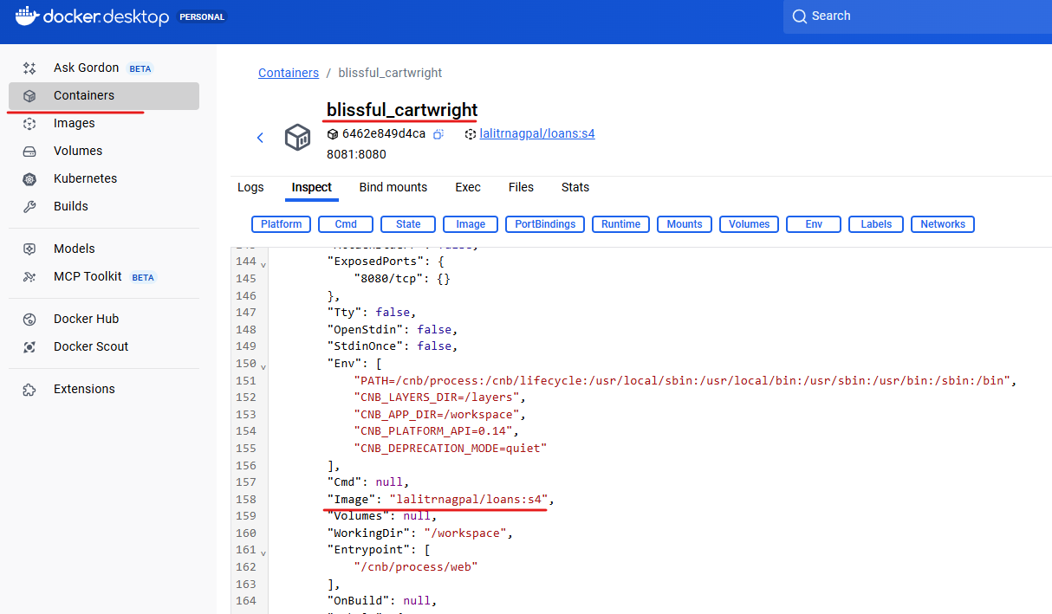

Below is the one for Cards

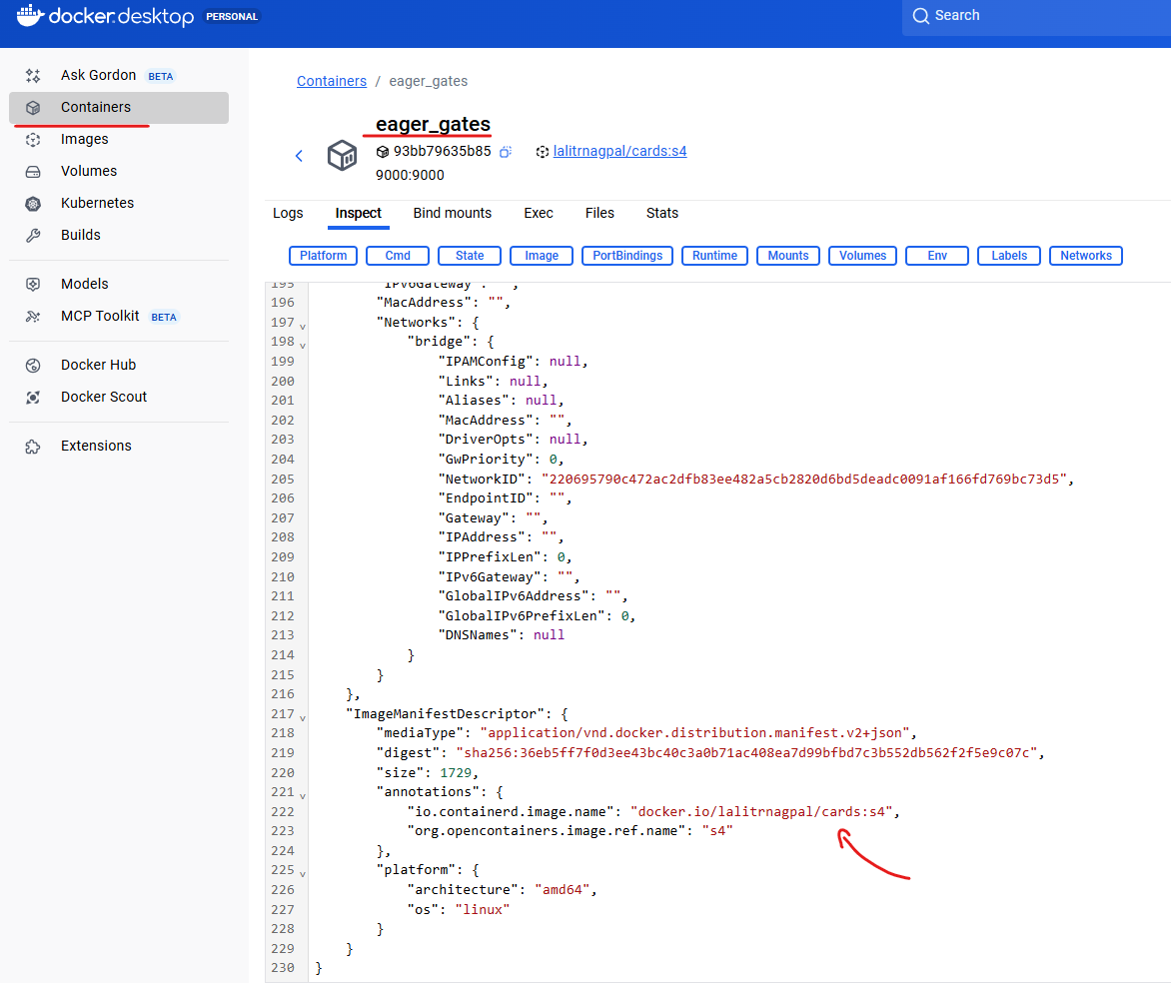

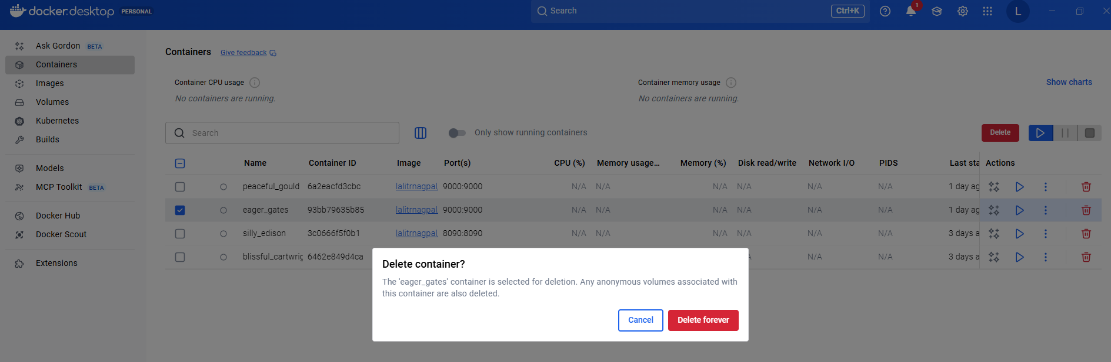

So now there is no Docker image of cards inside my local system, so I can also confirm the same by running Docker images.

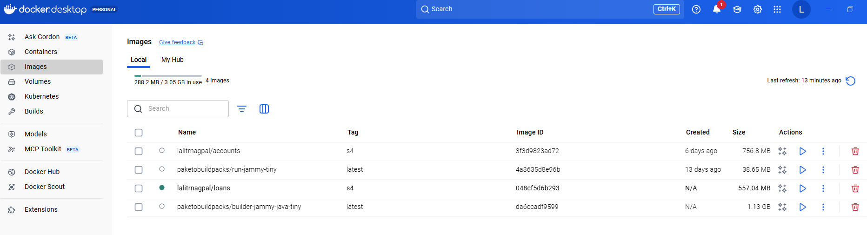

So you can see there is no cards related Docker image inside my system. So we can run the command which is Docker pull easybytes/cards:S4.

So this will download that image from the remote repository into my local system. I hope it is making sense to you. Docker Pull will do the exact opposite action of Docker push Docker push will take your Docker images from local system to the remote repository. Whereas if you want to fetch the images from remote repository into your local system, you need to use this docker pull command.

PS D:\002-Workspace\microservices\section4> docker pull lalitrnagpal/cards:s4

s4: Pulling from lalitrnagpal/cards

4b3ffd8ccb52: Pull complete

073011d3ceea: Pull complete

fd4969aa9957: Pull complete

075338da2d04: Pull complete

b315b75540ca: Pull complete

9712caec413d: Pull complete

c36a596532b6: Pull complete

f35cff1a101a: Pull complete

6d2c50dbf000: Pull complete

Digest: sha256:36eb5ff7f0d3ee43bc40c3a0b71ac408ea7d99bfbd7c3b552db562f2f5e9c07c

Status: Downloaded newer image for lalitrnagpal/cards:s4

docker.io/lalitrnagpal/cards:s4

PS D:\002-Workspace\microservices\section4>

So you can see it is being downloaded. Now the download is completed. If I try to run the Docker images again this time you should be able to see the cards inside my local system.

PS D:\002-Workspace\microservices\section4> docker images

REPOSITORY TAG IMAGE ID CREATED SIZE

lalitrnagpal/accounts s4 3f3d9823ad72 5 days ago 757MB

paketobuildpacks/run-jammy-tiny latest 4a3635d8e96b 13 days ago 38.7MB

lalitrnagpal/loans s4 048cf5d6b293 45 years ago 557MB

paketobuildpacks/builder-jammy-java-tiny latest da6ccadf9599 45 years ago 1.13GB

lalitrnagpal/cards s4 36eb5ff7f0d3 55 years ago 493MB

This way we can push our store any number of Docker images inside the remote repository provided by the Docker hub. From this Docker hub.

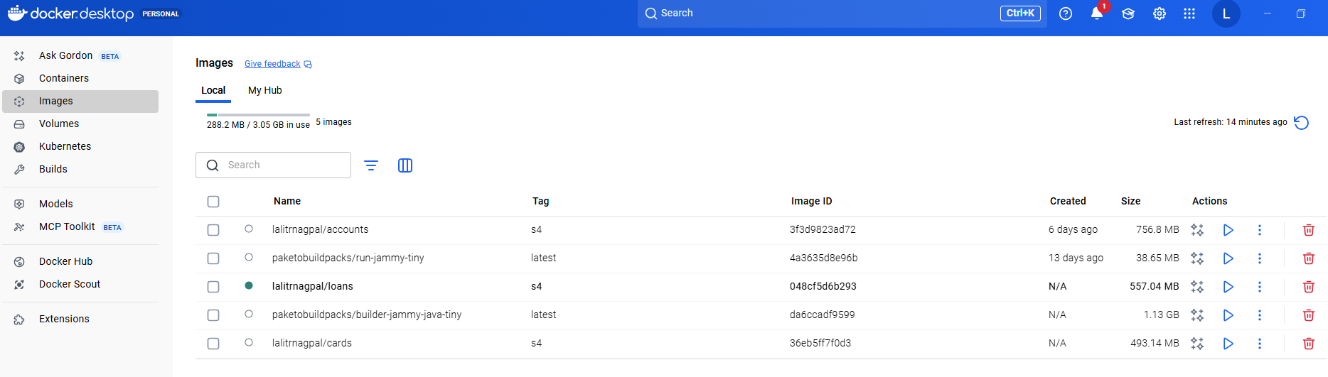

My teammates, they can pull the Docker images, they can use them, or we can have some CI/CD pipelines or tools to fetch the Docker images from my Docker hub and using the same Docker images, they are going to deploy my accounts microservice loans and cards, microservice in any of the cloud server or inside the virtual machines. I hope you are clear on how to push the images and pull the images.

### Docker Compose

We will see a problem that we face with the current setup that we have, and post that I'll also show you a solution for the problem. As of now, you can see we have three different images like cards, loans and accounts. These are the Docker images of three microservices that we have built so far to run our microservices we need to convert these Docker images into containers with the help of docker run command. So if I want to start my three microservice, I need to issue docker run command three different times along with the image name and the port mapping. What if I want to start multiple instances of my microservices in such scenarios, giving this docker run command manually for each microservice and for each instance of it is super, super cumbersome process and it is time consuming process. If I have 100 microservice, I need to issue these Docker run command 100 different times, which is not quite viable option for any human.

To overcome this challenge, we have another component inside Docker ecosystem with the name Docker Compose. Let me try to introduce this Docker Compose. So this is a location where you can read more details about the Docker compose.

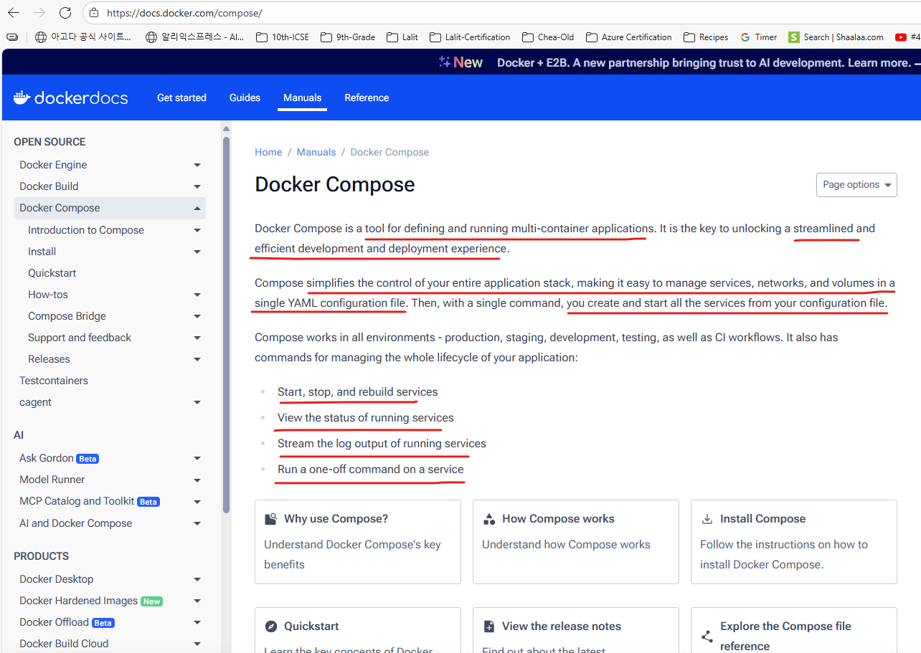

You can see Docker Compose is a tool for defining and running multiple container docker applications. So with the help of with Compose, we can use a Yaml file to configure all our application service. Then with a single command we can create or start all our services. So instead of running multiple Docker run commands, I can define all my Docker image details and how I want to start them inside a single Yaml file. Once I define all these details inside a single Yaml file, I can issue a single command and with a single command all of my microservice containers are going to start and this docker compose. We can make it work inside any environment like production, staging, development testing as well as continuous integration workflows. So that's why it is highly recommended to use Docker Compose. If you have multiple microservices inside your system and these Docker compose will help you to start, stop and rebuild services. View the status of running services. Stream the log output. Run a one off command. This way it has many other advantages. So whenever you install Docker desktop inside your system by default, Docker compose related components also will be installed. We can also validate the same by running a command which is Docker space compose version. This will print the what is the Docker compose version right now you have inside your system. So this is the version of Docker Compose right now that I have inside my system.

PS D:\002-Workspace\microservices\section4> docker compose version

Docker Compose version v2.40.2-desktop.1

PS D:\002-Workspace\microservices\section4>

And this also confirms that Docker Compose is installed inside my machine. For some reason, if you don't have this docker compose installed inside your system, don't worry, you can simply come to this page and here there is an link which will help you to install Docker compose inside your system. So please follow the steps based upon your operating system and you should be able to install the Docker compose successfully.

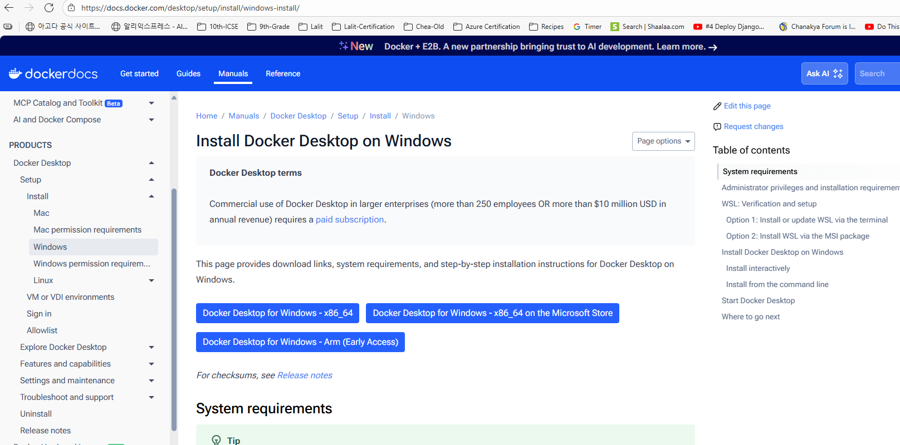

Now to get started with the Docker compose. Like I said, we need to write a configuration file and inside this configuration file we need to define all the details about our Docker images and how we want to start them. For the same, first, I need to create a configuration file and I'm going to create that under this accounts microservice. There is no specific reason on why I'm creating a configuration file under accounts. Since this is applicable for all microservices, you can create this configuration file any place. But since I want to check in this file into the GitHub repository I'm trying to create inside this accounts microservice maven project. So here I'm going to create a new file and the file name has to be docker-compose and the format are the extension of this Docker compose file should be yml. Because we are going to provide all our configuration details to the Docker server using Yaml format. So let me create this file. Post this you can see this is an Yaml file. It is automatically detected now here, since we want to define about all our service details, the very first syntax that we need to mention here is, services followed by colon – services:, and at these services we can define any number of service details. That's why we need to press enter and make sure there is a Tab space. If you don't have tab space then Yaml configuration is not going to work. You can see there is a tab space that I have created. After you have given tab space you can give, what is your service name? The service name that I want to give for accounts microservice is, accounts itself and under these accounts service I can provide the details like what is the image name that this service is going to use, For the same let me press enter as soon as I press enter since I'm using .yaml extension and there is a yaml plugin installed inside my intelliJ IDE.

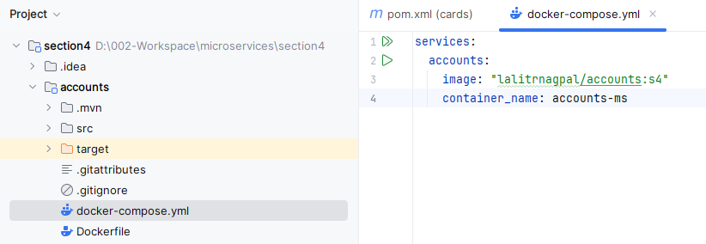

It is automatically giving a tab space. Right you can see I'm not exactly under the accounts so there is a tab space came into picture. Here since we want to provide the image details, I need to select the image and post that give colon followed by space. After that you can mention what is that accounts microservice image name. So the image name is eazybytes/accounts. And tag name is S4. If needed, you can also give this image name inside the double quotes so that will make your image name crystal clear to your docker compose file, post that we can give a container name. So with the help of this container_name, we can give a container name for our accounts microservice whenever it is trying to generate a new container from the Docker image that we have provided. So the container name that I'm going to give here is accounts-ms. MS indicates microservice. If you don't give this container, what will happen is whenever you are trying to create a container from your Docker image, a random name will be given to your container by the Docker server. You can also see under the containers right now there is a container of loans previously which we have created, so it has a random name which is angry Cannon.

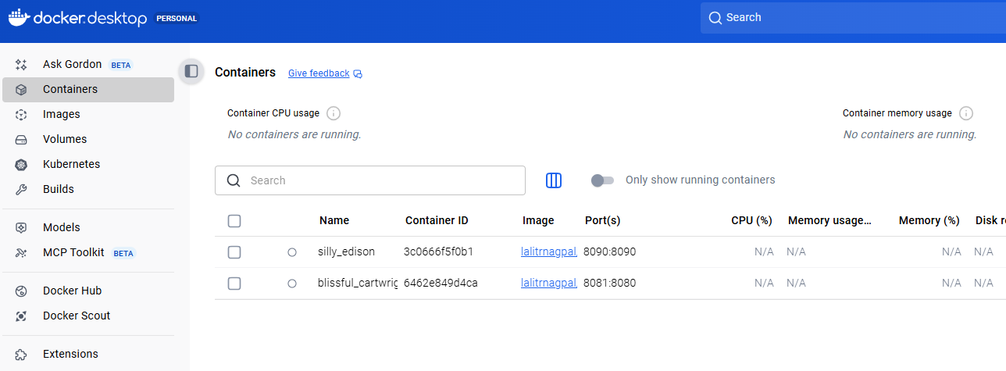

So with this I cannot really identify to which microservice this container belongs. So to identify that, I need to check the image details to avoid such inconvenience, we can define a name to our container. So this container is in running status. Let me stop this. So please make sure you have deleted all the containers inside your system so that you will get some space and memory inside your Docker desktop. Once we mention these container name, press enter and configure the ports mapping with the help of ports. So under the ports we can define multiple ports mapping. That's why inside the Yaml, whenever you are trying to provide multiple elements, we should follow this hyphen. So this hyphen indicates this is a single element inside an array like, you know, our accounts microservice is going to start at the port 8080 and at the same port I'm trying to expose to the external network. And if needed, if you want more number of port mapping, you can define multiple port mapping by pressing enter and following the syntax with the help of Hyphen.

**docker-compose.yml**

services:

accounts:

image: "lalitrnagpal/accounts:s4"

container_name: accounts-ms

ports:

- "8080:8080"

- "9090:9091"

But right now I don't have any requirements to create multiple port mappings, so that's why I'm deleting this and going to the same position where my ports is present. Now whenever my container is being created, I want to make sure that it has a maximum memory allocation. Beyond that, I don't want to assign that because inside my local system I have only 16 GB Ram. Since we are going to create multiple containers inside our course, we should make sure we are restricting our containers to a maximum memory. For the same, I need to mention a keyword which is deploy and this deploy you need to invoke resources. Post that under these resources, please invoke limits after the limits you can mention memory and under the memory mention 700 M with this I'm telling to this accounts microservice at a max I want to provide 700 M memory. Beyond that my Docker server is not going to assign.

services:

accounts:

image: "lalitrnagpal/accounts:s4"

container_name: accounts-ms

ports:

- "8080:8080"

deploy:

resources:

limits:

memory: 700m

So if you see there is a hierarchy that we have followed inside Yaml services is the parent and under the services there is a child with the name accounts under accounts we have details like image, container name, ports mapping and what are the deployment instructions. So under the deploy we have resources and a resources we have limits under the limits, we have memory. Now we can copy the same configuration and copy it at the same location where the accounts microservice details are mentioned. So please make sure this newly copied values are also present inside the same line where my accounts is present. Like you can see it is present in the same line portion. Now I can change this accounts to the loans because we want to mention the loans related configurations. Also, the image name is going to be changed to loans and the container name is going to be changed to the loans-ms. And the port mapping is going to be 8090 and the both sides and the deployment instructions are going to be the same. After loans, I'm going to copy the same again. And this time I'm going to rename all these loans details to cards. So let me do the same for image name as well. And the container name I'm going to change to cards-ms. And the port mapping is 9000:9000 the same I'm trying to mention here. And there is no change inside the deployment resource limits memory restrictions. Now if I try to start my services with this Docker compose file, all these services are going to start with a single command.

**docker-compose.yml**

services:

accounts:

image: "lalitrnagpal/accounts:s4"

container_name: accounts-ms

ports:

- "8080:8080"

deploy:

resources:

limits:

memory: 700m

loans:

image: "lalitrnagpal/loans:s4"

container_name: loans-ms

ports:

- "8090:8090"

deploy:

resources:

limits:

memory: 700m

cards:

image: "lalitrnagpal/cards:s4"

container_name: cards-ms

ports:

- "9000:9000"

deploy:

resources:

limits:

memory: 700m

As of now, there is no dependency between these microservices. They are all going to start in different, different isolated networks. What if I have a dependency between these microservices or what if in future, if I have a scenario where these microservices need to talk with each other? In that scenario, it is not going to work by default because all these services are going to get created inside their own network. So to make sure that the Intercommunication is working, we need to tag all these microservices under a same network by the same. What you have to do is just after these deploy instructions, mention networks, after these networks, we can define any number of networks. The network name that I want to mention here is EazyBank and this can be any name. So the same network information I'm going to mention for loans as well just after the deploy, I'll just make sure it is present exactly in the same portion of deploy. So let me do the same for cards as well. Now I have tagged a network to all my microservices with the name easybank to create a network with the name easybank. You can come to the place where the services is mentioned so you can see there is no space. I'm at the very first position of my line. Here I need to invoke a root element inside my docker compose and the root element is networks, just like how we have services at the root level. Similarly, we can also define networks. The network name that I want to create is the same name that we have configured inside our services. So this is the network that I want to create. So I'm just mentioning the easybank under my networks post that I'm just mentioning : followed by Driver under the driver, I'm going to mention bridge.

services:

accounts:

image: "lalitrnagpal/accounts:s4"

container_name: accounts-ms

ports:

- "8081:8081"

deploy:

resources:

limits:

memory: 700m

networks:

- lalitrnapgal-nw

loans:

image: "lalitrnagpal/loans:s4"

container_name: loans-ms

ports:

- "8090:8090"

deploy:

resources:

limits:

memory: 700m

networks:

- lalitrnapgal-nw

cards:

image: "lalitrnagpal/cards:s4"

container_name: cards-ms

ports:

- "9000:9000"

deploy:

resources:

limits:

memory: 700m

networks:

- lalitrnapgal-nw

networks:

lalitrnagpal:

driver: "bridge"

So with this I'm telling to my Docker server, please create a network with the name easybank with the driver bridge. Since I'm using the same network inside my accounts, microservice, loans microservice and the cards microservice. My Docker server is going to establish a bridge using which all my micro services they can communicate with each other. So this way we have defined all our instructions inside this docker compose Yaml file. Right now our docker compose file is ready. Inside the next lecture I'll show you how to start all our microservices with a single command. With the help of this Docker compose file.

#### Running using docker-compose

Let's see how to start all our microservices with the docker compose command. As of now, you can see I am into my cards microservice. So this is my present working directory. And inside this folder there is no docker-compose.yml file. If I try to give a command which is docker compose up, which is up with this docker compose up, we should be able to start all our microservices that we have defined inside our docker-compose.ymlfile. But the problem right now we may face is inside folder. We don't have this yml file. Let's see what error it is going to throw. So if I try to execute here you can see no configuration file provided, not found. That's why please make sure you are running this docker compose up command from the location where you are docker-compose.yml file is present.

PS D:\002-Workspace\microservices\section4> docker compose up

no configuration file provided: not found

So let me go back to the accounts folder and inside this folder we know that docker-compose.yml file is available. I can also confirm the same by running the command list. You can see there is an docker-compose.yml file. Now I'm going to run the docker compose up command.

PS D:\002-Workspace\microservices\section4\accounts> docker compose up

[+] Running 4/4

✔ Network accounts_lalitrnagpal_nw Created 0.1s

✔ Container loans-ms Created 0.2s

✔ Container accounts-ms Created 0.2s

✔ Container cards-ms Created 0.2s

Attaching to accounts-ms, cards-ms, loans-ms

loans-ms | Calculated JVM Memory Configuration: -XX:MaxDirectMemorySize=10M -Xmx82321K -XX:MaxMetaspaceSize=122478K -XX:ReservedCodeCacheSize=240M -Xss1M (Total Memory: 700M, Thread Count: 250, Loaded Class Count: 19210, Headroom: 0%)

loans-ms | Enabling Java Native Memory Tracking

loans-ms | Adding 146 container CA certificates to JVM truststore

loans-ms | Spring Cloud Bindings Enabled

loans-ms | Picked up JAVA_TOOL_OPTIONS: -Djava.security.properties=/layers/paketo-buildpacks_bellsoft-liberica/java-security-properties/java-security.properties -XX:+ExitOnOutOfMemoryError -XX:MaxDirectMemorySize=10M -Xmx82321K -XX:MaxMetaspaceSize=122478K -XX:ReservedCodeCacheSize=240M -Xss1M -XX:+UnlockDiagnosticVMOptions -XX:NativeMemoryTracking=summary -XX:+PrintNMTStatistics -Dorg.springframework.cloud.bindings.boot.enable=true

cards-ms |

cards-ms | . ____ _ __ _ _

cards-ms | /\\ / ___'_ __ _ _(_)_ __ __ _ \ \ \ \

cards-ms | ( ( )\___ | '_ | '_| | '_ \/ _` | \ \ \ \

cards-ms | \\/ ___)| |_)| | | | | || (_| | ) ) ) )

cards-ms | ' |____| .__|_| |_|_| |_\__, | / / / /

cards-ms | =========|_|==============|___/=/_/_/_/

cards-ms |

cards-ms | :: Spring Boot :: (v3.4.1)

cards-ms |

cards-ms | 2025-10-30T06:09:18.404Z INFO 1 --- [ main] com.eazybytes.cards.CardsApplication : Starting CardsApplication using Java 17.0.16 with PID 1 (/app/classes started by root in /)

cards-ms | 2025-10-30T06:09:18.409Z INFO 1 --- [ main] com.eazybytes.cards.CardsApplication : No active profile set, falling back to 1 default profile: "default"

loans-ms |

loans-ms | . ____ _ __ _ _

loans-ms | /\\ / ___'_ __ _ _(_)_ __ __ _ \ \ \ \

loans-ms | ( ( )\___ | '_ | '_| | '_ \/ _` | \ \ \ \

loans-ms | \\/ ___)| |_)| | | | | || (_| | ) ) ) )

loans-ms | ' |____| .__|_| |_|_| |_\__, | / / / /

loans-ms | =========|_|==============|___/=/_/_/_/

loans-ms |

loans-ms | :: Spring Boot :: (v3.4.1)

loans-ms |

loans-ms | 2025-10-30T06:09:19.211Z INFO 1 --- [loans] [ main] com.eazybytes.loans.LoansApplication : Starting LoansApplication v0.0.1-SNAPSHOT using Java 17.0.17 with PID 1 (/workspace/BOOT-INF/classes started by cnb in /workspace)

loans-ms | 2025-10-30T06:09:19.217Z DEBUG 1 --- [loans] [ main] com.eazybytes.loans.LoansApplication : Running with Spring Boot v3.4.1, Spring v6.2.1

loans-ms | 2025-10-30T06:09:19.219Z INFO 1 --- [loans] [ main] com.eazybytes.loans.LoansApplication : The following 1 profile is active: "prod"

cards-ms | 2025-10-30T06:09:20.737Z INFO 1 --- [ main] .s.d.r.c.RepositoryConfigurationDelegate : Bootstrapping Spring Data JPA repositories in DEFAULT mode.

cards-ms | 2025-10-30T06:09:20.860Z INFO 1 --- [ main] .s.d.r.c.RepositoryConfigurationDelegate : Finished Spring Data repository scanning in 101 ms. Found 1 JPA repository interface.

loans-ms | 2025-10-30T06:09:21.713Z INFO 1 --- [loans] [ main] .s.d.r.c.RepositoryConfigurationDelegate : Bootstrapping Spring Data JPA repositories in DEFAULT mode.

loans-ms | 2025-10-30T06:09:21.841Z INFO 1 --- [loans] [ main] .s.d.r.c.RepositoryConfigurationDelegate : Finished Spring Data repository scanning in 104 ms. Found 1 JPA repository interface.

cards-ms | 2025-10-30T06:09:22.249Z INFO 1 --- [ main] o.s.b.w.embedded.tomcat.TomcatWebServer : Tomcat initialized with port 9000 (http)

cards-ms | 2025-10-30T06:09:22.274Z INFO 1 --- [ main] o.apache.catalina.core.StandardService : Starting service [Tomcat]

cards-ms | 2025-10-30T06:09:22.275Z INFO 1 --- [ main] o.apache.catalina.core.StandardEngine : Starting Servlet engine: [Apache Tomcat/10.1.34]

cards-ms | 2025-10-30T06:09:22.464Z INFO 1 --- [ main] o.a.c.c.C.[Tomcat].[localhost].[/] : Initializing Spring embedded WebApplicationContext

cards-ms | 2025-10-30T06:09:22.468Z INFO 1 --- [ main] w.s.c.ServletWebServerApplicationContext : Root WebApplicationContext: initialization completed in 3904 ms

cards-ms | 2025-10-30T06:09:22.979Z INFO 1 --- [ main] com.zaxxer.hikari.HikariDataSource : HikariPool-1 - Starting...

cards-ms | 2025-10-30T06:09:23.345Z INFO 1 --- [ main] com.zaxxer.hikari.pool.HikariPool : HikariPool-1 - Added connection conn0: url=jdbc:h2:mem:testdb user=SA

cards-ms | 2025-10-30T06:09:23.349Z INFO 1 --- [ main] com.zaxxer.hikari.HikariDataSource : HikariPool-1 - Start completed.

loans-ms | 2025-10-30T06:09:23.540Z INFO 1 --- [loans] [ main] o.s.b.w.embedded.tomcat.TomcatWebServer : Tomcat initialized with port 8090 (http)

cards-ms | 2025-10-30T06:09:23.563Z INFO 1 --- [ main] o.hibernate.jpa.internal.util.LogHelper : HHH000204: Processing PersistenceUnitInfo [name: default]

loans-ms | 2025-10-30T06:09:23.574Z INFO 1 --- [loans] [ main] o.apache.catalina.core.StandardService : Starting service [Tomcat]

loans-ms | 2025-10-30T06:09:23.575Z INFO 1 --- [loans] [ main] o.apache.catalina.core.StandardEngine : Starting Servlet engine: [Apache Tomcat/10.1.34]

loans-ms | 2025-10-30T06:09:23.687Z INFO 1 --- [loans] [ main] o.a.c.c.C.[Tomcat].[localhost].[/] : Initializing Spring embedded WebApplicationContext

loans-ms | 2025-10-30T06:09:23.690Z INFO 1 --- [loans] [ main] w.s.c.ServletWebServerApplicationContext : Root WebApplicationContext: initialization completed in 4308 ms

cards-ms | 2025-10-30T06:09:23.720Z INFO 1 --- [ main] org.hibernate.Version : HHH000412: Hibernate ORM core version 6.6.4.Final

cards-ms | 2025-10-30T06:09:23.819Z INFO 1 --- [ main] o.h.c.internal.RegionFactoryInitiator : HHH000026: Second-level cache disabled

loans-ms | 2025-10-30T06:09:24.245Z INFO 1 --- [loans] [ main] com.zaxxer.hikari.HikariDataSource : HikariPool-1 - Starting...

cards-ms | 2025-10-30T06:09:24.381Z INFO 1 --- [ main] o.s.o.j.p.SpringPersistenceUnitInfo : No LoadTimeWeaver setup: ignoring JPA class transformer

cards-ms | 2025-10-30T06:09:24.482Z WARN 1 --- [ main] org.hibernate.orm.deprecation : HHH90000025: H2Dialect does not need to be specified explicitly using 'hibernate.dialect' (remove the property setting and it will be selected by default)

cards-ms | 2025-10-30T06:09:24.518Z INFO 1 --- [ main] org.hibernate.orm.connections.pooling : HHH10001005: Database info:

cards-ms | Database JDBC URL [Connecting through datasource 'HikariDataSource (HikariPool-1)']

cards-ms | Database driver: undefined/unknown

cards-ms | Database version: 2.3.232

cards-ms | Autocommit mode: undefined/unknown

cards-ms | Isolation level: undefined/unknown

cards-ms | Minimum pool size: undefined/unknown

cards-ms | Maximum pool size: undefined/unknown

loans-ms | 2025-10-30T06:09:24.696Z INFO 1 --- [loans] [ main] com.zaxxer.hikari.pool.HikariPool : HikariPool-1 - Added connection conn0: url=jdbc:h2:mem:testdb user=SA

loans-ms | 2025-10-30T06:09:24.701Z INFO 1 --- [loans] [ main] com.zaxxer.hikari.HikariDataSource : HikariPool-1 - Start completed.

loans-ms | 2025-10-30T06:09:24.955Z INFO 1 --- [loans] [ main] o.hibernate.jpa.internal.util.LogHelper : HHH000204: Processing PersistenceUnitInfo [name: default]

loans-ms | 2025-10-30T06:09:25.106Z INFO 1 --- [loans] [ main] org.hibernate.Version : HHH000412: Hibernate ORM core version 6.6.4.Final

loans-ms | 2025-10-30T06:09:25.191Z INFO 1 --- [loans] [ main] o.h.c.internal.RegionFactoryInitiator : HHH000026: Second-level cache disabled

loans-ms | 2025-10-30T06:09:25.803Z INFO 1 --- [loans] [ main] o.s.o.j.p.SpringPersistenceUnitInfo : No LoadTimeWeaver setup: ignoring JPA class transformer

loans-ms | 2025-10-30T06:09:25.920Z WARN 1 --- [loans] [ main] org.hibernate.orm.deprecation : HHH90000025: H2Dialect does not need to be specified explicitly using 'hibernate.dialect' (remove the property setting and it will be selected by default)

loans-ms | 2025-10-30T06:09:25.962Z INFO 1 --- [loans] [ main] org.hibernate.orm.connections.pooling : HHH10001005: Database info:

loans-ms | Database JDBC URL [Connecting through datasource 'HikariDataSource (HikariPool-1)']

loans-ms | Database driver: undefined/unknown

loans-ms | Database version: 2.3.232

loans-ms | Autocommit mode: undefined/unknown

loans-ms | Isolation level: undefined/unknown

loans-ms | Minimum pool size: undefined/unknown

loans-ms | Maximum pool size: undefined/unknown

cards-ms | 2025-10-30T06:09:26.246Z INFO 1 --- [ main] o.h.e.t.j.p.i.JtaPlatformInitiator : HHH000489: No JTA platform available (set 'hibernate.transaction.jta.platform' to enable JTA platform integration)

cards-ms | Hibernate: alter table if exists cards alter column card_id set data type bigint

cards-ms | Hibernate: alter table if exists cards alter column created_at set data type timestamp(6)

cards-ms | Hibernate: alter table if exists cards alter column created_by set data type varchar(255)

cards-ms | Hibernate: alter table if exists cards alter column updated_at set data type timestamp(6)

cards-ms | Hibernate: alter table if exists cards alter column updated_by set data type varchar(255)

cards-ms | Hibernate: alter table if exists cards alter column card_number set data type varchar(255)

cards-ms | Hibernate: alter table if exists cards alter column card_type set data type varchar(255)

cards-ms | Hibernate: alter table if exists cards alter column mobile_number set data type varchar(255)

cards-ms | 2025-10-30T06:09:28.475Z INFO 1 --- [ main] j.LocalContainerEntityManagerFactoryBean : Initialized JPA EntityManagerFactory for persistence unit 'default'

cards-ms | 2025-10-30T06:09:29.655Z WARN 1 --- [ main] JpaBaseConfiguration$JpaWebConfiguration : spring.jpa.open-in-view is enabled by default. Therefore, database queries may be performed during view rendering. Explicitly configure spring.jpa.open-in-view to disable this warning

loans-ms | 2025-10-30T06:09:30.066Z INFO 1 --- [loans] [ main] o.h.e.t.j.p.i.JtaPlatformInitiator : HHH000489: No JTA platform available (set 'hibernate.transaction.jta.platform' to enable JTA platform integration)

loans-ms | Hibernate: alter table if exists loans alter column loan_id set data type bigint

loans-ms | Hibernate: alter table if exists loans alter column created_at set data type timestamp(6)

loans-ms | Hibernate: alter table if exists loans alter column created_by set data type varchar(255)

loans-ms | Hibernate: alter table if exists loans alter column updated_at set data type timestamp(6)

loans-ms | Hibernate: alter table if exists loans alter column updated_by set data type varchar(255)

loans-ms | Hibernate: alter table if exists loans alter column loan_number set data type varchar(255)

loans-ms | Hibernate: alter table if exists loans alter column loan_type set data type varchar(255)

loans-ms | Hibernate: alter table if exists loans alter column mobile_number set data type varchar(255)

loans-ms | 2025-10-30T06:09:30.226Z INFO 1 --- [loans] [ main] j.LocalContainerEntityManagerFactoryBean : Initialized JPA EntityManagerFactory for persistence unit 'default'

cards-ms | 2025-10-30T06:09:31.103Z INFO 1 --- [ main] o.s.b.a.h2.H2ConsoleAutoConfiguration : H2 console available at '/h2-console'. Database available at 'jdbc:h2:mem:testdb'

cards-ms | 2025-10-30T06:09:31.195Z INFO 1 --- [ main] o.s.b.a.e.web.EndpointLinksResolver : Exposing 1 endpoint beneath base path '/actuator'

loans-ms | 2025-10-30T06:09:31.385Z WARN 1 --- [loans] [ main] JpaBaseConfiguration$JpaWebConfiguration : spring.jpa.open-in-view is enabled by default. Therefore, database queries may be performed during view rendering. Explicitly configure spring.jpa.open-in-view to disable this warning

cards-ms | 2025-10-30T06:09:31.385Z INFO 1 --- [ main] o.s.b.w.embedded.tomcat.TomcatWebServer : Tomcat started on port 9000 (http) with context path '/'

cards-ms | 2025-10-30T06:09:31.427Z INFO 1 --- [ main] com.eazybytes.cards.CardsApplication : Started CardsApplication in 13.755 seconds (process running for 14.589)

loans-ms | 2025-10-30T06:09:33.068Z INFO 1 --- [loans] [ main] o.s.b.a.h2.H2ConsoleAutoConfiguration : H2 console available at '/h2-console'. Database available at 'jdbc:h2:mem:testdb'

loans-ms | 2025-10-30T06:09:33.137Z INFO 1 --- [loans] [ main] o.s.b.a.e.web.EndpointLinksResolver : Exposing 15 endpoints beneath base path '/actuator'

loans-ms | 2025-10-30T06:09:33.299Z INFO 1 --- [loans] [ main] o.s.b.w.embedded.tomcat.TomcatWebServer : Tomcat started on port 8090 (http) with context path '/'

loans-ms | 2025-10-30T06:09:33.328Z INFO 1 --- [loans] [ main] com.eazybytes.loans.LoansApplication : Started LoansApplication in 15.235 seconds (process running for 16.091)

The app on port 8080 did not get created as port was already busy, so lets free that port

PS D:\002-Workspace\microservices\section4\accounts> netstat -ano | findstr :8080

TCP 0.0.0.0:8080 0.0.0.0:0 LISTENING 5860

TCP [::]:8080 [::]:0 LISTENING 5860

PS D:\002-Workspace\microservices\section4\accounts> tasklist /fi "PID eq 5860"

Image Name PID Session Name Session# Mem Usage

========================= ======== ================ =========== ============

AgentService.exe 5860 Services 0 2,340 K

**docker-compose.yml**

services:

accounts:

image: "lalitrnagpal/accounts:s4"

container_name: accounts-ms

ports:

- "8081:8081"

deploy:

resources:

limits:

memory: 700m

networks:

- lalitrnapgal-nw

loans:

image: "lalitrnagpal/loans:s4"

container_name: loans-ms

ports:

- "8090:8090"

deploy:

resources:

limits:

memory: 700m

networks:

- lalitrnapgal-nw

cards:

image: "lalitrnagpal/cards:s4"

container_name: cards-ms

ports:

- "9000:9000"

deploy:

resources:

limits:

memory: 700m

networks:

- lalitrnapgal-nw

networks:

lalitrnagpal:

driver: "bridge"

PS D:\002-Workspace\microservices\section4\accounts> docker compose up

[+] Running 3/3

✔ Container loans-ms Running 0.0s

✔ Container cards-ms Running 0.0s

✔ Container accounts-ms Recreated 0.2s

Attaching to accounts-ms, cards-ms, loans-ms

accounts-ms |

accounts-ms | . ____ _ __ _ _

accounts-ms | /\\ / ___'_ __ _ _(_)_ __ __ _ \ \ \ \

accounts-ms | ( ( )\___ | '_ | '_| | '_ \/ _` | \ \ \ \

accounts-ms | \\/ ___)| |_)| | | | | || (_| | ) ) ) )

accounts-ms | ' |____| .__|_| |_|_| |_\__, | / / / /

accounts-ms | =========|_|==============|___/=/_/_/_/

accounts-ms |

accounts-ms | :: Spring Boot :: (v3.5.6)

accounts-ms |

accounts-ms | 2025-10-30T06:20:45.691Z INFO 1 --- [ main] c.e.accounts.AccountsApplication : Starting AccountsApplication v0.0.1-SNAPSHOT using Java 17.0.2 with PID 1 (/accounts-0.0.1-SNAPSHOT.jar started by root in /)

accounts-ms | 2025-10-30T06:20:45.696Z INFO 1 --- [ main] c.e.accounts.AccountsApplication : No active profile set, falling back to 1 default profile: "default"

accounts-ms | 2025-10-30T06:20:47.331Z INFO 1 --- [ main] .s.d.r.c.RepositoryConfigurationDelegate : Bootstrapping Spring Data JPA repositories in DEFAULT mode.

accounts-ms | 2025-10-30T06:20:47.455Z INFO 1 --- [ main] .s.d.r.c.RepositoryConfigurationDelegate : Finished Spring Data repository scanning in 99 ms. Found 2 JPA repository interfaces.

accounts-ms | 2025-10-30T06:20:48.564Z INFO 1 --- [ main] o.s.b.w.embedded.tomcat.TomcatWebServer : Tomcat initialized with port 8080 (http)

accounts-ms | 2025-10-30T06:20:48.591Z INFO 1 --- [ main] o.apache.catalina.core.StandardService : Starting service [Tomcat]

accounts-ms | 2025-10-30T06:20:48.592Z INFO 1 --- [ main] o.apache.catalina.core.StandardEngine : Starting Servlet engine: [Apache Tomcat/10.1.46]

accounts-ms | 2025-10-30T06:20:48.665Z INFO 1 --- [ main] o.a.c.c.C.[Tomcat].[localhost].[/] : Initializing Spring embedded WebApplicationContext

accounts-ms | 2025-10-30T06:20:48.668Z INFO 1 --- [ main] w.s.c.ServletWebServerApplicationContext : Root WebApplicationContext: initialization completed in 2852 ms

accounts-ms | 2025-10-30T06:20:48.855Z INFO 1 --- [ main] com.zaxxer.hikari.HikariDataSource : HikariPool-1 - Starting...

accounts-ms | 2025-10-30T06:20:49.195Z INFO 1 --- [ main] com.zaxxer.hikari.pool.HikariPool : HikariPool-1 - Added connection conn0: url=jdbc:h2:mem:testdb user=SA

accounts-ms | 2025-10-30T06:20:49.197Z INFO 1 --- [ main] com.zaxxer.hikari.HikariDataSource : HikariPool-1 - Start completed.

accounts-ms | 2025-10-30T06:20:49.380Z INFO 1 --- [ main] o.hibernate.jpa.internal.util.LogHelper : HHH000204: Processing PersistenceUnitInfo [name: default]

accounts-ms | 2025-10-30T06:20:49.515Z INFO 1 --- [ main] org.hibernate.Version : HHH000412: Hibernate ORM core version 6.6.29.Final

accounts-ms | 2025-10-30T06:20:49.594Z INFO 1 --- [ main] o.h.c.internal.RegionFactoryInitiator : HHH000026: Second-level cache disabled

accounts-ms | 2025-10-30T06:20:50.054Z INFO 1 --- [ main] o.s.o.j.p.SpringPersistenceUnitInfo : No LoadTimeWeaver setup: ignoring JPA class transformer

accounts-ms | 2025-10-30T06:20:50.175Z INFO 1 --- [ main] org.hibernate.orm.connections.pooling : HHH10001005: Database info:

accounts-ms | Database JDBC URL [Connecting through datasource 'HikariDataSource (HikariPool-1)']

accounts-ms | Database driver: undefined/unknown

accounts-ms | Database version: 2.3.232

accounts-ms | Autocommit mode: undefined/unknown

accounts-ms | Isolation level: undefined/unknown

accounts-ms | Minimum pool size: undefined/unknown

accounts-ms | Maximum pool size: undefined/unknown

accounts-ms | 2025-10-30T06:20:51.288Z INFO 1 --- [ main] o.h.e.t.j.p.i.JtaPlatformInitiator : HHH000489: No JTA platform available (set 'hibernate.transaction.jta.platform' to enable JTA platform integration)

accounts-ms | 2025-10-30T06:20:51.320Z INFO 1 --- [ main] j.LocalContainerEntityManagerFactoryBean : Initialized JPA EntityManagerFactory for persistence unit 'default'

accounts-ms | 2025-10-30T06:20:52.007Z WARN 1 --- [ main] JpaBaseConfiguration$JpaWebConfiguration : spring.jpa.open-in-view is enabled by default. Therefore, database queries may be performed during view rendering. Explicitly configure spring.jpa.open-in-view to disable this warning

accounts-ms | 2025-10-30T06:20:52.663Z INFO 1 --- [ main] o.s.b.w.embedded.tomcat.TomcatWebServer : Tomcat started on port 8080 (http) with context path '/'

accounts-ms | 2025-10-30T06:20:52.699Z INFO 1 --- [ main] c.e.accounts.AccountsApplication : Started AccountsApplication in 8.06 seconds (process running for 9.317)

You can see behind the scenes it is trying to start my containers and right now my terminal is also free. So let me clear the console and try to run the command, which is docker ps. So with the single command, I'm able to start three different microservice that are running at the port 8080:8090, 9000. These are the container names that we have created. We can also confirm the same inside the Docker desktop. So under the containers you can see since I'm trying to run my docker compose command from the accounts folder, the parent folder will come here. So under this accounts folder we have three different microservices are running.

PS D:\002-Workspace\microservices\section4\accounts> docker ps -a

CONTAINER ID IMAGE COMMAND CREATED STATUS PORTS NAMES

977db9df1f6f lalitrnagpal/accounts:s4 "java -jar accounts-…" 2 minutes ago Up 2 minutes 0.0.0.0:8081->8081/tcp, [::]:8081->8081/tcp accounts-ms

7622cd88d1d0 lalitrnagpal/loans:s4 "/cnb/process/web" 13 minutes ago Up 13 minutes 0.0.0.0:8090->8090/tcp, [::]:8090->8090/tcp loans-ms

90e0049ab2c0 lalitrnagpal/cards:s4 "java -cp @/app/jib-…" 13 minutes ago Up 13 minutes 0.0.0.0:9000->9000/tcp, [::]:9000->9000/tcp cards-ms

3c0666f5f0b1 lalitrnagpal/loans:s4 "/cnb/process/web" 3 days ago Exited (137) 28 hours ago silly_edison

6462e849d4ca lalitrnagpal/loans:s4 "/cnb/process/web" 3 days ago Exited (143) 3 days ago blissful_cartwright

If I try to run this command, all my containers are going to start and the same log is going to be displayed inside my terminal. I don't want to keep my terminal busy, so that's why I'm going to start this in a detached mode. -d will start all your containers behind the scenes, so let me try to execute this command.

PS D:\002-Workspace\microservices\section4\accounts> docker compose up -d

[+] Running 3/3

✔ Container loans-ms Started 0.6s

✔ Container accounts-ms Started 0.6s

✔ Container cards-ms Started 0.7s

PS D:\002-Workspace\microservices\section4\accounts>

Otherwise when you press ctrl + c – all the containers stop

Gracefully Stopping... press Ctrl+C again to force

Container cards-ms Stopping

Container accounts-ms Stopping

Container accounts-ms Stopped

Container cards-ms Stopped

Container loans-ms Stopped

PS D:\002-Workspace\microservices\section4\accounts> docker ps -a

CONTAINER ID IMAGE COMMAND CREATED STATUS PORTS NAMES

977db9df1f6f lalitrnagpal/accounts:s4 "java -jar accounts-…" 4 hours ago Exited (143) About a minute ago accounts-ms

7622cd88d1d0 lalitrnagpal/loans:s4 "/cnb/process/web" 4 hours ago Exited (143) About a minute ago loans-ms

90e0049ab2c0 lalitrnagpal/cards:s4 "java -cp @/app/jib-…" 4 hours ago Exited (143) About a minute ago cards-ms

3c0666f5f0b1 lalitrnagpal/loans:s4 "/cnb/process/web" 3 days ago Exited (137) 31 hours ago silly_edison

6462e849d4ca lalitrnagpal/loans:s4 "/cnb/process/web" 3 days ago Exited (143) 3 days ago blissful_cartwright

One is loans microservice, and the third one is cards microservice for accounts microservice you may have question like why it is showing only ms but not accounts-ms. The accounts is already present here. That's why it is not showing accounts-ms again here. I think it's a kind of bug inside the Docker desktop, but that's fine.

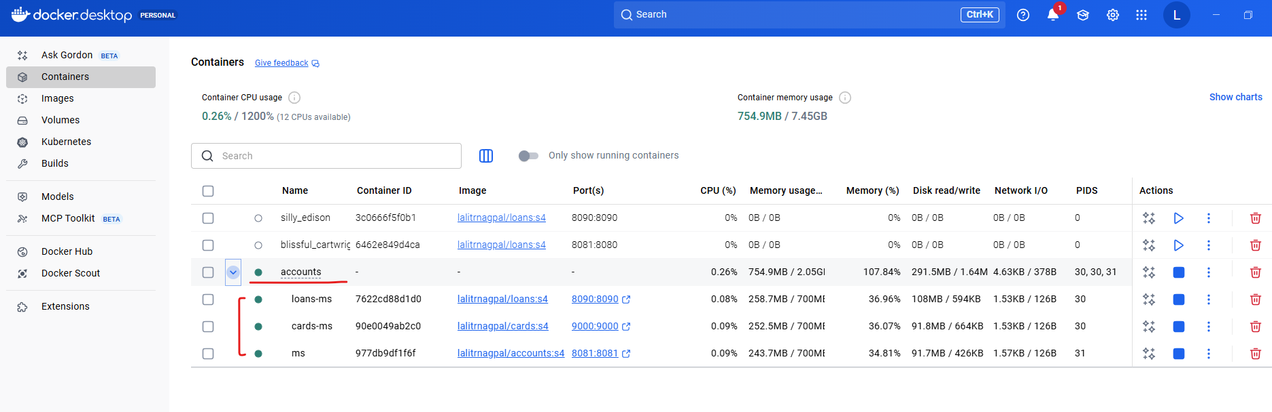

Inside our CLI, we are able to see the container name properly.

PS D:\002-Workspace\microservices\section4\accounts> docker ps -a

CONTAINER ID IMAGE COMMAND CREATED STATUS PORTS NAMES

977db9df1f6f lalitrnagpal/accounts:s4 "java -jar accounts-…" 4 hours ago Up About a minute 0.0.0.0:8081->8081/tcp, [::]:8081->8081/tcp accounts-ms

7622cd88d1d0 lalitrnagpal/loans:s4 "/cnb/process/web" 4 hours ago Up About a minute 0.0.0.0:8090->8090/tcp, [::]:8090->8090/tcp loans-ms

90e0049ab2c0 lalitrnagpal/cards:s4 "java -cp @/app/jib-…" 4 hours ago Up About a minute 0.0.0.0:9000->9000/tcp, [::]:9000->9000/tcp cards-ms

3c0666f5f0b1 lalitrnagpal/loans:s4 "/cnb/process/web" 3 days ago Exited (137) 32 hours ago silly_edison

6462e849d4ca lalitrnagpal/loans:s4 "/cnb/process/web" 3 days ago Exited (143) 3 days ago blissful_cartwright

You can see all these three containers are running properly. Now I can try to test them. Frist I'm trying to create an account, but please make sure the port number is 8080 because we configured the port mapping as 8080.

Port was occupied so I killed the task that was occupying the port

PS D:\002-Workspace\microservices\section4\accounts> netstat -ano | findstr :8080

TCP 0.0.0.0:8080 0.0.0.0:0 LISTENING 5860

TCP [::]:8080 [::]:0 LISTENING 5860

TCP [::1]:64507 [::1]:8080 TIME_WAIT 0

TCP [::1]:64508 [::1]:8080 TIME_WAIT 0

PS D:\002-Workspace\microservices\section4\accounts> tasklist /fi "PID eq 5860"

Image Name PID Session Name Session# Mem Usage

========================= ======== ================ =========== ============

AgentService.exe 5860 Services 0 6,700 K

PS D:\002-Workspace\microservices\section4\accounts> taskkill /F /PID 5860

ERROR: The process with PID 5860 could not be terminated.

Reason: Access is denied.

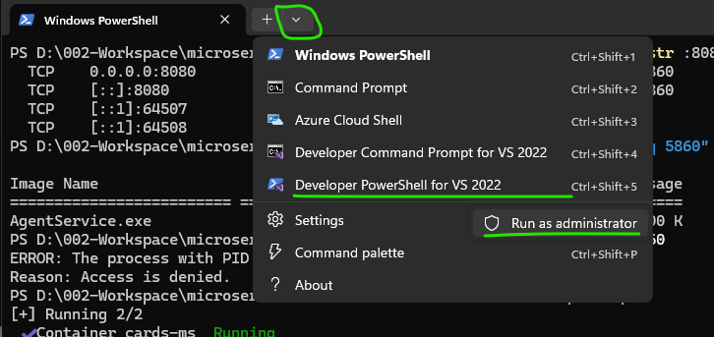

**Kill the task**

PS C:\Program Files (x86)\Microsoft Visual Studio\2022\BuildTools> taskkill /F /PID 5860

SUCCESS: The process with PID 5860 has been terminated.

PS C:\Program Files (x86)\Microsoft Visual Studio\2022\BuildTools>

So let me click on the send button and you can see I'm getting a successful response. Now I'll go to the create loan. I will click on the send button and you will get a successful response. Let me do the same for Create Card. And here also I'm getting a successful response. So this confirms all our containers are started successfully with a single command. How about stopping all of them with a single command again. For the same, it's going to be super, super easy. Just like how we have docker compose up. You can also use docker compose down. So let me run this command docker compose down -d. I think for docker compose down, we can't use this -d. So let me try to execute docker compose down alone and that will stop all my containers.

PS D:\002-Workspace\microservices\section4\accounts> docker compose down

[+] Running 4/4

✔ Container accounts-ms Removed 1.5s

✔ Container loans-ms Removed 1.2s

✔ Container cards-ms Removed 1.0s

✔ Network accounts_lalitrnagpal_nw Removed 0.5s

PS D:\002-Workspace\microservices\section4\accounts>

You can see those are getting removed. Now I'll go to my Docker desktop. You can see now my containers are no more there and all the containers are deleted. If you don't want them to be deleted, you can run a command which is docker compose stop. But since it is always advisable to delete the containers whenever you are trying to stop them, please use the docker compose down command. So we have used two commands docker compose up which will start all your containers with a single command. And similarly we also use docker compose down which will stop and remove all your containers from your Docker desktop. I hope this is clear. I didn't show you the demo of network that we have created. Like there is a network easybank that we have created as of now in the upcoming sections. When we try to have such scenario, I'll be showing you the demo and how the intercommunication between the containers are working with the help of this driver bridge network that we have created. This way you can create any number of services inside your Docker compose file and you can start them and you can stop them. You can restart them, you can achieve everything with a single command. Please make sure you are learning the structure and syntax of this docker-compose.yml file. This is super super easy. You can also find this inside the GitHub repo. Please make sure you are following this indentation of this yaml file properly. Otherwise things won't work like you expected. Every space is important inside the yaml file.

#### Docker Compose Commands Demo

In the previous lecture, we explored the commands of docker Compose, which is docker compose up, and similarly docker compose down. We saw that with the help of docker compose up, we will be able to create the containers. So whenever we use this docker compose up command, it is going to create your containers from scratch. If you see here right now there are three containers created from scratch because I have used docker compose up command. Now using docker compose down command, I can stop and I can also remove the containers. Think like there is a scenario where I don't want to remove my containers, but simply I want to stop them. In such scenario you can use docker compose stop. This will stop all the running containers that you have started with the help of docker compose command. You can also see right now the containers are simply stopped. If I want to start them again, the command that I need to use is docker compose start. So there is a clear difference between start and up Command. Start Command **will look for the existing containers** and it will try to start them again. So that is what happening here. Like you can see right now, they are in the running status. Now, this time I'm going to use docker compose down, which will stop and remove my containers. So now you can see all of my containers are removed. We confirm the same inside my Docker desktop. Now if I try to execute a command which is docker compose start since there are no containers, it will simply fail with a reason.

PS D:\002-Workspace\microservices\section4\accounts> docker compose down

[+] Running 4/4

✔ Container accounts-ms Removed 0.1s

✔ Container loans-ms Removed 0.1s

✔ Container cards-ms Removed 0.1s

✔ Network accounts_lalitrnagpal_nw Removed 0.4s

PS D:\002-Workspace\microservices\section4\accounts> docker compose start

service "cards" has no container to start

There is no service with the name cards are similarly, there is no service with the name, loans and accounts. And even if you try to run a command stop without any running containers, there will be no effect due to this command. Now let me try to run the command docker compose up again with a -d. So this will create the containers from scratch and start the same. After starting I'm going to simply stop them with the command docker compose stop and this will stop all the running containers like you can see. My containers are not deleted. They are only being stopped.

PS D:\002-Workspace\microservices\section4\accounts> docker compose up -d

[+] Running 3/3

✔ Container cards-ms Started 0.5s

✔ Container loans-ms Started 0.5s

✔ Container accounts-ms Started 0.4s

PS D:\002-Workspace\microservices\section4\accounts> docker ps -a

CONTAINER ID IMAGE COMMAND CREATED STATUS PORTS NAMES

1a330a20dea5 lalitrnagpal/accounts:s4 "java -jar accounts-…" About a minute ago Up 38 seconds 0.0.0.0:8080->8080/tcp, [::]:8080->8080/tcp accounts-ms

d4707eb0659f lalitrnagpal/cards:s4 "java -cp @/app/jib-…" About a minute ago Up 37 seconds 0.0.0.0:9000->9000/tcp, [::]:9000->9000/tcp cards-ms

ab08828c8972 lalitrnagpal/loans:s4 "/cnb/process/web" About a minute ago Up 38 seconds 0.0.0.0:8090->8090/tcp, [::]:8090->8090/tcp loans-ms

3c0666f5f0b1 lalitrnagpal/loans:s4 "/cnb/process/web" 3 days ago Exited (137) 34 hours ago silly_edison

6462e849d4ca lalitrnagpal/loans:s4 "/cnb/process/web" 3 days ago Exited (143) 3 days ago blissful_cartwright

PS D:\002-Workspace\microservices\section4\accounts> docker compose stop

[+] Stopping 3/3

✔ Container cards-ms Stopped 0.5s

✔ Container loans-ms Stopped 0.6s

✔ Container accounts-ms Stopped 0.8s

PS D:\002-Workspace\microservices\section4\accounts> docker ps -a

CONTAINER ID IMAGE COMMAND CREATED STATUS PORTS NAMES

1a330a20dea5 lalitrnagpal/accounts:s4 "java -jar accounts-…" 2 minutes ago Exited (143) 8 seconds ago accounts-ms

d4707eb0659f lalitrnagpal/cards:s4 "java -cp @/app/jib-…" 2 minutes ago Exited (143) 8 seconds ago cards-ms

ab08828c8972 lalitrnagpal/loans:s4 "/cnb/process/web" 2 minutes ago Exited (143) 8 seconds ago loans-ms

3c0666f5f0b1 lalitrnagpal/loans:s4 "/cnb/process/web" 3 days ago Exited (137) 34 hours ago silly_edison

6462e849d4ca lalitrnagpal/loans:s4 "/cnb/process/web" 3 days ago Exited (143) 3 days ago blissful_cartwright

PS D:\002-Workspace\microservices\section4\accounts> docker compose start

[+] Running 3/3

✔ Container accounts-ms Started 0.4s

✔ Container loans-ms Started 0.3s

✔ Container cards-ms Started 0.4s

In this scenario, if I try to run the command which is docker compose up, it is not going to create the containers from scratch. Instead, it is going to leverage the existing containers already with the same names like cards-ms and accounts microservice and loans microservice. So that is what's happening here. I hope you are getting a complete picture of docker compose up, docker compose down, docker compose start and docker compose stop. So there is a clear difference between these commands, so please make sure you are clear and use them accordingly on your day to day basis. Most of the times I'm going to use docker compose up and docker compose down because **I always make sure I'm deleting my containers when I don't need them**. That will give me some space inside my local system.

PS D:\002-Workspace\microservices\section4\accounts> docker compose down

[+] Running 4/4

✔ Container accounts-ms Removed 0.4s

✔ Container cards-ms Removed 0.7s

✔ Container loans-ms Removed 0.6s

✔ Network accounts_lalitrnagpal_nw Removed 0.4s

### Docker Commands Deep Dive

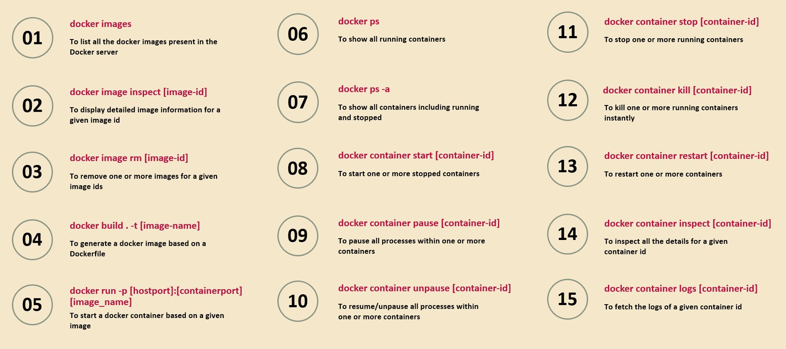

The very first Docker command that we have here is docker images. We are already using these Docker images command. A lot of times to see the list of Docker images present inside my local Docker server. And if I have a scenario where I want to know more details about a specific image

Then I can run the second command, which is docker image inspect <image ID> So whenever you're trying to pass a <imageId> or <containerId> or <any-other-Id> inside Docker, you don't have to mention the entire ID value. You can simply mention first three characters or four characters and your Docker server is smart enough to detect the entire image ID or container ID based upon the short value that you have provided.

The next command is to remove that Docker image. I showed you how to remove a Docker image from the Docker desktop

If you don't have access to Docker desktop, then you can issue this command from your CLI, which is docker image rm, rm indicates remove. And to this command you can pass. What is the image ID? If you have multiple images to remove, you can mention all those multiple image IDs separated by a space value.

We have Docker build command. Using this Docker build command, we can generate a Docker image based upon a Docker file. So please make sure when you are running this Docker build .command the Docker file present inside the same location where you are running this command from the terminal to this Docker build command, we should provide the complete Docker image name with the help of -t indicates tag.

And the 5th command that we have here is docker run command. We use this already many times with the help of this docker run command, along with the port mapping details and the Docker image name, we can start a Docker container based upon a given image. The 6th command that we have here is docker ps This will show all the running containers and similarly, if you want to see all the containers, including running and the stopped ones

The 7th command, which is docker ps -a.

The next command, which is 8th command is docker container start. What is a container ID? We want to start a specific container which is previously stopped. Then you can run this command. If you want multiple containers to start, then you can mention all those container IDs separated by a space value. And for whatever reason, if you want your container to pass for some time or if you want your container to not accept any traffic, then you can run this docker container pass command along with the container Id. Once the container is passed. Definitely after some time you want to unpass it. So in such scenarios you can run the 10th command, which is docker container and unpass and what is the container ID? So this will resume your container and it will start accepting the request.

And the 11th command is to stop the running container. Whenever you want to stop any running container, you need to use docker container stop. And what is a container ID? Whenever you use this docker container stop command, your Docker server is going to give some time for your container to close any resources, which means your Docker server is not going to kill your running container instantly. It is going to give some time like 5 seconds and within this 5 seconds your Docker container can close any resources that is opened by it, like database connections or file systems.

Whereas with the 12th command, which is like docker container kill, you can kill one or more running containers instantly. That's the difference between stop and kill. With the kill command, we are going to kill the container instantly, whereas the stop command will give you like 5 seconds for your container to close any resources.

The 13th command, we can restart containers with the command docker container restart and just like image inspect.

If you want to know more details about your container, you can use this docker container inspect command. To this command, you can pass a containerId. For debugging, if you want to see the logs of a container.

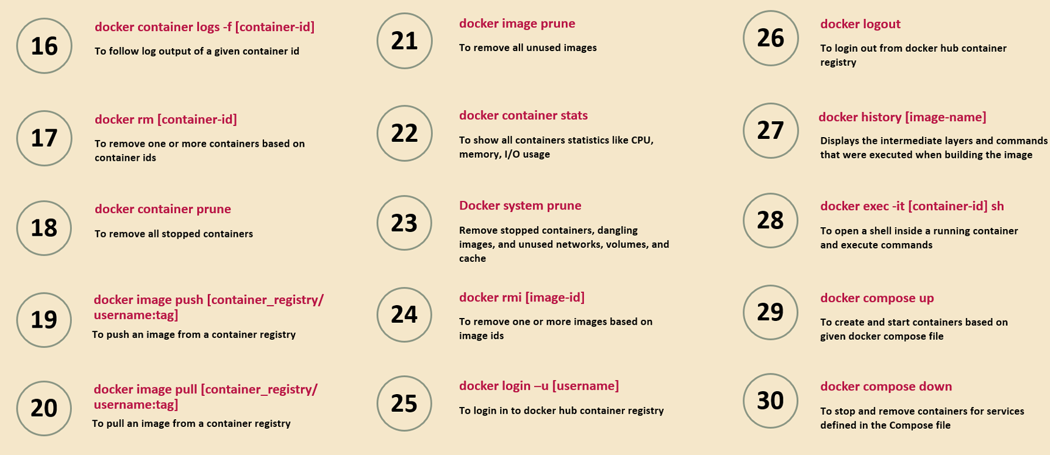

Run this 15th command, which is docker container logs <container-id>. And what is the container ID? This will fetch all the logs of a given container ID, but like I showed before, the more convenient way of checking the logs is with the help of Docker desktop. So inside your Docker desktop, go to containers and click on the container name and you will be able to see the logs of the container in live. Now moving on to the next important commands, sometimes you want to continuously follow the logs of a container like you want to see the logs in action what is happening. In such scenario, you can use this -f flag which tells to your Docker server that you want to follow the log output of a given container ID continuously inside your terminal and to remove your container

You can run the 17th command, which which is Docker rm and what is your container ID? If you want to remove multiple containers at the same time, you can provide all those container IDs separated by the space value

The 18th command, which which is docker container prune. This will help you to remove all the stopped containers with a single command. You don't even have to mention what are the stopped container IDs. So by default, this command is going to remove all the stopped containers.

And the docker image push and docker image pull commands we already discussed. Using these commands, we can push and pull the images from local system to remote repository and vice versa.

And just like Docker container prune, we also have Docker image prune like you can see in the 21st command. So this is going to remove all the unused images. So how your Docker server is going to identify all unused images. The answer is very simple. If there are no associated containers of an image is present either in start or stop mode, then that image will be considered as an unused image by your Docker server. From Docker Desktop, I showed you how to see the statistics of CPU usage or memory usage of your container.

If you want to see from your CLI as well, you can run this command which is docker container stats. So this will show all container statistics like CPU utilization, memory and IO usage. And just like how we have image prune and container prune, we also have Docker system prune. This will remove all the stopped containers, unused images, unused networks, volumes, cache inside your Docker server. And under that 24th command you can see I have mentioned one more approach on how to delete our image.

Docker rmi, I indicates image with this rmi we are telling to our Docker server to remove the image which is associated to an image ID that we have provided. Now coming to the next command, which is 25th command.

Whenever you want to log in into your remote Docker hub from your CLI, you need to use this docker login -u and followed by what is your username. Post that it will ask you the password. You can enter your password and with that from your CLI you are going to get logged in. But we don't have to follow this because inside Docker desktop there is a sign in option which will allow you to sign in with the help of browser as long as you logged in with the Docker desktop, your CLI also is automatically connected to your Docker hub account. But in the scenarios where you don't have Docker desktop installed, you have only Docker and Docker server. Then in such cases, these Docker login will help you to log in into your remote hub repository.

And similarly we also have Docker log out to log out from the Docker Hub Container Registry account.

Now moving on to that 27th command, which is Docker History Command with the help of Docker History Command and providing an image name, we can see all the intermediate layers and the commands that were executed while building an image. So this is going to help you to debug your image. If you are facing any issues behind the scenes, there will be lot of work that will be done by the Buildpacks or the Google jib or the Docker server while generating a Docker image. So to understand the intermediate layers and the commands that it has used to generate the Docker image, you can use this command.

Sometimes you may want to run some commands inside your running container, so the running container is present in its own network to run any CLI commands or any terminal commands from the Docker desktop, you always have an option to directly go to the terminal and run the commands. Whereas if you want the similar behavior with the help of Docker CLI, you can execute these 28th command which is docker execute -it and followed by what is your <containerId> followed by sh. So with that you are telling I want to open a shell inside a running container based upon the container id that you have passed and this will open a shell inside a running container from your CLI itself and you can execute the commands.

And at last we discussed that Docker compose related commands like like docker compose up, which will create and start the containers based upon the given Docker compose file.

And similarly we have docker compose down which will stop and remove the containers. And if you don't want to delete your containers, you can simply use docker compose stop command.

And similarly, if you simply want to start the containers and if you don't want to create the containers from scratch, then you can use the command docker compost start. So these are all the important commands that you can use on your day to day basis. And these commands will be also handy to you whenever you go for any interview. That's why I have mentioned all the important commands inside the slides that I'm going to provide, and at the same time I have also mentioned them inside the GitHub repo page, so please refer them whenever you have some questions.

### Docker Extensions and Logs Explorer

Let me introduce a Docker extension that may be useful for you on day to day basis. You can see inside your Docker desktop there is an option add extensions. There are thousands of Docker extensions available which you can use based upon your requirements on day to day basis.

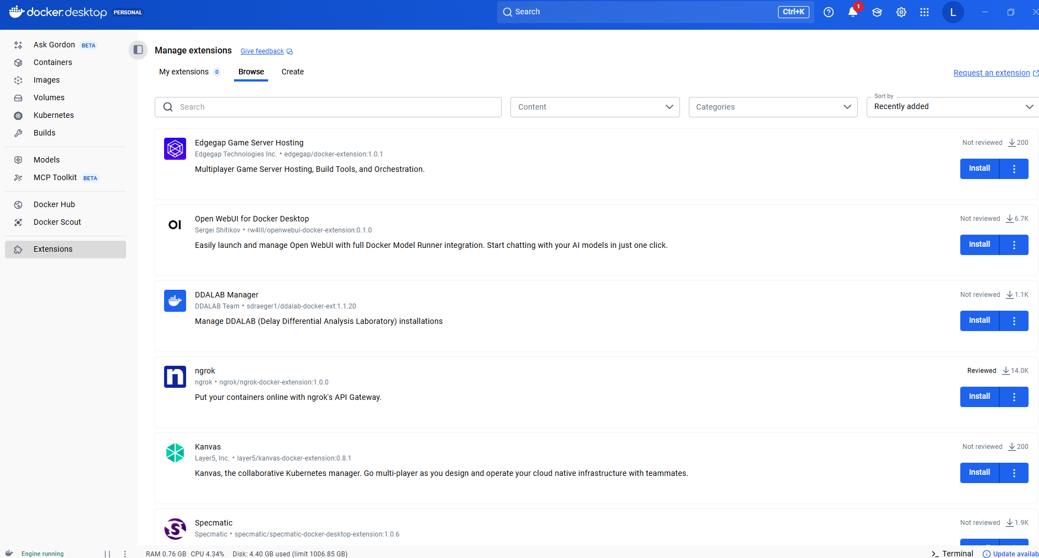

So whenever you are into a problem while using Docker containers, Docker images or Docker desktop, always search for if there is any extension that will solve your problem. By installing these extensions, you can make your life easy. One such extension is related to logs, so if you search for log, there is an extension with the name Logs Explorer. You can see if you can click on this.

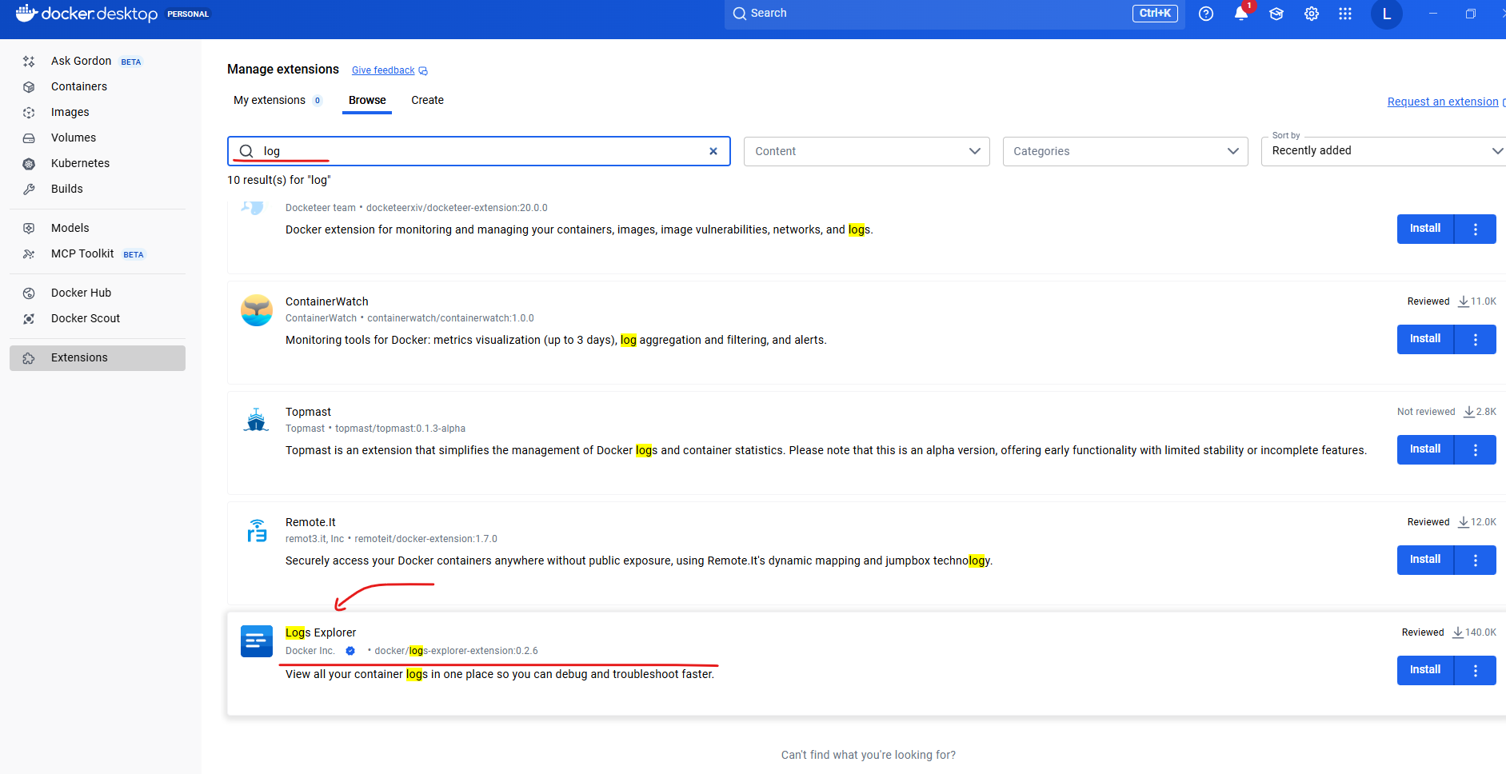

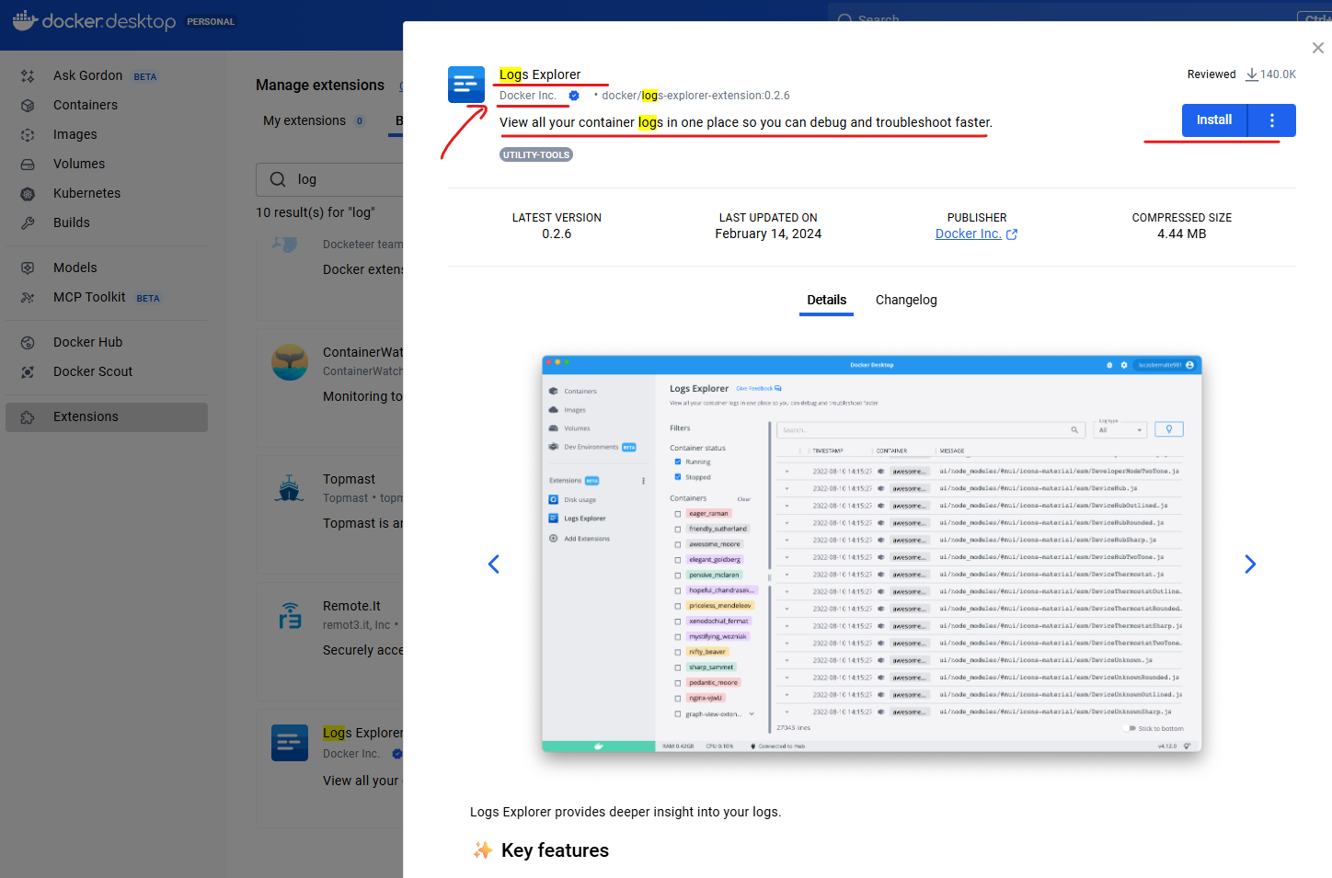

This is officially published by the Docker company itself. You can click on this install button as soon as you click on this install button, this extension will be installed inside your Docker desktop. So let me close this right now. You can see the installation is completed. With that, I have a logs explorer under my extensions, so let me click on that. You can see there is no logs information right now because I have installed this just now. So with the help of these Logs Explorer, we can see all the logs of our running containers or stopped containers. So let me show you a demo of this extension.

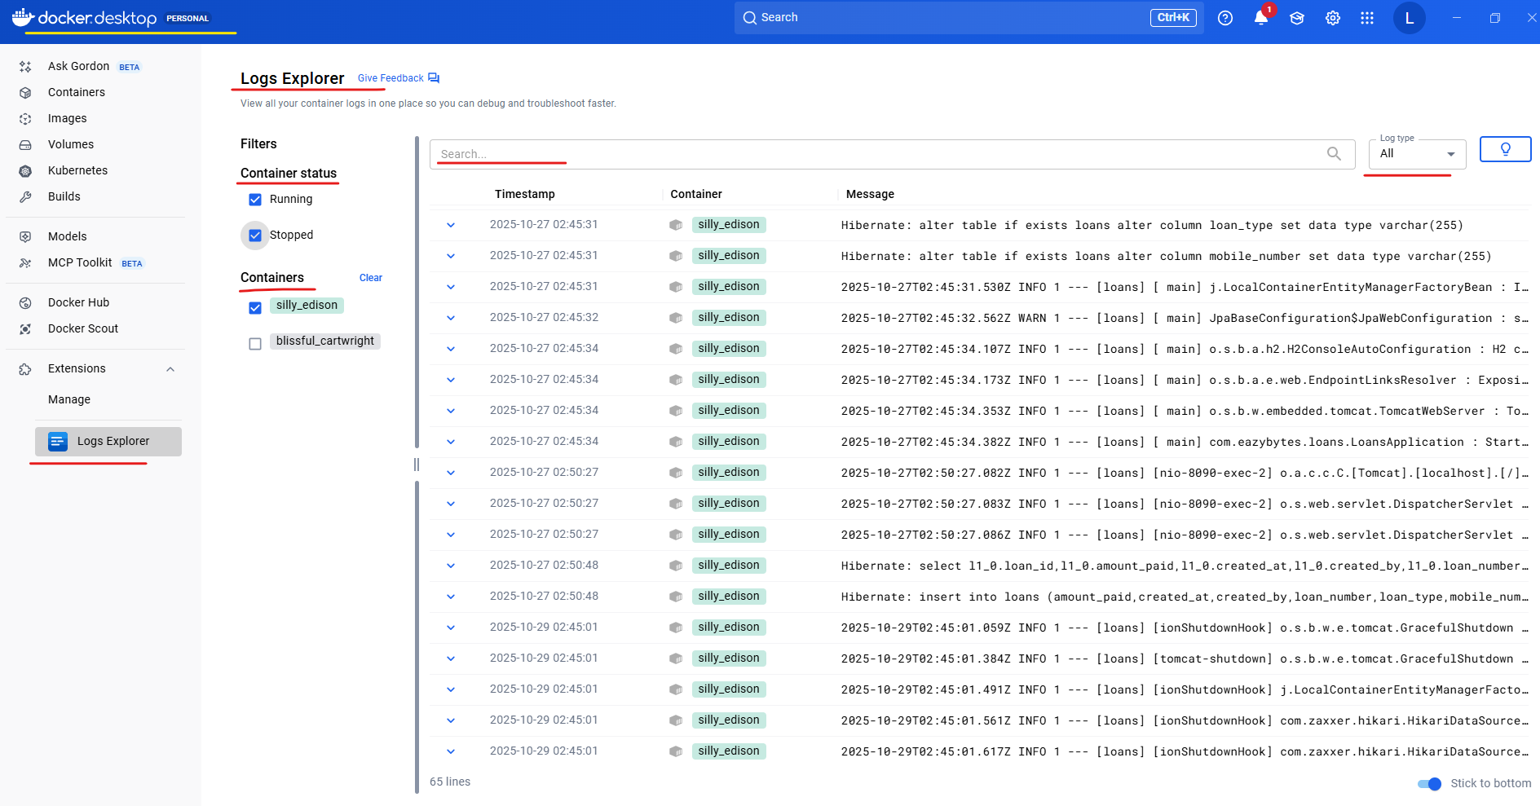

For the same, I'm going to run a command which is docker compose up, which will start all of my containers. Now I can go to my Docker desktop. Here you can see under accounts there are three different microservices are running like loans microservice, cards microservice and accounts microservice. And each microservice has its own color. Like all accounts microservice related logs are highlighted in a blue color. Similarly for loan, it is red color, and for cards it is green color.

For some reason I was not able to see the logs in Docker Desktop > Logs Explorer when service taken up via docker compose up

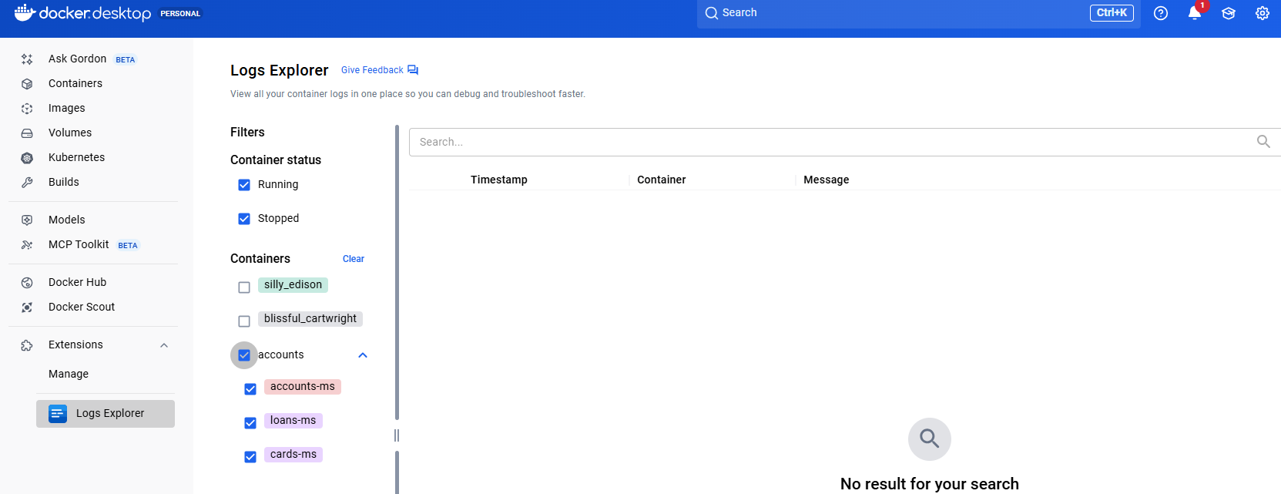

And can see for the ones that were created using docker earlier via jib/ buildpacks or dockerfile

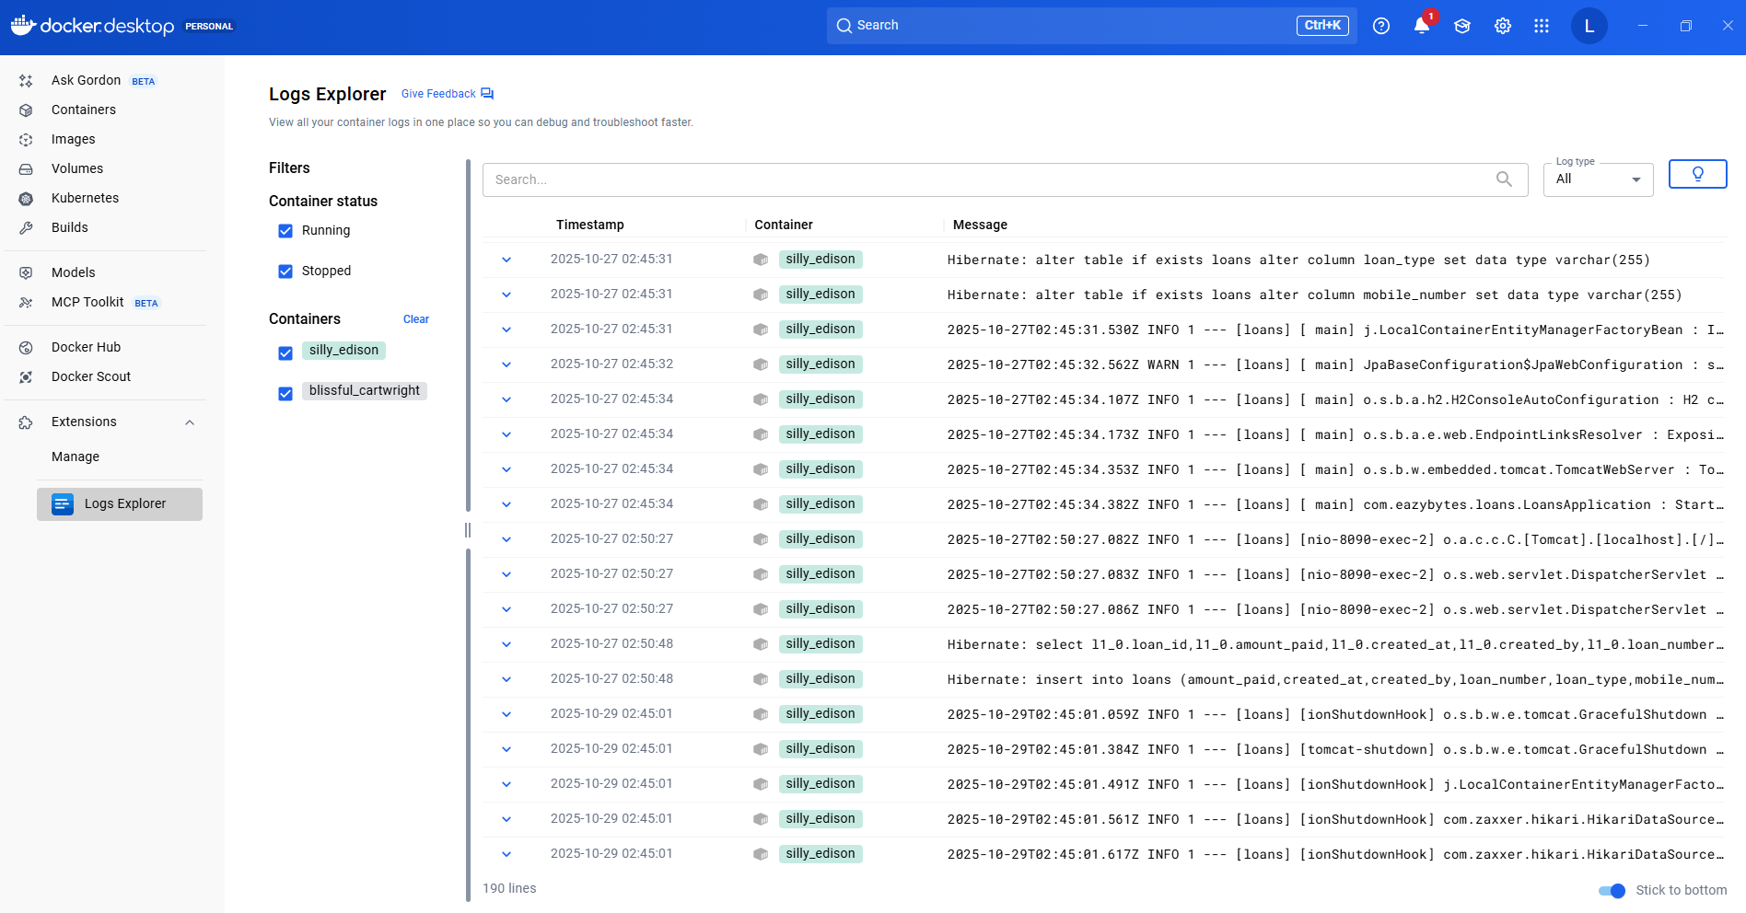

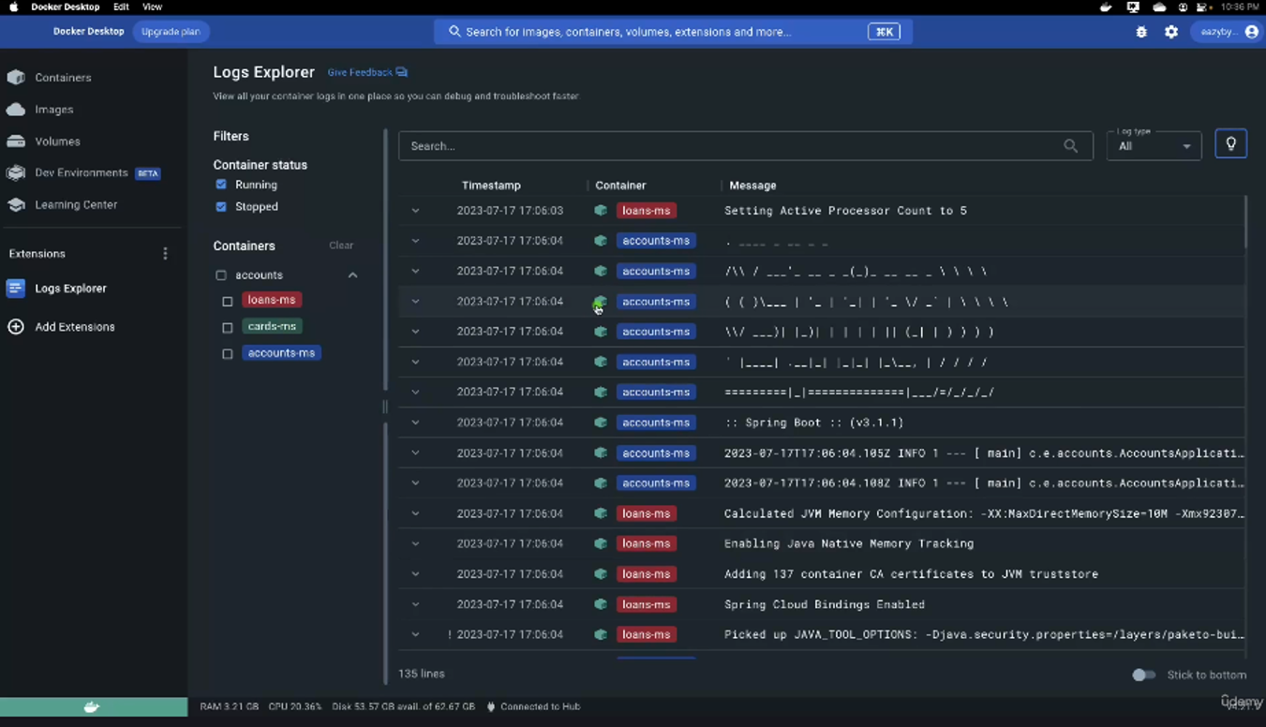

So you can look for all the logs from this Logs Explorer itself instead of navigating each of the container. If you are looking for the logs of a specific container, you can select here and that will do the filtration automatically and you will be able to see only the logs related to the loans microservice. And at the same time there is also a filter option to see the running containers logs or the stopped container logs. There is also a search button and if you want to see the logs based upon the specific log type like standard output or standard error, you can select the option accordingly.

This way, these Docker extensions are going to make our lives super, super easy and Logs Explorer is one such extension. I would strongly recommend you to install this extension inside your system as well. In future anytime like I said, if you face any problem with the Docker or if there is some task which is taking you a lot of time, then look for extensions because somebody might have faced the same issue and they might have built the extension, which which is right now available for others to use. So with the help of these extensions, make your life easy. That's what my recommendation here.

The docker logs command can be used to look at the logs of a container.

docker logs -f backend_api_1

Before I try to conclude this section, I just wanted to share a few important information. One such information is I have uploaded the section 4 related code inside the GitHub repo. Like you can see under this section 4 you should be able to see three different microservices with the name accounts, cards and loans. And inside the accounts you will be able to see the Docker file and Docker compose file that we have created along with the other Maven related configurations that we have done inside the pom.xml. So please refer to this GitHub repo for any questions. Since I also provided you the PDF content, please try to revise the same multiple times so that the concepts are going to be super, super clear for you. So we did a lot of hard work inside this section.

<https://github.com/eazybytes/microservices/tree/3.4.1/section4>

## Cloud Native Apps, 15 Factor Methodology

### Cloud Native Applications

This section is a small theory section where we are going to discuss about the definition of cloud native applications. What are the characters of Cloud Native applications and 12 factor methodology and 15 factor methodology? These are the standards that any microservice developer has to know because by following these standards only we are going to build many concepts inside the microservice in the upcoming sections. Now coming to the question, what is a cloud native application?

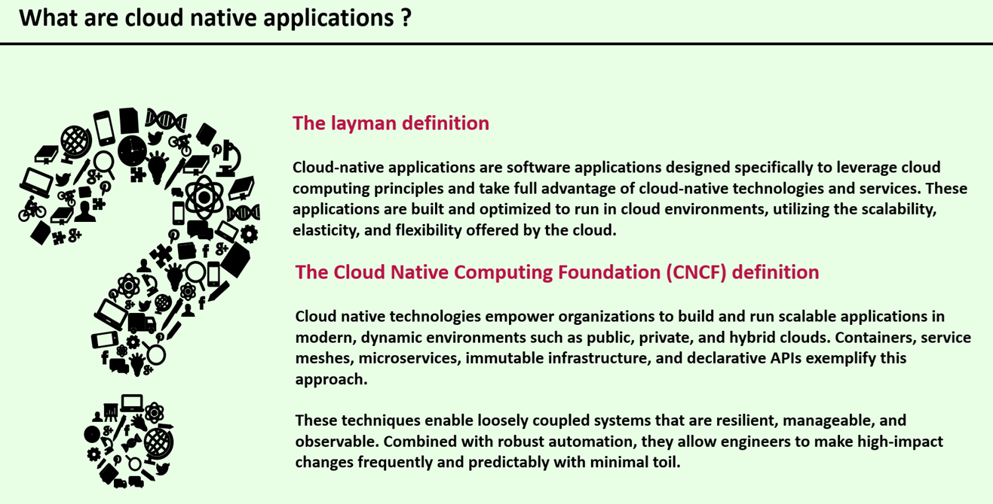

You might be hearing this jargon or this buzzword a lot inside your project or inside some blogs or podcasts or YouTube videos. So let's try to understand what are these cloud native applications and how they are related to the microservices. First, I'll try to provide a layman language. Like any non-technical person can understand this definitions.

**Layman Definition**

Cloud Native applications are the software applications that are designed and developed specifically to leverage the cloud computing principles and take the full advantage of cloud native technologies and services, which means these applications are built and optimized to run inside any cloud environments by utilizing the cloud advantages like scalability, elasticity and flexibility.

In simple words, cloud native applications are built for cloud environments so that the organizations can take complete advantage of cloud provider services and technologies. Now let's try to understand the official definition of cloud native applications from the Cloud Native Computing Foundation. So if you see here,

**Cloud Native Computing Foundation ( CNCF ) Definition**

Cloud native technologies empower organizations to build and run scalable applications in modern dynamic environments such as public, private and hybrid clouds. Containers, service meshes, microservices, immutable infrastructure, and declarative APIs exemplify this approach.

So the cloud environment can be anything, it can be it can be your own data center, it can be GCP, azure, or it can be a hybrid combination of private cloud and public cloud. Regardless of what type of cloud computing you're trying to use, your cloud native applications will work. So how this is possible is when we are trying to build cloud native applications, we will try to leverage technologies like containers, service meshes, microservices, immutable infrastructure and declarative APIs. So all these technologies make your applications to run on any cloud so you won't get vendor lock in with any particular cloud environment. On top of these cloud advantages.



These techniques also enable developing loosely coupled systems that are resilient, manageable and observable. Resilient means they can withstand any failures manageable you already know they are easy to manage and observable means we'll get to know everything about our applications, how it is working, are there any issues? There is also a separate section inside this course about the observability. We'll be discussing more details in that section. So with all these new techniques, along with the robust automation, these cloud native applications, they allow engineers to develop high impact changes frequently and predictably with minimal toil. So this will give freedom to the organizations and the developers if they want to make a small change or if they want to make a small enhancement, they can do that very quickly without any defects or regression issues being introduced. Because they are all loosely coupled and it is very easy to test them to develop new enhancements. I hope this is clear to you. So if anyone asks you what is the definition of cloud native application inside an interview or inside any project, first try to understand whether the opposite person who is asking is a technical person or a non-technical person. If he is a non-technical person, please share this layman definition. Whereas if the person is a technical person, you can share the official definition from the Cloud Native Computing Foundation.

### Important Characteristics of Cloud Native Applications

Right now we are clear about the definition of cloud native applications. inside this lecture, let me explain you about the important characteristics of cloud native applications. So whenever you see these characters for any application, then you can easily assume they are cloud native applications. The very first main character of Cloud Native application is microservice. When you are building microservice based applications, which are like loosely coupled and smaller in nature, then that gives a flexibility to you to develop them parallelly and deploy and scale independently. So this is the main advantage of the cloud native applications.

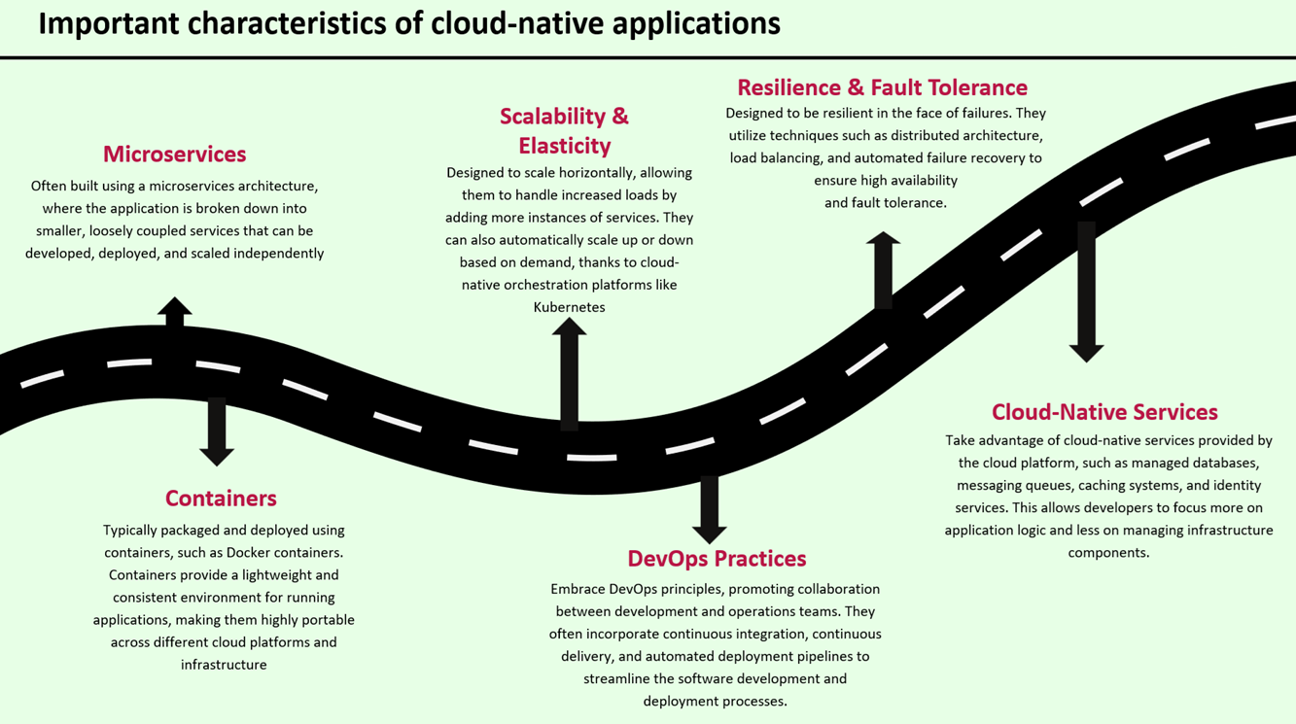

So cloud native application is a broader topic and under that topic microservices is one of the important feature. After building microservices like separating your business logic, you will obviously containerize your applications with the help of Docker or any other containerization software.

**Containers**

So what are these containers we already discussed? These are typically packaged and deployed using Docker containers. These containers provide a lightweight and consistent environment for running applications and making them highly portable across different cloud platforms and infrastructure. With the help of these containers, only the code will work very similarly regardless of which cloud environment you are trying to deploy. You take this container, you try to deploy inside your local system and you deploy inside the AWS, GCP, Azure Cloud in all the places it is going to work in very similar manner. Whereas this is not the scenario with a monolithic application. Your monolithic application won't give such kind of flexibility. You need to put a lot of efforts to bring that consistency across all the cloud platforms.

**Scalability and Elasticity**

The next character of cloud native applications is they provide scalability and elasticity. Since you are building your applications based upon microservices and with the help of containers, they can be easily scaled horizontally allowing them to handle any kind of traffic that comes towards your applications. So adding more instances of services is going to be super easy and this can be achieved automatically with the help of container orchestration platforms like Kubernetes. We also have separate section inside this course where I'll be showing you how automatically scale your microservice applications with the help of Kubernetes.

**Devops Practices**

Moving on to the next principle, these cloud native applications, they follow DevOps practices, by embracing all these DevOps principles. They promote a collaboration culture between the development and operations teams. Whenever these cloud native applications are being built, they will not be any blame game between the developers and operations team when they are building cloud native application because they are following these DevOps practices and with the help of these DevOps practices, they will incorporate continuous integration, continuous delivery and automated deployment pipelines to streamline the software development and deployment process. So these cloud native applications, they will give complete flexibility to the organizations, whether they want to do continuous integration only or whether they want to go with the continuous delivery or if they want to go with the continuous deployment as well.

**Resilience and Fault Tolerance**

The next character of native applications is, they are resilient and fault tolerance in nature. Whatever applications that we are going to develop with the help of cloud native principles, they can withstand any kind of failures which will make them resilient and they will utilize techniques such as distributed architecture, load balancing and automated fail recovery to ensure high availability and fault tolerance. One example that I can give here is, think like you have a microservice by following the cloud native application principles, you will deploy this microservice in multiple locations. Even if one of the location has a downtime due to some power outage or due to some internet issue, the microservice will continue to work from the other location that you have deployed. And at the same time, for some reason, if one of your microservice instance is not working platforms like Kubernetes, they can automatically shut down that microservice instance and bring up a new instance. This way you are ensuring the failure recovery automatically and bringing fault tolerance inside your applications.

**Cloud Native Services**

Moving on to the next character of cloud Native applications, which is they utilize cloud native services to a great extent. Like I said, cloud native applications means they are developed to leverage the cloud environments to a great extent. When an organization or an application uses these cloud native services provided they don't have to focus on infrastructure because all these services will be monitored and maintained by the cloud platform provider itself. With that, the developers and the organizations they can simply focus more on the application logic and enhancing the business logic with a very less focus on the infrastructure components. Like you can see these are all the important characters of cloud native applications. Inside this course, we are going to touch all of these characters in the various sections. Whenever you see a application is following all these characters, then you can simply assume that is an cloud native application.

### Difference B/W Cloud Native and Traditional Apps

The very first difference of cloud native application and traditional applications is, cloud native applications will have predictable behavior, whereas with traditional applications, the behavior is going to be unpredictable. For example, inside microservice environment, if there is an issue, we can easily track that where the issue is because all your business logic is loosely coupled and separated into multiple microservices, so you can easily predict where the exception happens. Whereas inside monolithic application, since all your business logic clubbed together, you never know where the exception happens until your developer put a lot of efforts by debugging all the lines of code that you have inside your application.

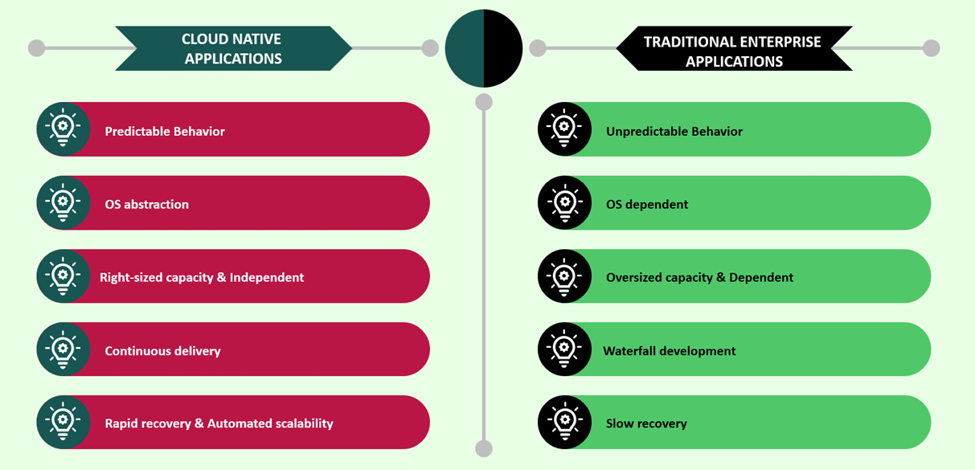

The next difference that we have here is cloud native applications they are not OS dependent. They will abstract the operating system, whereas traditional enterprise applications, they are dependent on operating system. This is because inside cloud native applications we are going to adopt docker containers and Docker images where they will abstract the operating system and they will work in any operating system. The next difference that we have here is, cloud native applications they are rightly sized and they are following the right capacity and they work in an independent manner. Whereas with traditional applications they are oversized capacity because you have all your business logic inside a single application or inside a single codebase. That's why most of the times traditional enterprise applications, they are dependent on each other. Moving on to the next difference cloud native applications they support continuous delivery with the help of DevOps principles and automation, whereas traditional enterprise applications, they follow waterfall development. They won't support Agile style of working inside any organization. Then the last difference that we have here is Cloud Native Application supports rapid recovery and automated scalability. Inside cloud native applications if one of the microservice instance is not working properly Kubernetes, they can automatically create a new instance and try to recover automatically and also scale your applications automatically based upon the incoming traffic. Whereas with traditional applications, since they are not going to use Docker containers, obviously they cannot rely on the platforms like Kubernetes with that reasons with the traditional enterprise applications, the recovery is going to be super slow and at the same time there won't be any automated style of recovery and scalability. From these differences It is very clear that Cloud Native application is a clear winner compared to the traditional enterprise applications. So now you agree that cloud native applications are good and that's why we are trying to learn and build microservices inside this course. But here you may have a question like do we have any principles or guidelines that we need to follow while building these cloud native applications in order to get all these advantages? Off course, there are good guidelines and principles that we can follow while building these cloud native applications or microservices.

### 12 Factors and Beyond

Many of us who is trying to build cloud native applications or microservices will have a basic question, which is how to get succeeded in building a better cloud native application or a better microservices applications. Are there any guiding principles that can be considered for the same? To answer your question, yes, we do have standards, so let's try to understand them. Back in 2012, the engineering team at Heroku Cloud Platform, they introduced 12 factor methodology. So these are the 12 different development principles that are aimed at guiding the developers in designing and developing cloud native applications. These 12 different principles under the 12 factor methodology are the result of the Heroku team expertise from many, many years building these cloud native applications.

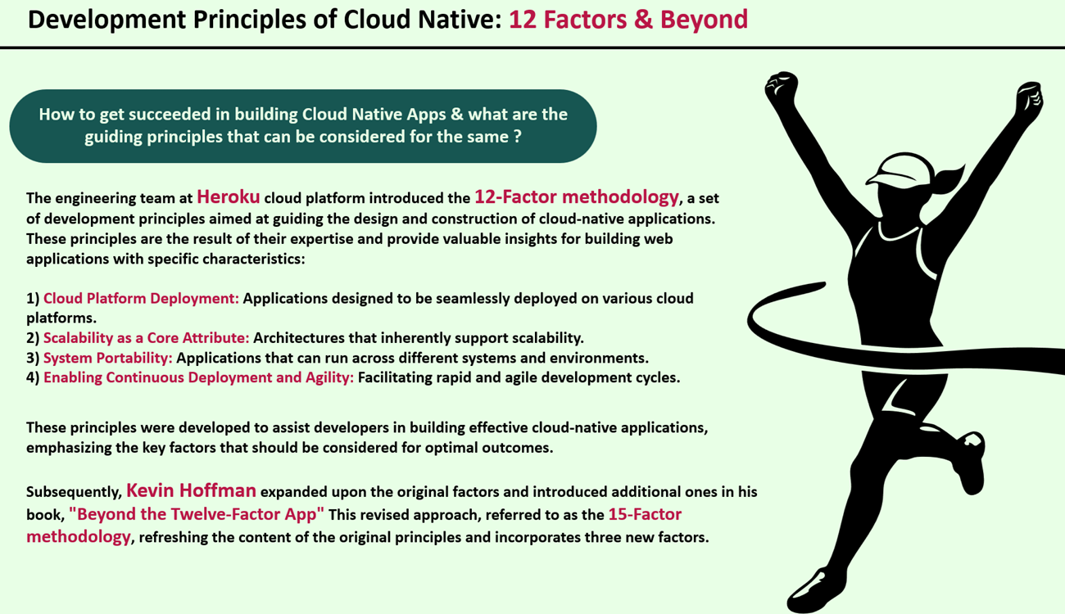

When you follow these 12 factor methodology, your applications will have advantages like ready for cloud platform deployment regardless of whatever cloud platform that you choose. You can seamlessly deploy your cloud native applications. And at the core of this cloud native applications, they are going to support scalability and elasticity. And very similarly, these cloud native systems that you are going to develop with the help of 12 factor methodology, they allow system portability, which means your applications can run across different systems and environments without any issues. And at last these applications will support continuous deployment and agility. So in the initial days, everyone are recommended to follow these 12 factor methodology. But later on, after few years since the technology is getting evolved day by day, a person with the name Kevin Hoffman, he expanded these 12 factor methodology by adding three more principles. And in his book with the name Beyond the 12 Factory app, he revised all these 12 factor methodology. And on top of that, he also introduced three more development principles. And with that, a new 15 factor methodology came into picture. And this is the most latest one right now everyone is referring to. So do you want to see what are these principles? Let's try to see the summary of these methodologies. So these are the 15 methodologies are the principles or guidelines that any developer or organization should follow while building cloud native applications. Without following these standards, they can't tell their applications as cloud native applications because they will end up with some problems since they are not following these standards. These standards are built based upon the development experience of cloud native applications. If you see first, this is the website like everyone used to refer 12factor.net So inside this website you can read all the 12 factor methodologies and if you can scroll down here, these are the 12 factors. If you can click on each of them, there is a detailed description about each of these methodologies.

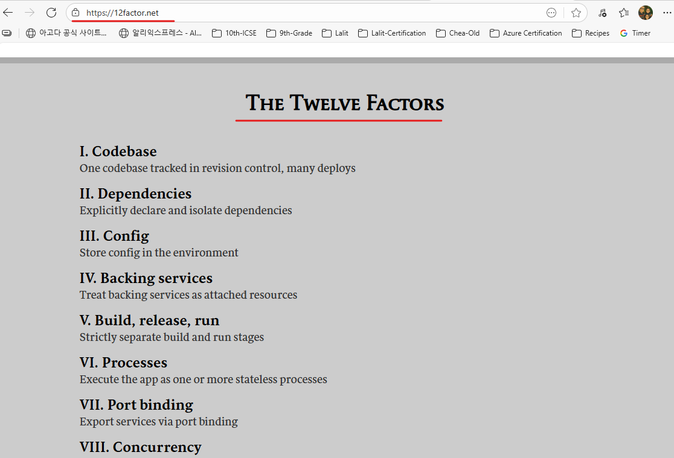

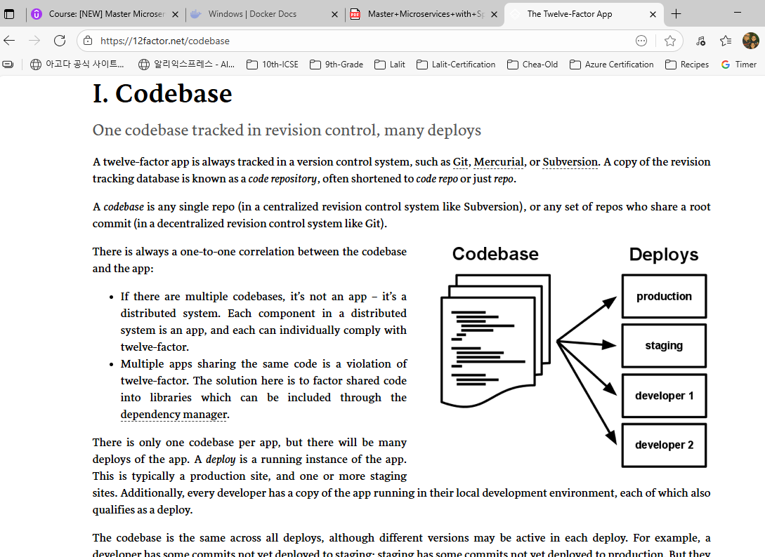

So don't worry, I'm going to explain them inside this course. You don't need to read all of them and digest them. I'm going to explain them in an easily understandable format.

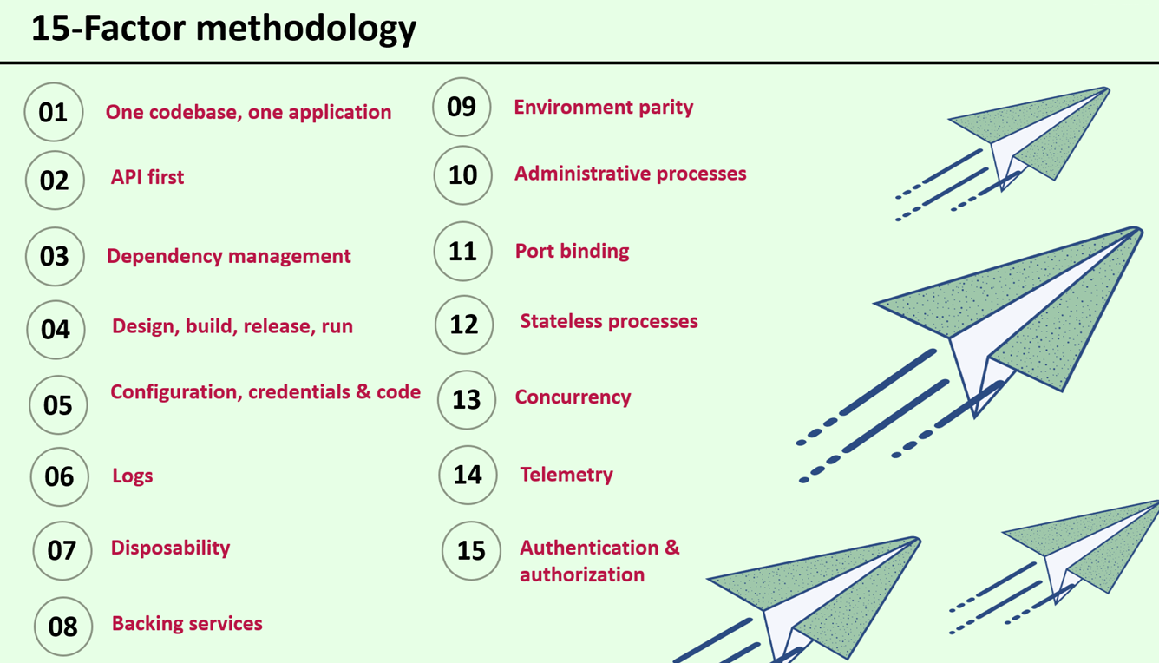

But like I said, these Twelve-Factor app is right now outdated. Like I said, Kevin Hoffman, he wrote a book with the name Beyond the Twelve-Factor App. And inside this book he added three more principles or guidelines. And with that this became 15 factor methodology. You can see the description of this book. In 2012, Early cloud pioneer Heroku developed the 12 Factor app, a set of rules and guidelines for helping organizations for building cloud native applications. It served as an excellent starting point, but as a technology changes day by day, some areas need revisiting to accommodate the current best practices this practical book expands on the original guidelines to help you to build applications that not only function in the cloud but also thrive. I hope you are clear. Like what is the difference between 12 Factor app and the 15 factor app methodology? So 15 factor methodology is the most updated one.

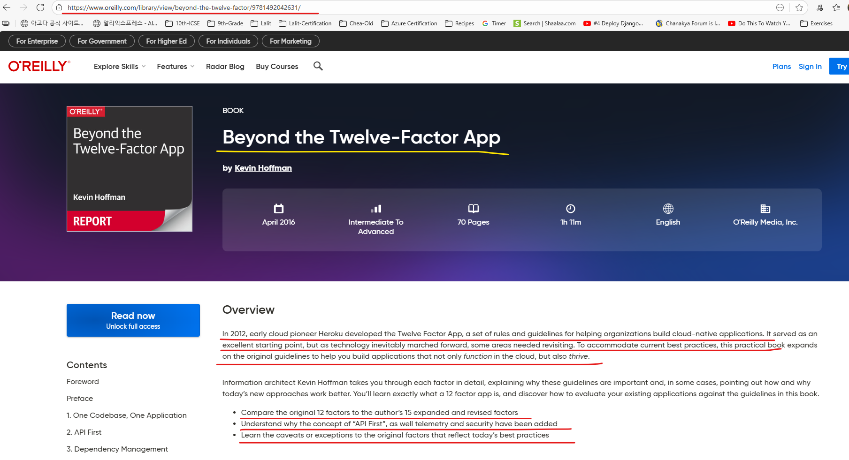

<https://www.oreilly.com/library/view/beyond-the-twelve-factor/9781492042631/>

If you attend an interview focusing on microservices, definitely there will be some questions around these 12 factor methodology or 15 factor methodology. That's why it is very important to understand these methodologies one by one. So let's try to deep dive into these methodologies and learn quickly about them.

## 15-Factors Deep Dive